**QUANTUM MECHANICS**

**Exercises**

**Section 35.2 The Schrödinger Equation**

**10. Interpret** We are to find the units of the wave function *ψ*(*x*) for a one-dimensional problem.

**Develop** The one-dimensional wave function is related to the probability by Equation 35.2, 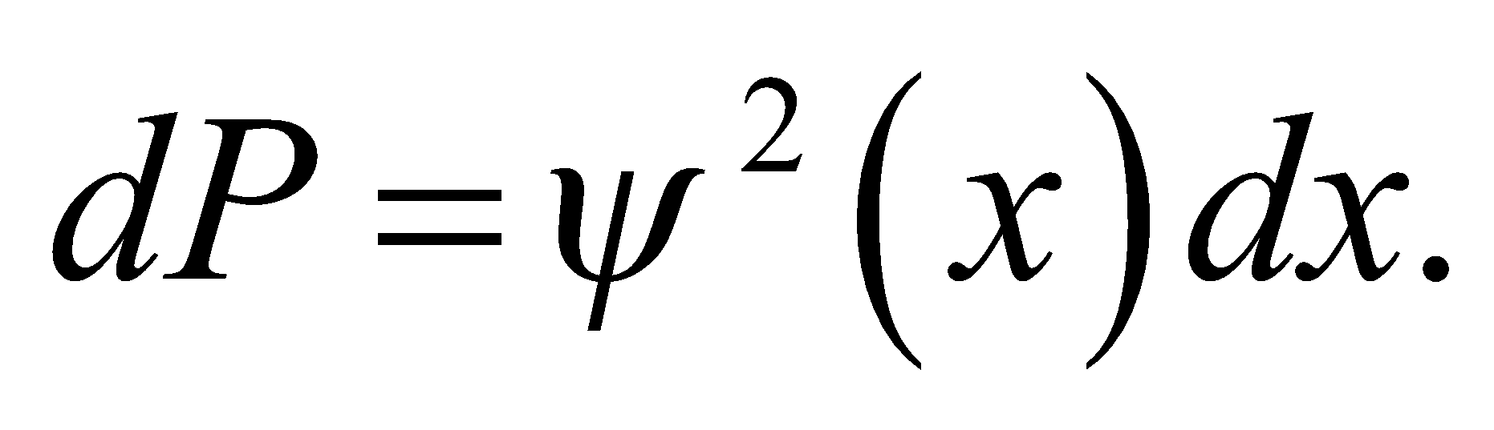 Given that dP is a probability and is therefore dimensionless, we can find the units for *ψ*(*x*).

**Evaluate** The units of *ψ*(*x*) are those of *dP*/*dx*, or inverse length. In SI units, this would be m−1.

**Assess** The units of inverse length make sense because *ψ*(*x*) gives the probability *per unit length* of finding the particle.

**11. Interpret** We are given the wave function of a particle and are to deduce from this the most probable position of the particle and the position(s) where the probability of finding the particle is 50%.

**Develop** The quantity 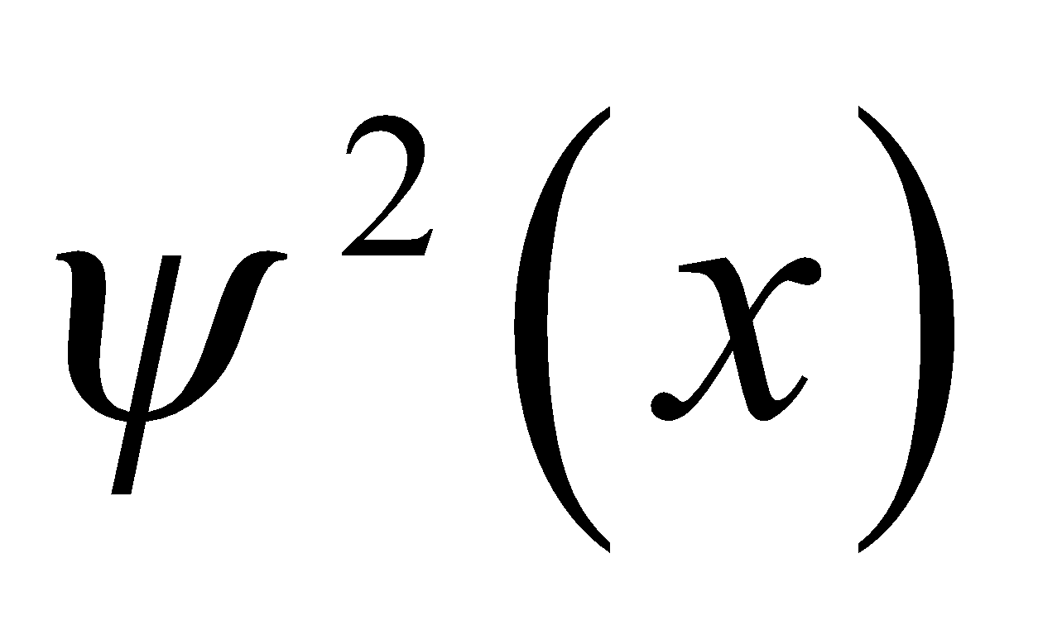 represents the probability of finding the particle at the position *x*. Therefore, the particle is most likely to be found at the position where the probability density  is a maximum.

**Evaluate** **(a)** The maximum of 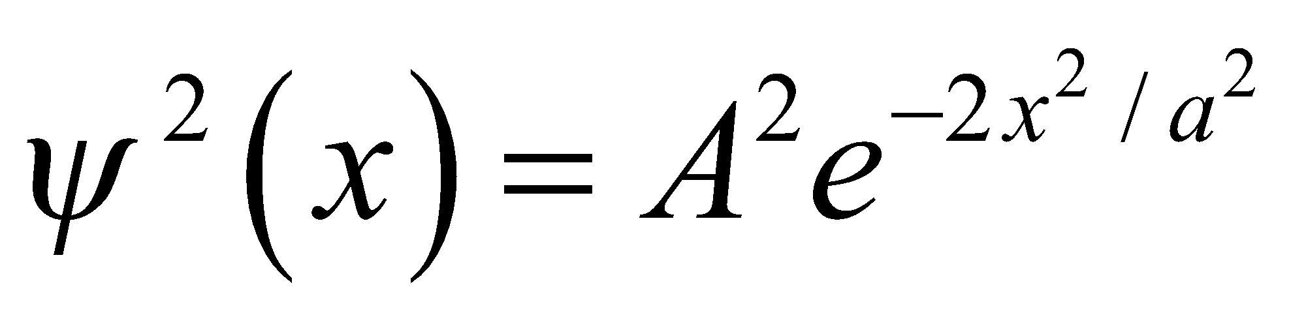 occurs where 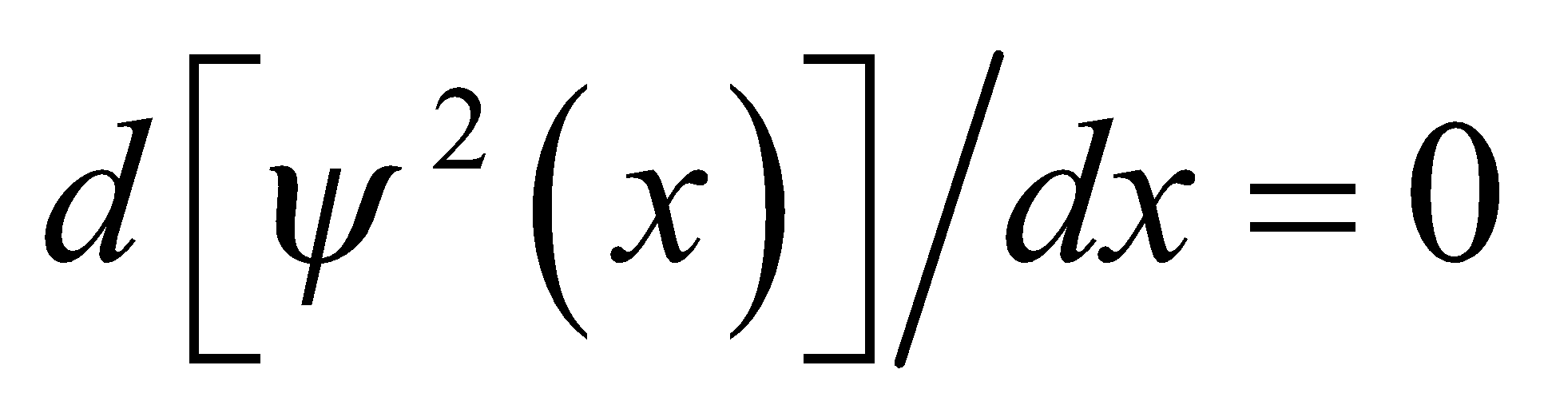 and 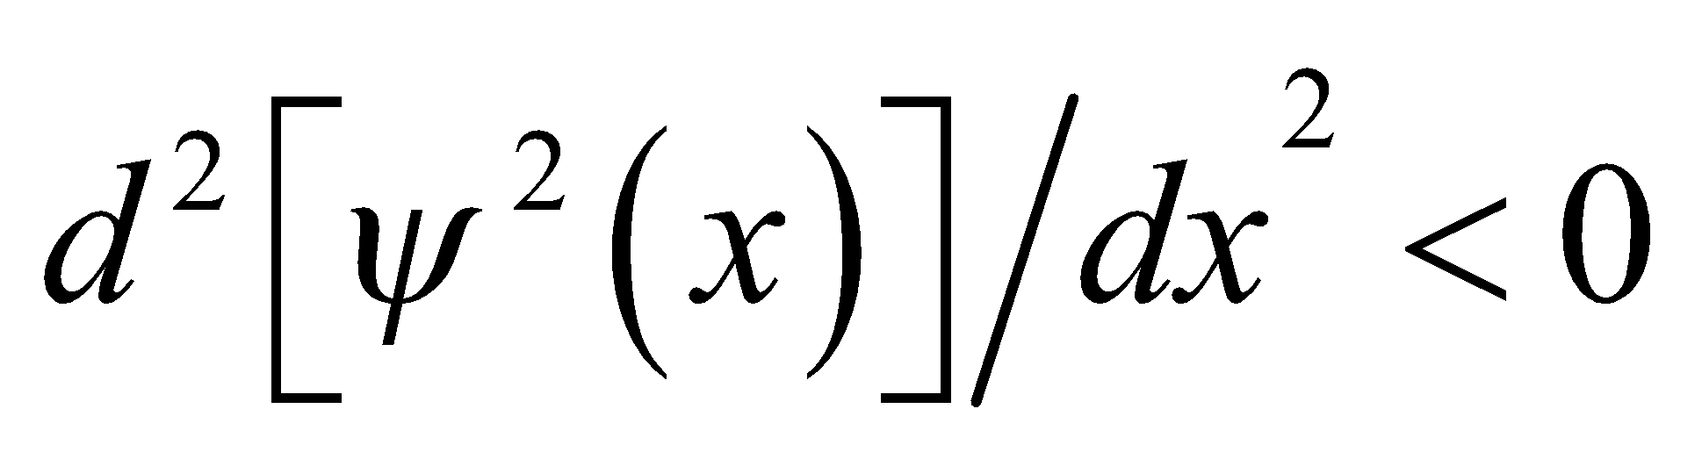. Evaluating the first derivative gives

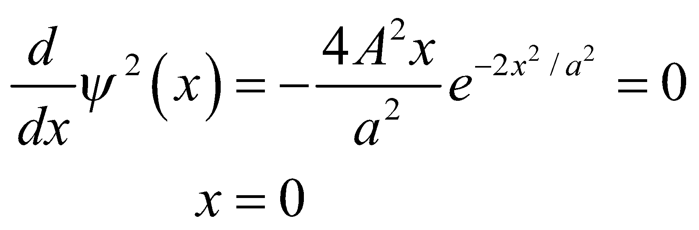

Evaluating the second derivative at *x* = 0 gives

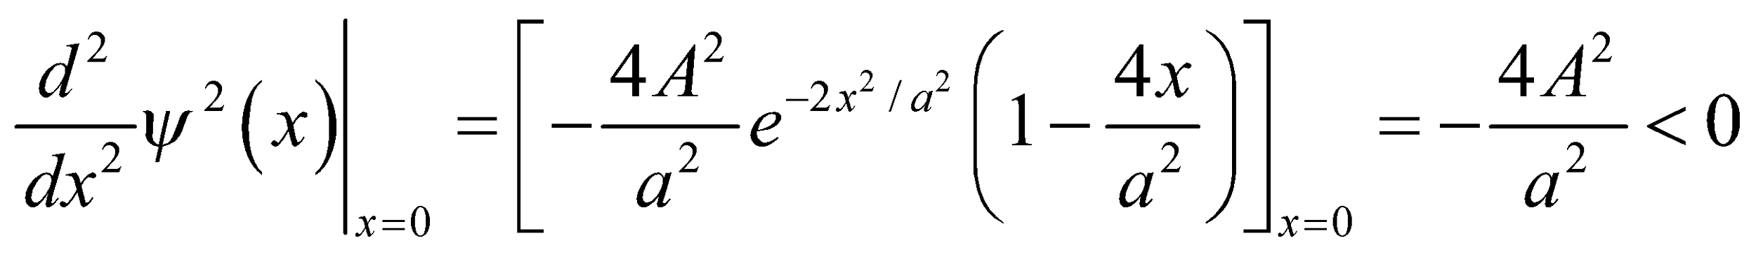

which shows that the extremum at *x* = 0 is indeed a maximum. Thus, most probable place to find the particle is at *x* = 0.

**(b)** The probability density  falls to half its maximum value when 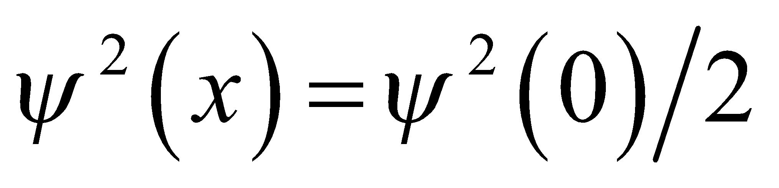. Solving this equation gives 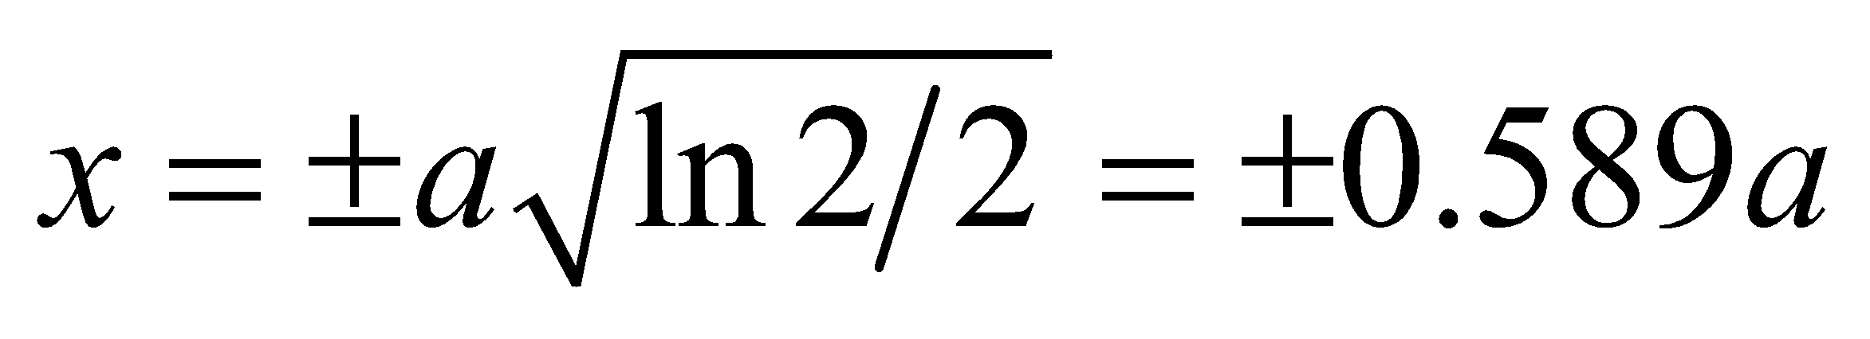.

**Assess** The probability distribution is shown below. Note that  peaks at *x* = 0 and appears to be halved at *x*/*a* ~ ±0.6.



**12. Interpret** This problem is an exercise in normalizing the wave function *ψ*(*x*) given the boundary conditions.

**Develop** The wave function is like the first excited state of an infinite square well found in Section 35.3, except that 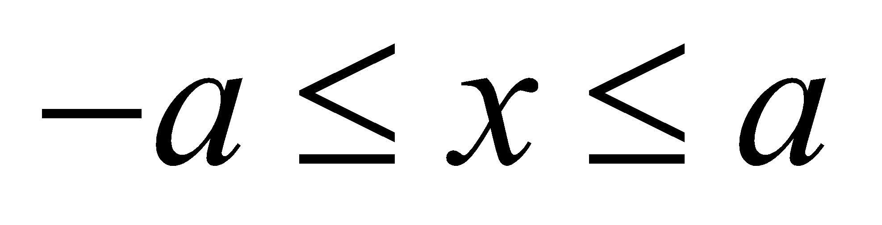 rather than 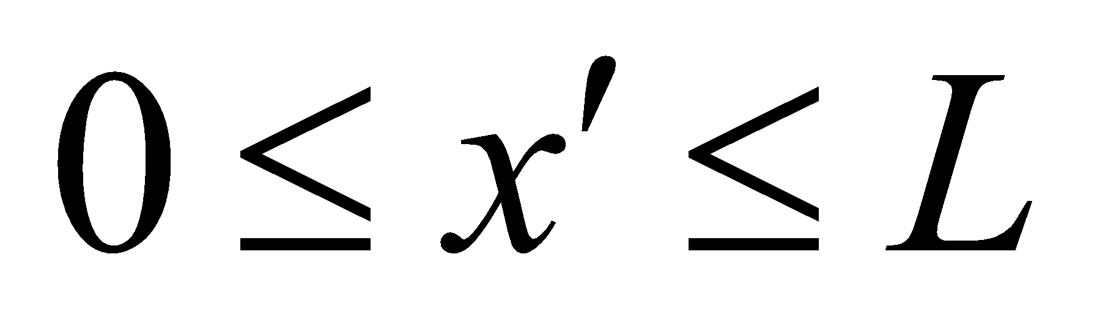, as in Fig. 35.5. The correspondence is explicit if one takes 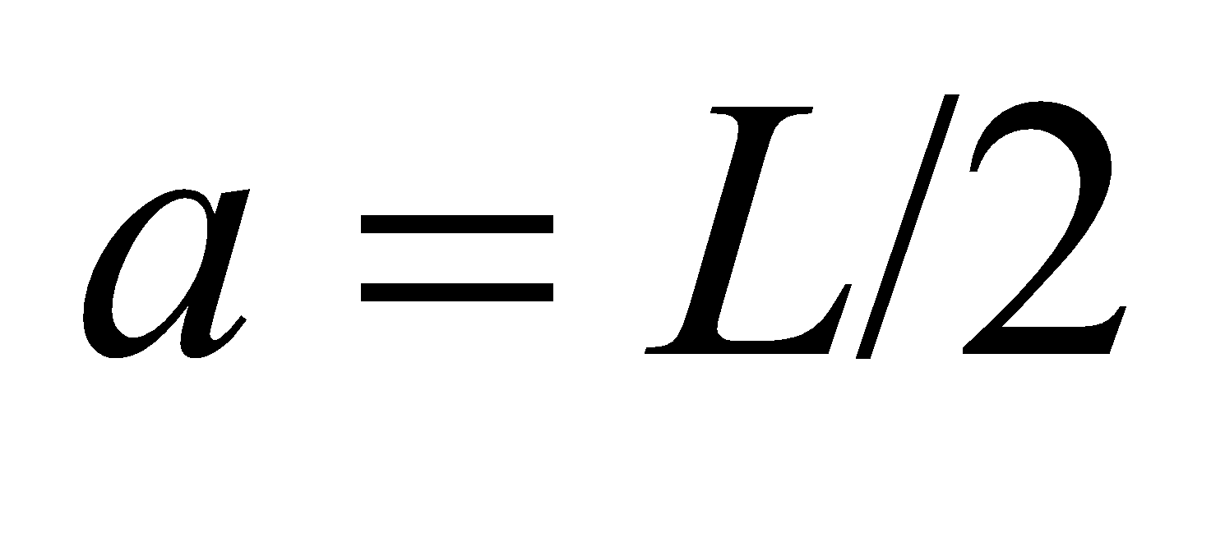 and 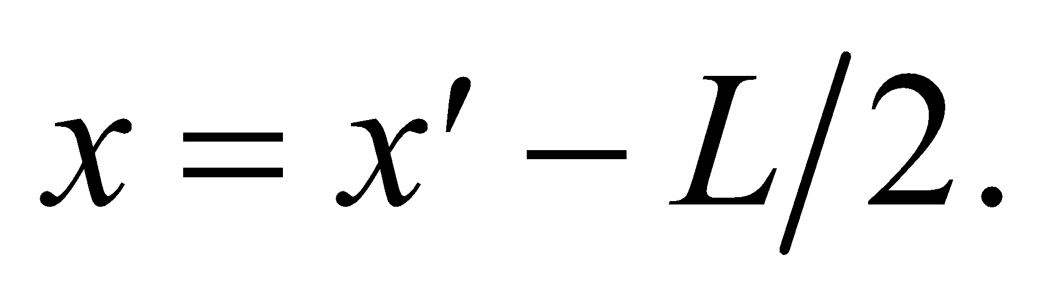 Then

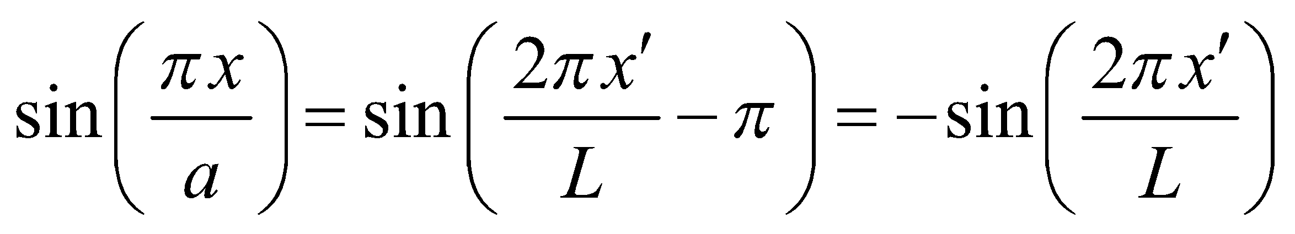

which is the wave function in the equation 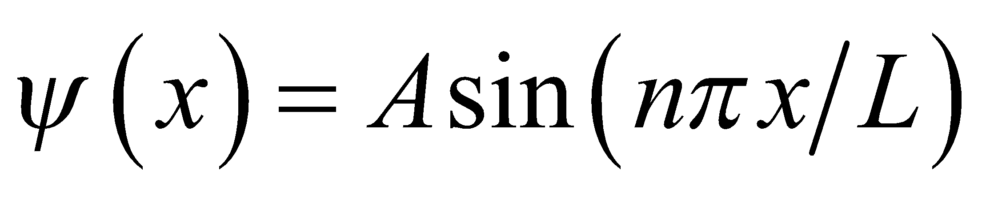 for *n* = 2, except for an overall phase.

**Evaluate** The normalization constant for this wave function is therefore 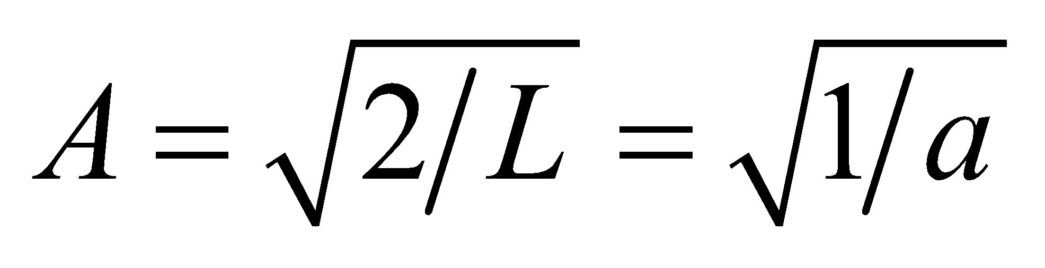.

**Assess** Of course, *A* can be determined by repeating the integration,

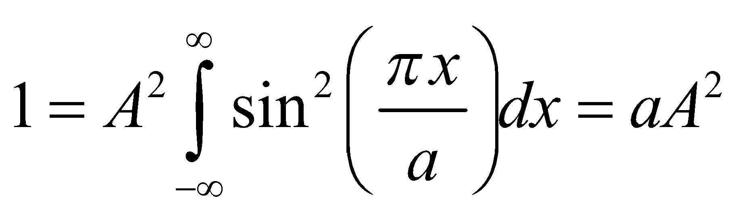

which gives the same result.

**Section 35.3 Particles and Potentials**

**13. Interpret** We are to find the principal quantum number of a particle in an infinite square well given the particle’s energy relative to the ground state.

**Develop** The energy levels for a particle in an infinite square well are (Equation 35.5) 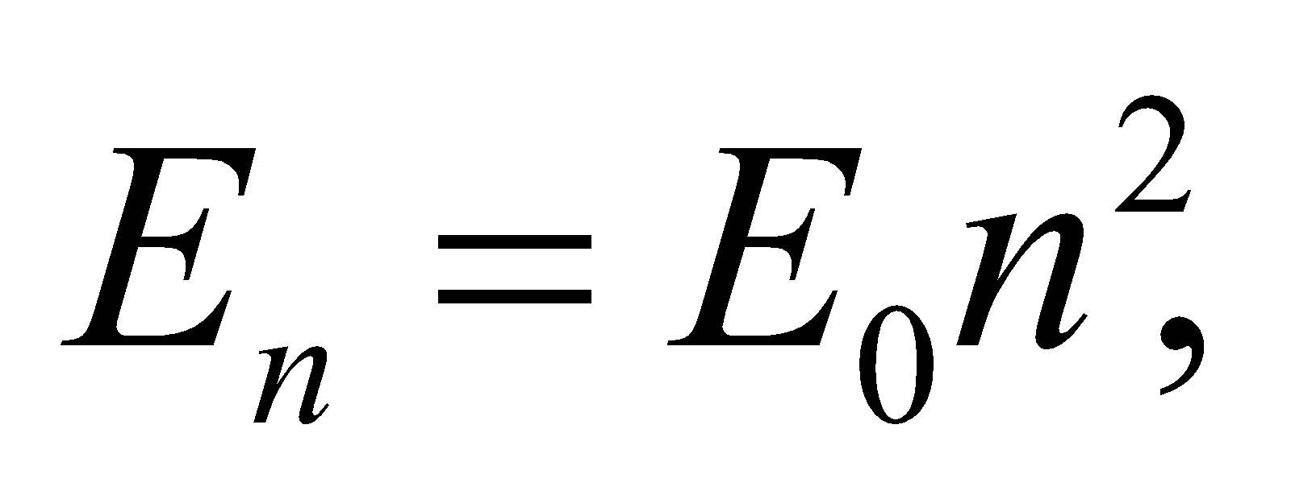 where 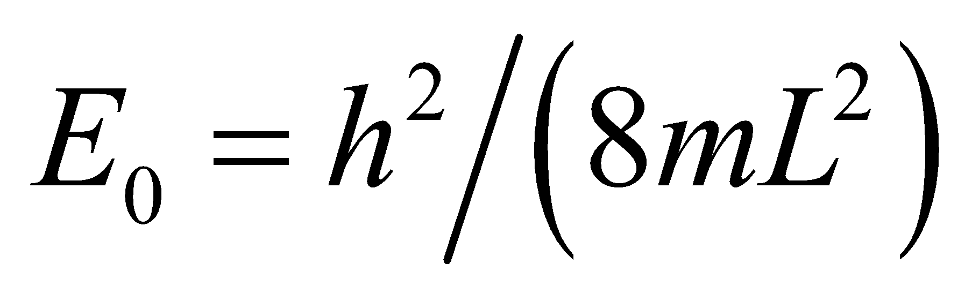 is the ground state energy. Thus, we must find the quantum number *n* such that

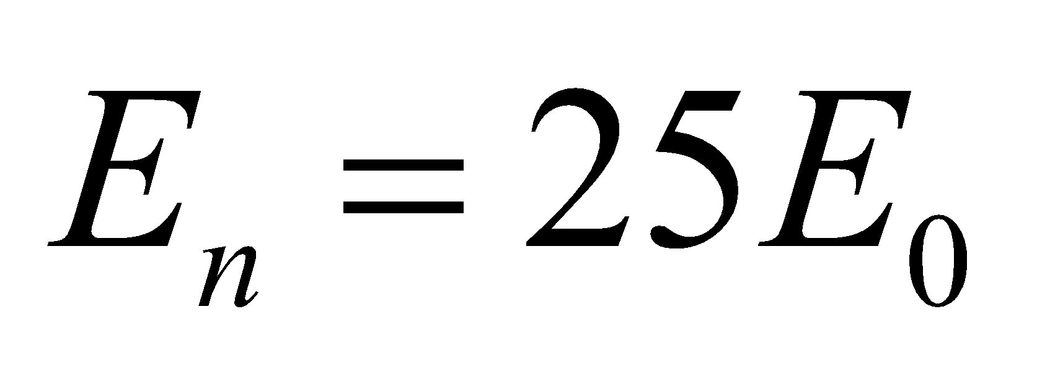**.**

**Evaluate** Solving the equation gives

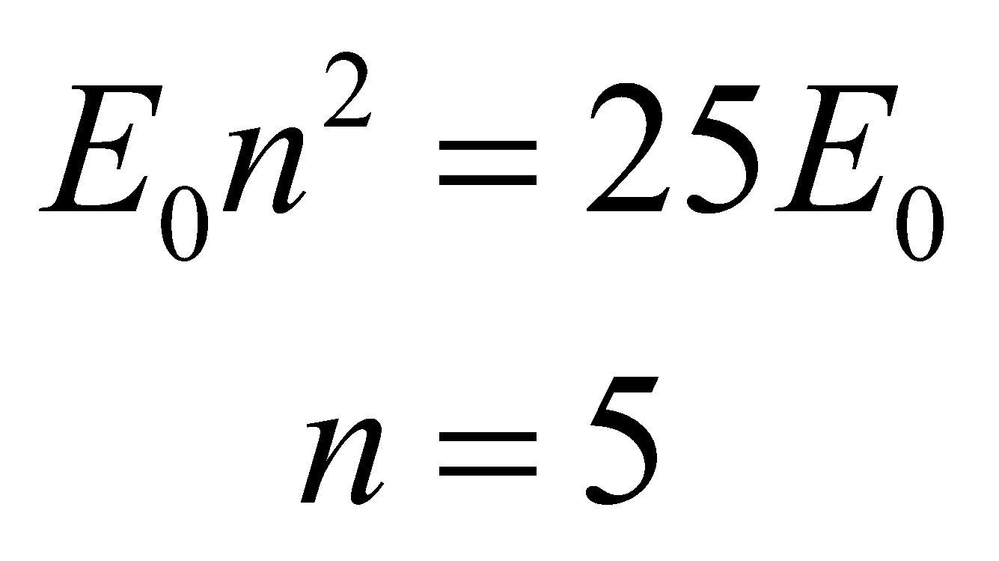

**Assess** The energy levels go as *n* squared.

**14. Interpret** The energy difference between two levels is 33 times the ground state energy. We are to find the principal quantum numbers for each of the levels.

**Develop** The energy levels in an infinite square well are 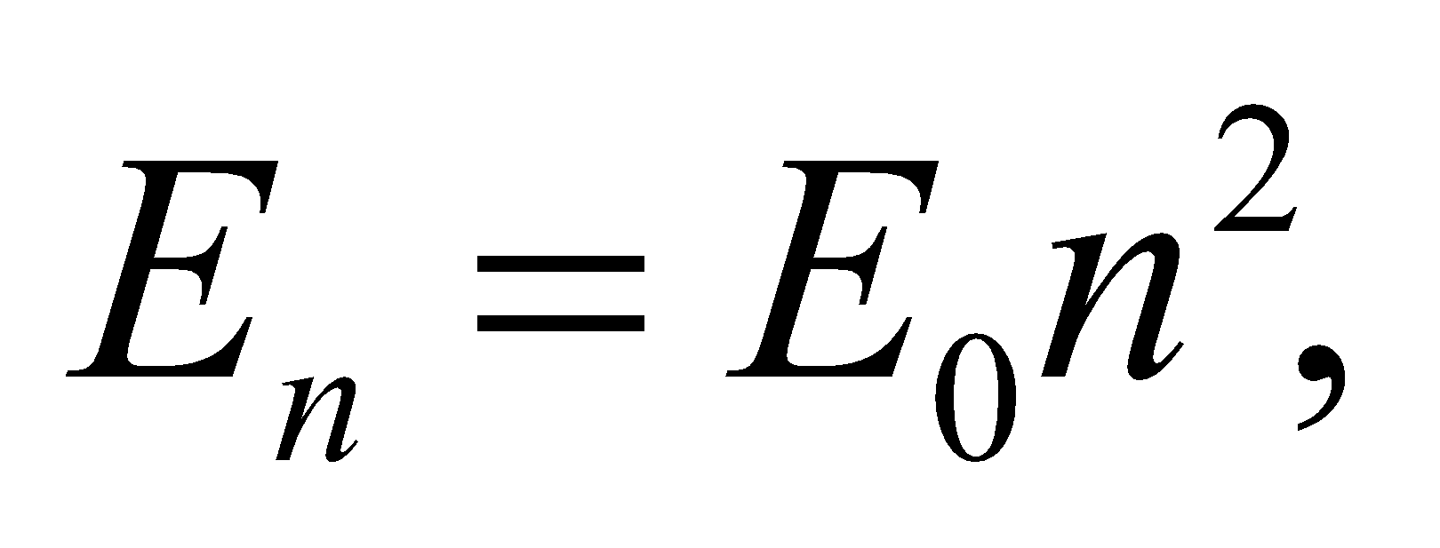 (Equation 35.5) where  is the ground state energy. We are given that

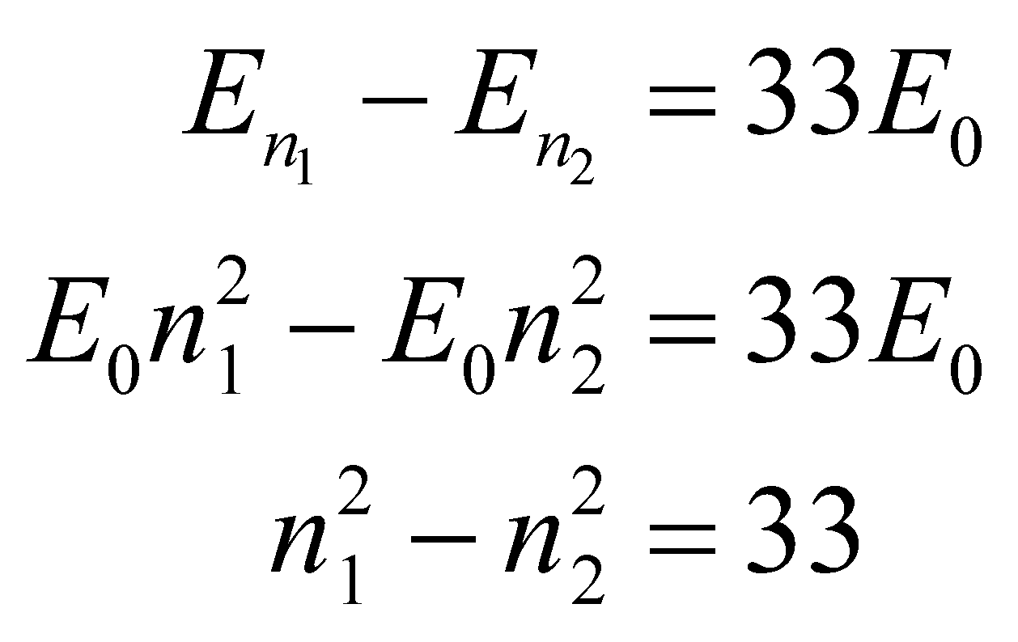

**Evaluate** The possible quantum numbers are 1, 4, 9, 16, 25, 36, 49…, so we see that 49 − 16 = 33. Thus, our quantum numbers are *n*1 = 7 and *n*2 = 4.

**Assess** Sometimes just looking at a problem and thinking about it like this is the best approach.

**15. Interpret**We have an electron confined in an infinite potential well, and are to find its ground-state energy.

**Develop** The energy levels for an infinite square potential well are given by Equation 35.5:

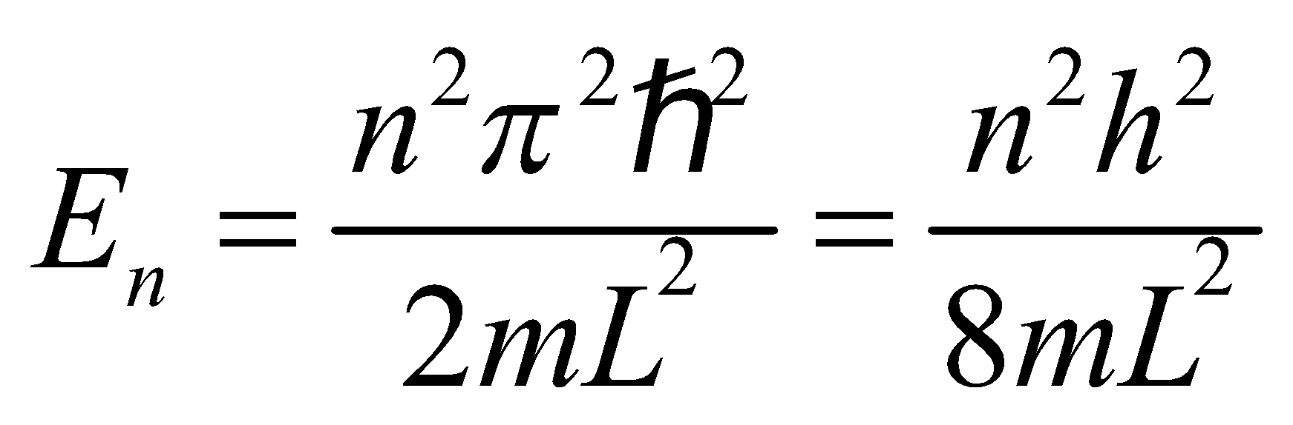

The ground-state energy corresponds to *n* = 1.

**Evaluate** From the above equation, we find the ground-state energy to be

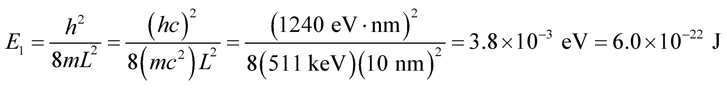

**Assess** A nonzero ground-state energy is a common feature of quantum systems. Note that the energy levels are quantized and proportional to *n*2.

**16. Interpret** Given the ground-state energy of a proton in an infinite square well, we are to find the width of the well.

**Develop** The lowest possible energy of the proton (in a one-dimensional infinite square well) is its ground-state energy, which is given to be *E*1 = 100 eV. Use Equation 35.5 to find the well width *L*.

**Evaluate** The well width is

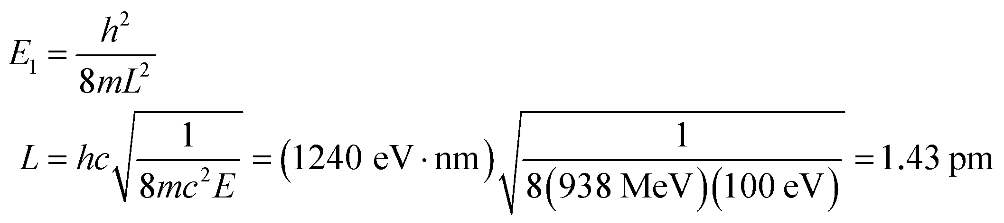

**Assess** This is much smaller than the Bohr radius *a*0 = 52.9 pm, so this well is not realistic because it is smaller than the smallest atomic size.

**17. Interpret** The problem asks us to compute the lowest energy states of a quantum wire.

**Develop** The energy levels for an infinite square well potential is given in Equation 35.5:

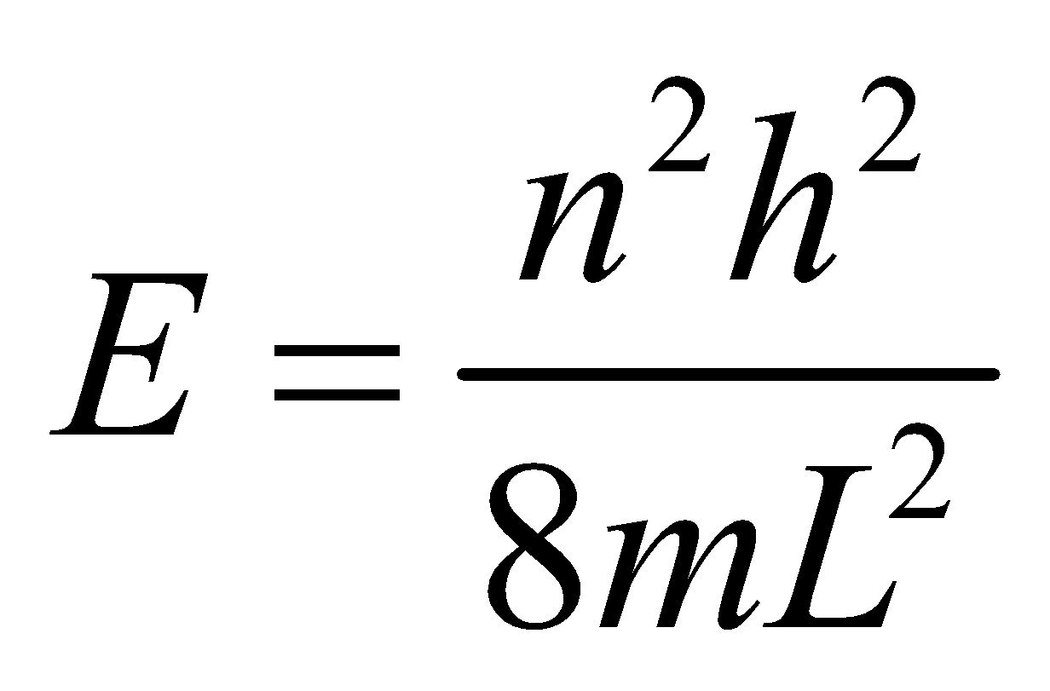

To simplify the calculation, we will multiply the top and bottom of the fraction by *c*2, so that we can use the rest energy of the electron, 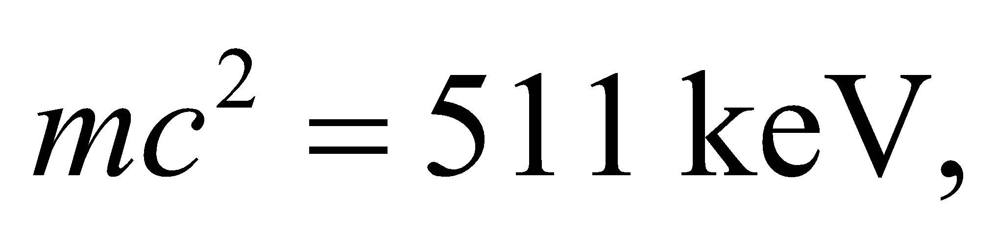and the shorthand 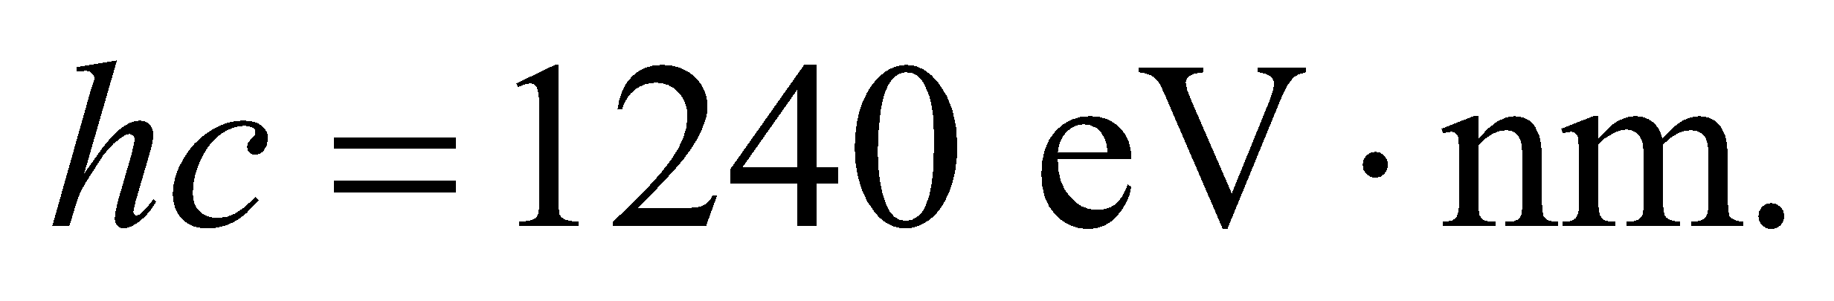

**Evaluate**  (a) Plugging in the tube diameter for the well width, we get for the 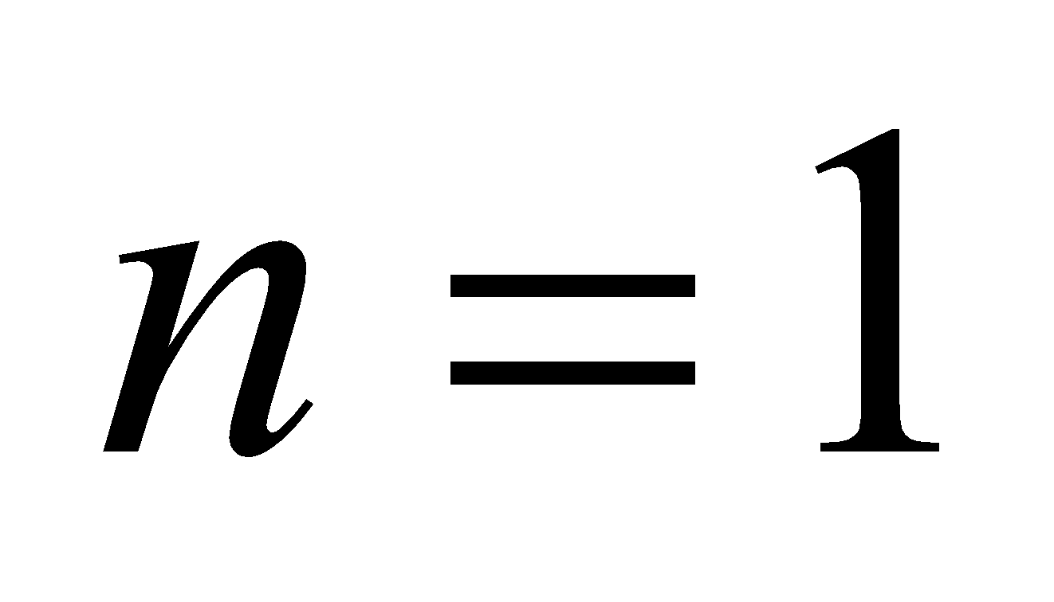 ground state

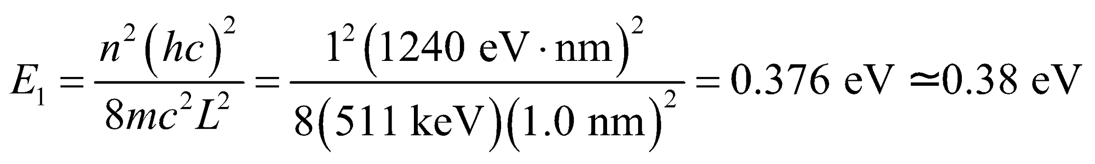

(b) The first excited state has 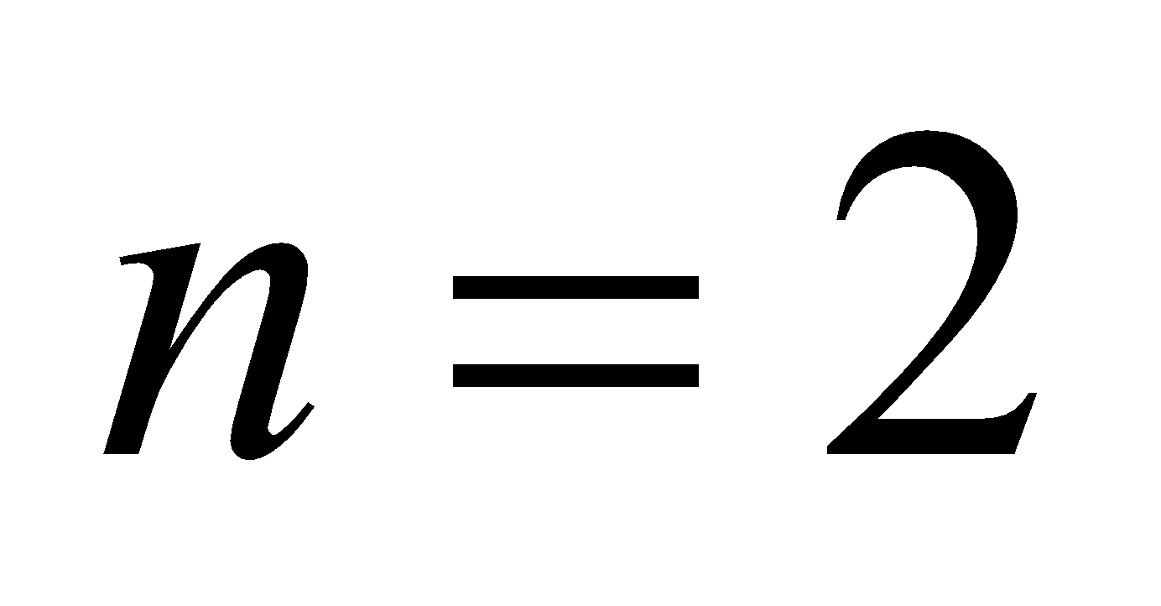 and its energy is 4 times the ground state:

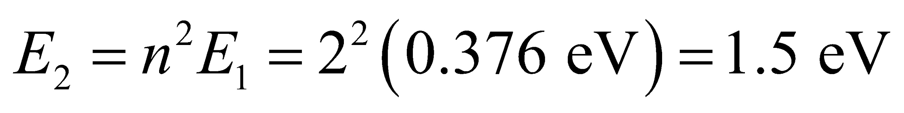

**Assess** The answers seem reasonable. In the lowest energy states, electrons in the nanotube will have roughly the same energy as electrons accelerated by a 1 V potential difference.

**18. Interpret** In this problem we want to demonstrate the smallness of the quantum effect when dealing with macroscopic objects. We are to imagine ourselves as a particle in a room-sized potential well, and find the value of Planck’s constant needed to give us the desired minimum speed.

**Develop** In a one-dimensional infinite square well, the lowest energy of a particle is (see Equation 35.5)

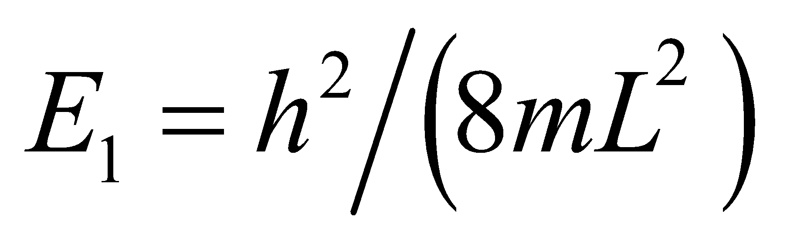. Since we are in the nonrelativistic domain, we can set 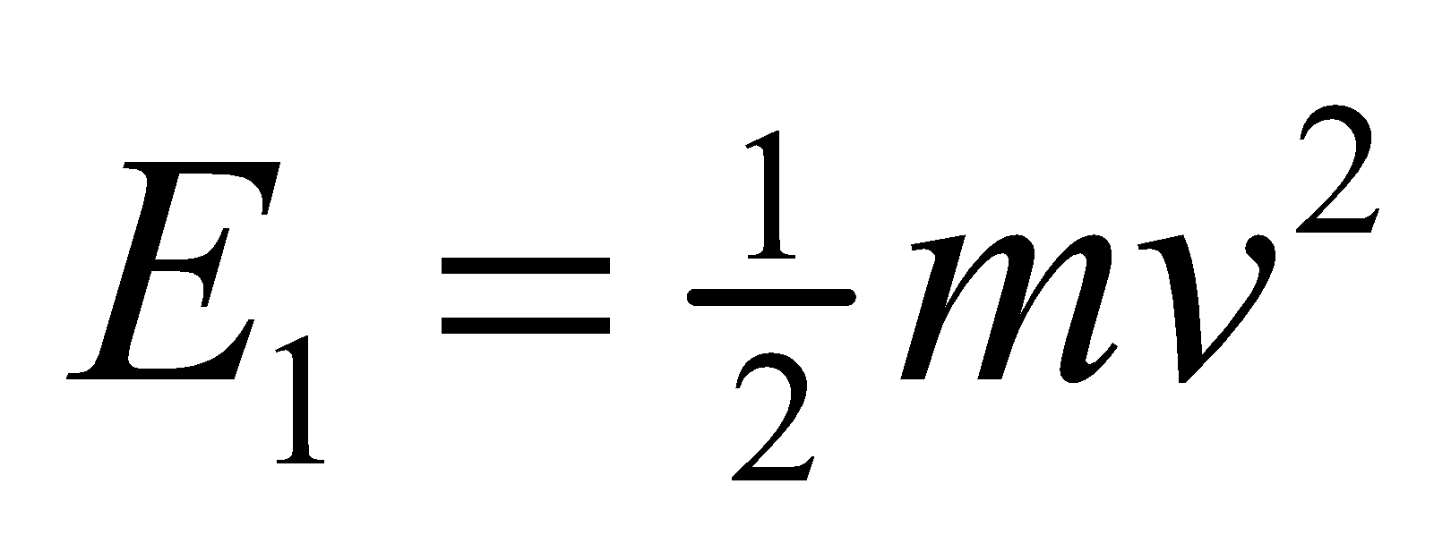 to deduce the “would-be” Planck constant for the quantum effect to be noticeable.

**Evaluate** Equating 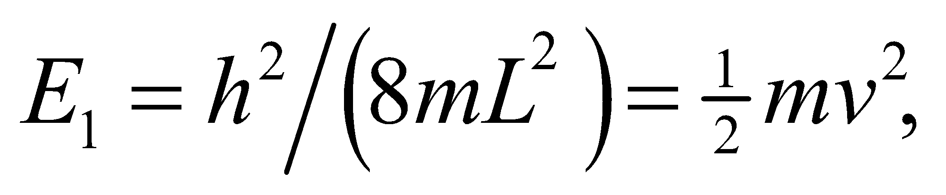 we get 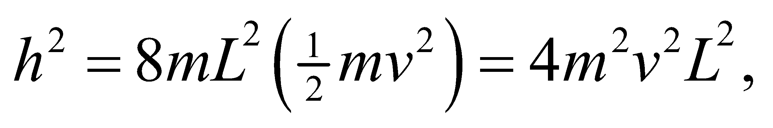 or



to two significant figures. This is 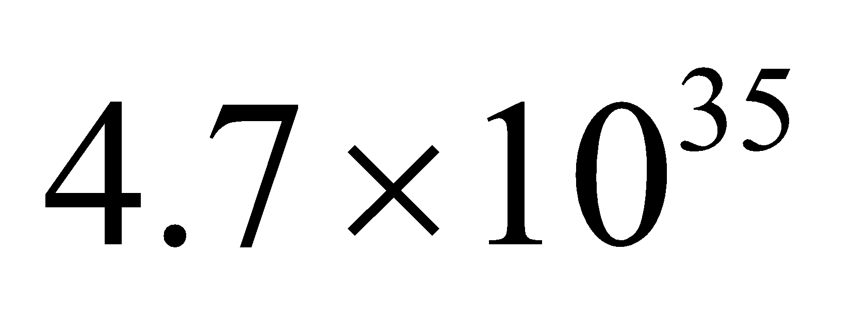 times larger than the actual value of Planck’s constant.

**Assess** When dealing with motion of macroscopic objects, one may simply apply classical physics and ignore quantum effect.

**19. Interpret** This problem involves and infinite potential well in which an unknown particle is trapped. Given the difference in energy between the ground state and the first excited state, we are to determine if the particle is an electron or a proton.

**Develop** Use the result of Schrödinger’s equation applied to an infinite potential well (Equation 35.5). The energy difference *ΔE* between the first excited state (*n* = 2) and the ground-state (*n* = 1) of a one-dimensional infinite square well is

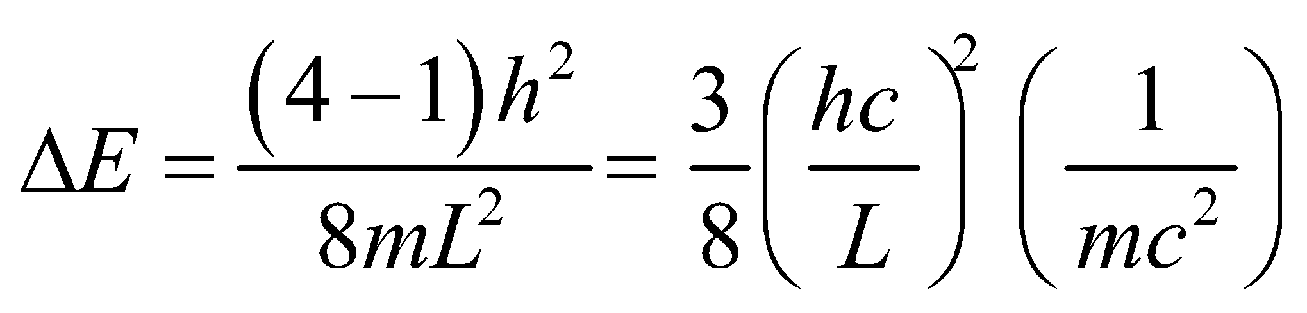

**Evaluate** Using given values, we find that

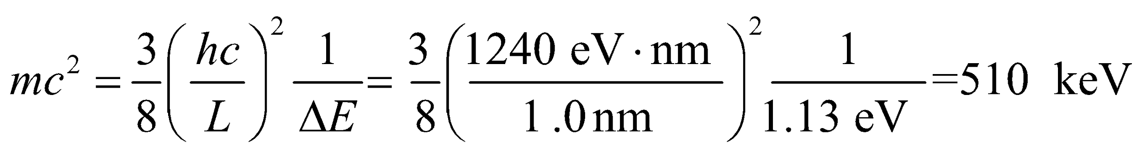

which is very close to the electron’s rest energy.

**Assess** The particle must be an electron.

**20. Interpret** We shall treat the snail as a particle confined in an infinite potential well. We want to show that a classical treatment of this problem is adequate for large quantum number *n*, in accordance with the correspondence principle.

**Develop** The kinetic energy of the snail is

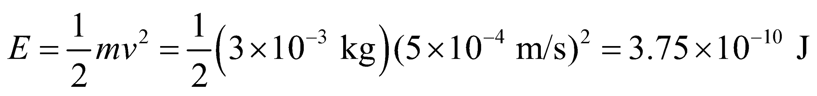

If this is regarded as the energy of a 3-g particle confined to a one-dimensional infinite square well of width *L* = 15 cm, the energy quantum number can be estimated from Equation 35.5:



**Evaluate** Equating the kinetic energy with the energy derived from Schrödinger’s equation, we find the quantum number to be

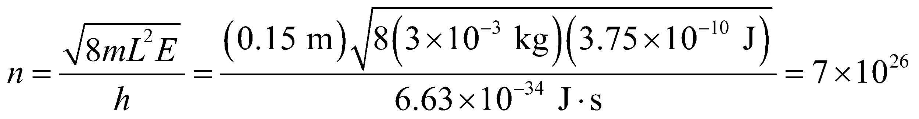

The correspondence principle implies that classical theory ought to be quite adequate for quantum numbers this large.

**Assess** We expect classical physics to be adequate in characterizing the motion of the crawling snail. When we try to quantize the system, we find *n* to be very large, as expected from the correspondence principle.

**21. Interpret** We are to find the ground-state energy of an alpha particle (i.e., He2+) trapped in the given infinite quantum well.

**Develop** Use the result of Schrödinger’s equation applied to an infinite potential well (Equation 35.5). For the ground state, *n* = 1. From Appendix C, we find that 1 u = 931.5 MeV/*c*2.

**Evaluate** With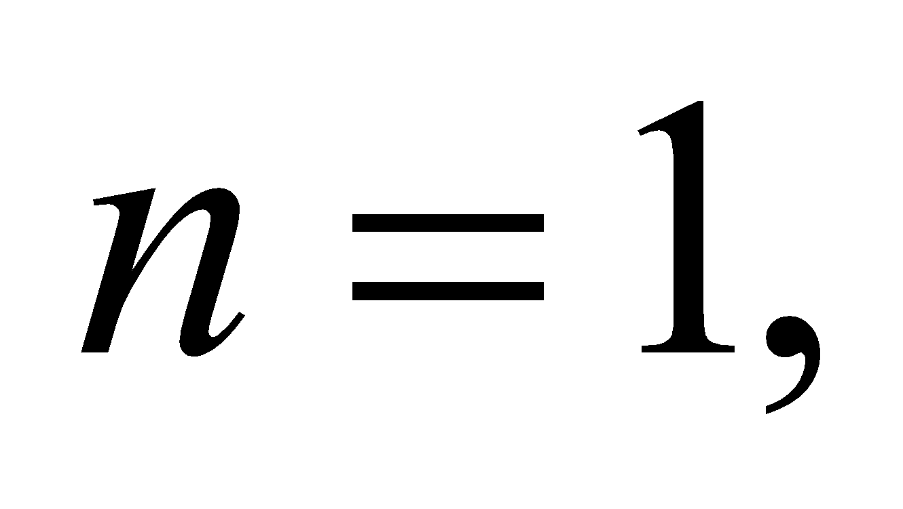 the lowest alpha-particle energy in a one-dimensional infinite square well of width *L* = 15 fm is

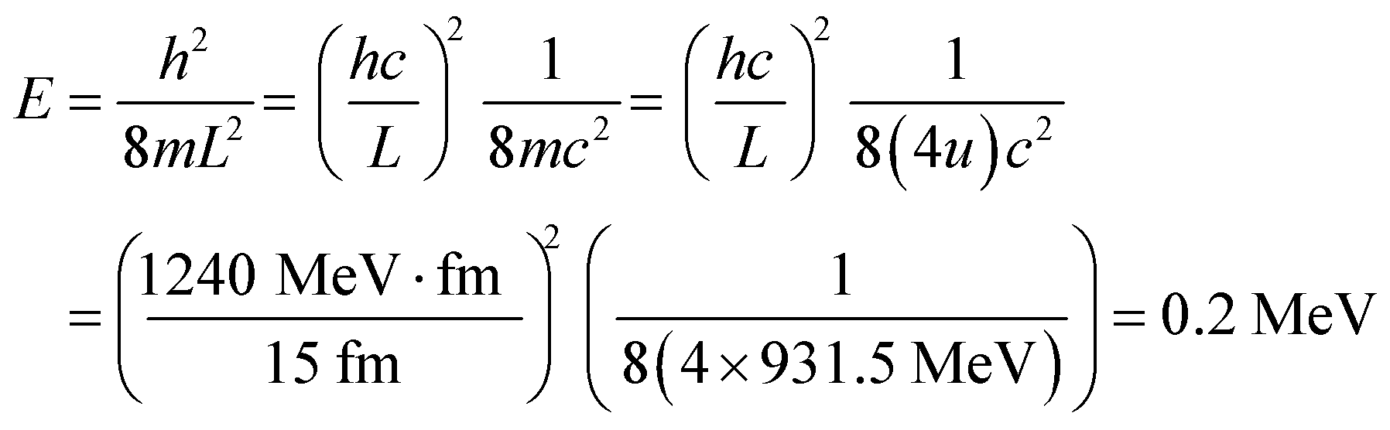

**Assess** This is a rather high energy, which is not surprising given the small size of the potential well. Note that the Bohr radius is *a*0 = 52.9 pm gives the typical atomic size, which includes the electrons. Thus, our alpha particle is confined to a space much less than the size of an atom.

**22. Interpret** We are given the ground-state energy of a particle in a harmonic oscillator potential, and asked to find the corresponding classical frequency of the oscillator.

**Develop** The ground-state energy of a one-dimensional harmonic oscillator is given by Equation 35.7 with *n* = 0:

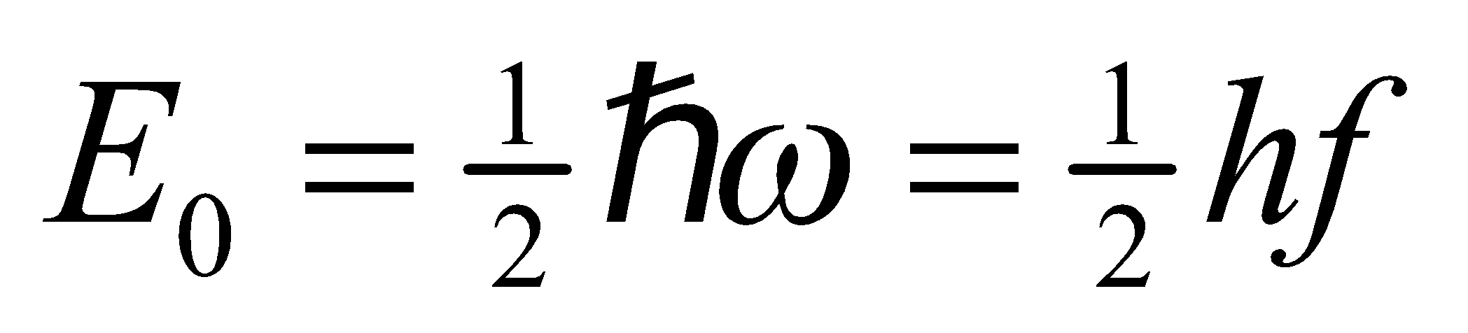

**Evaluate** Thus, the classical frequency is

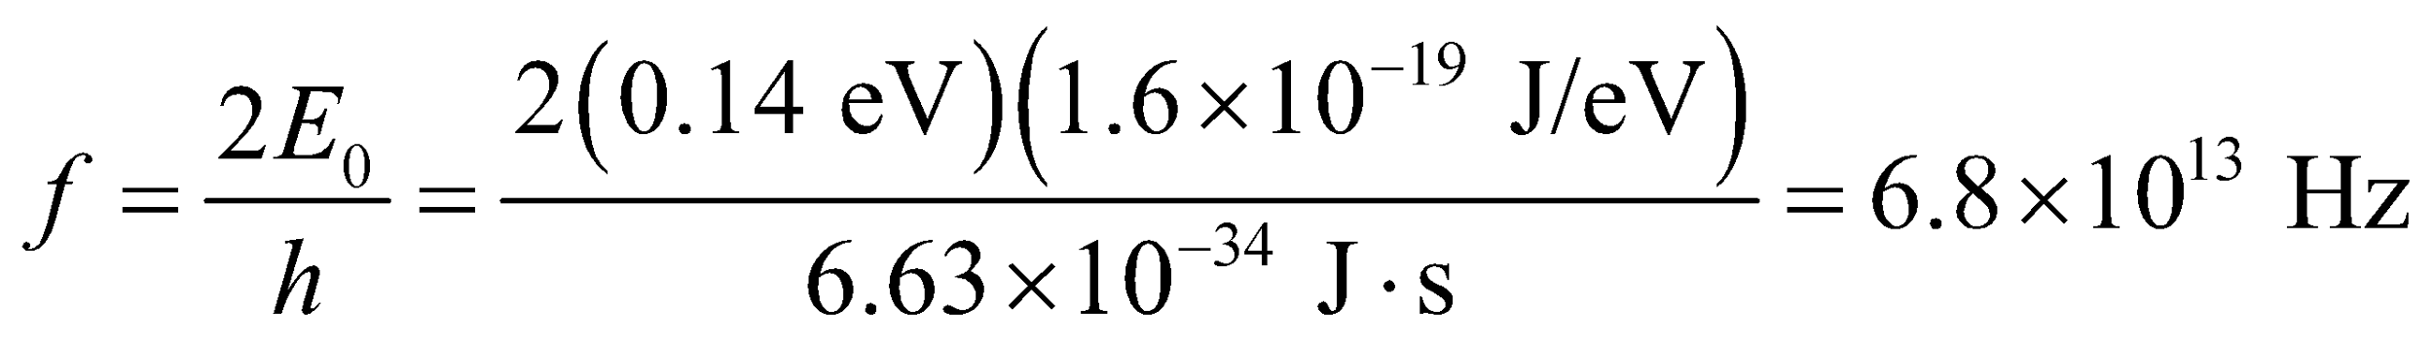

**Assess** A nonzero ground-state energy is a common feature of quantum systems. Note that because the spacing between adjacent energy levels is 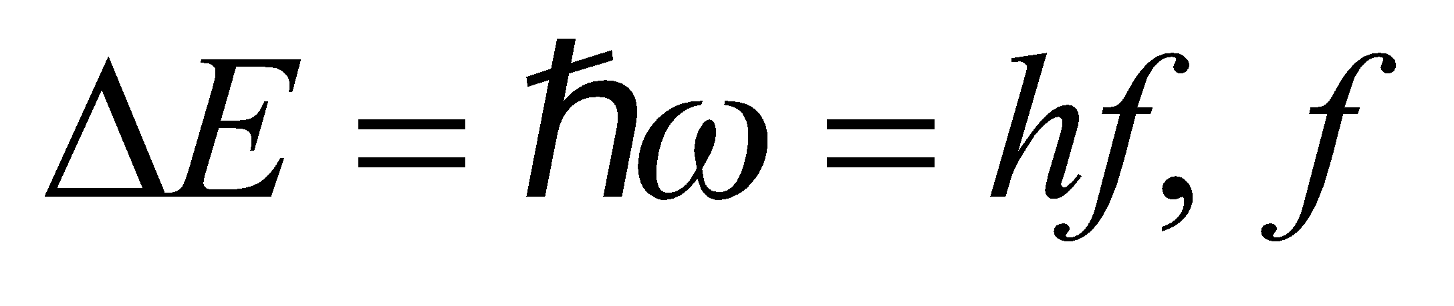 represents the frequency of the photon that must be absorbed or emitted for transitions to take place.

**23. Interpret** We are to find the energy of the lowest state for a particle in a harmonic oscillator potential.

**Develop** Apply Equation 35.7. The lowest state is the ground state and has quantum number *n* = 0 for a harmonic oscillator.

**Evaluate** With *n* = 0, Equation 35.7 gives the ground-state energy as



**Assess** Note that the energy of a particle in a harmonic oscillator potential is independent of mass.

**24. Interpret** In this problem we are asked to find the classical frequency of an oscillator, given the energy of photons emitted in a transition from an arbitrary state *n* to state *n* − 1.

**Develop** If a harmonic oscillator emits a photon, conservation of energy demands that the final state of the harmonic oscillator be lower than the initial state. For a one-dimensional harmonic oscillator, the energy spacing between adjacent states is 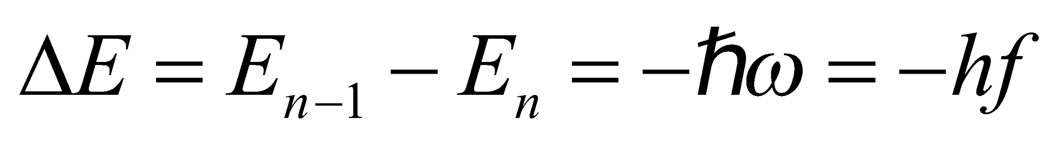 (see Equation 35.7). Conservation of energy demands that the initial energy be the same as the final energy, or

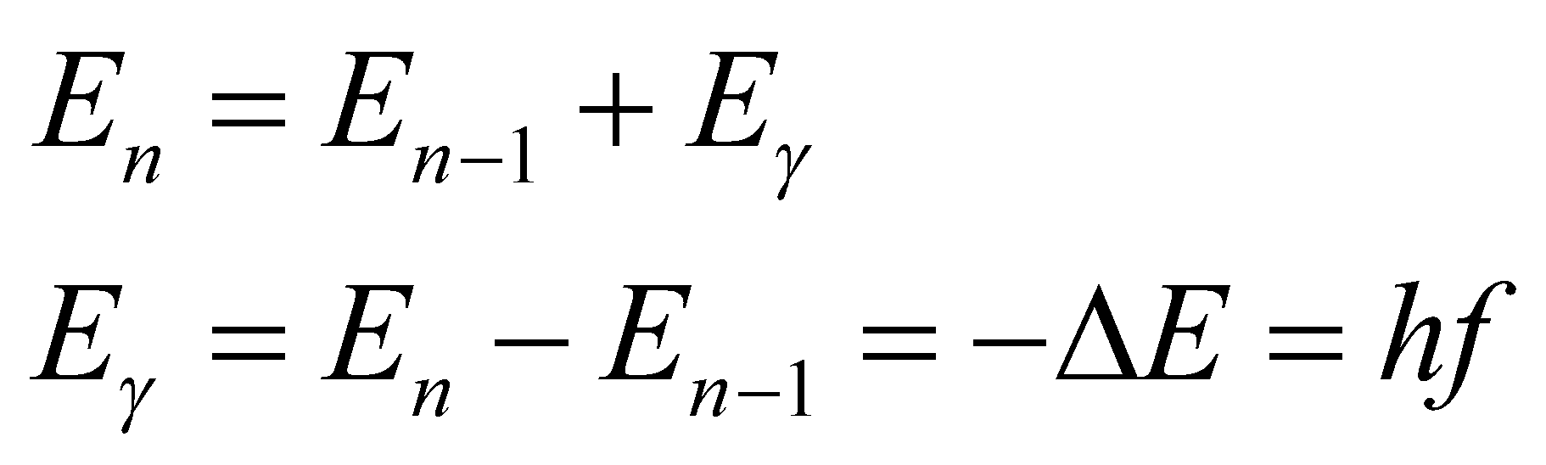

where 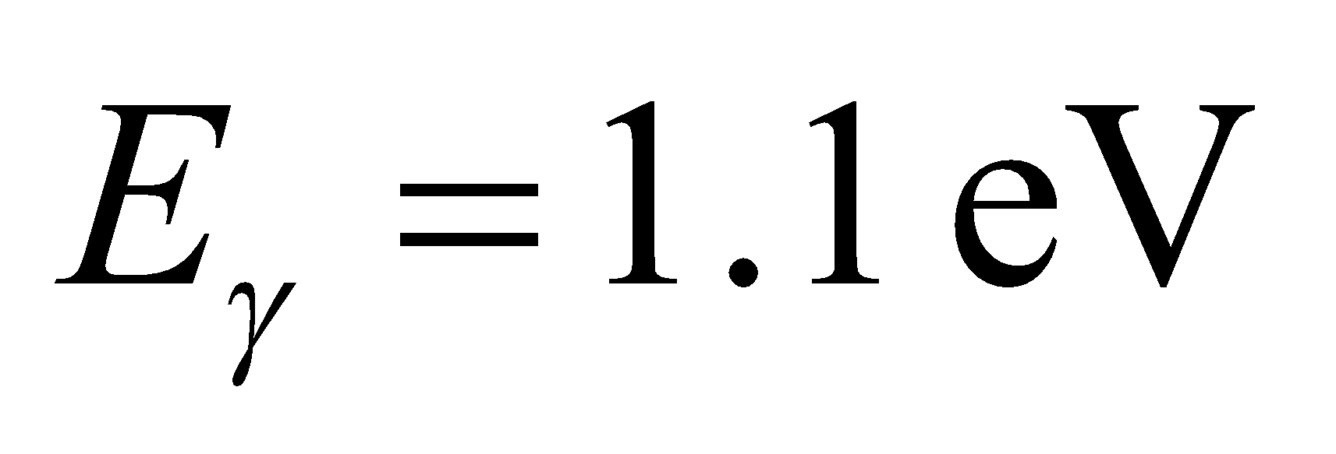 is the energy of the emitted photon.

**Evaluate** From the above equation, we find the classical oscillation frequency to be

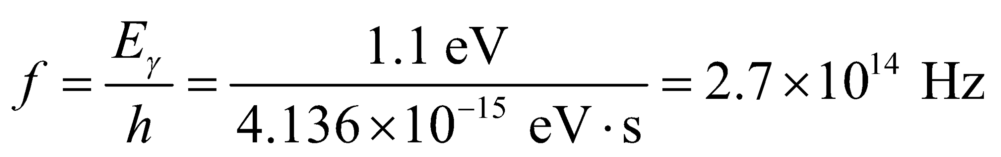

**Assess** For transition to occur, an oscillator must emit (or absorb) photons of this frequency.

**25. Interpret** We are to find the energy separation between states in a harmonic oscillator given the ground-state energy.

**Develop** Equation 35.7 gives the energy levels in a harmonic oscillator: 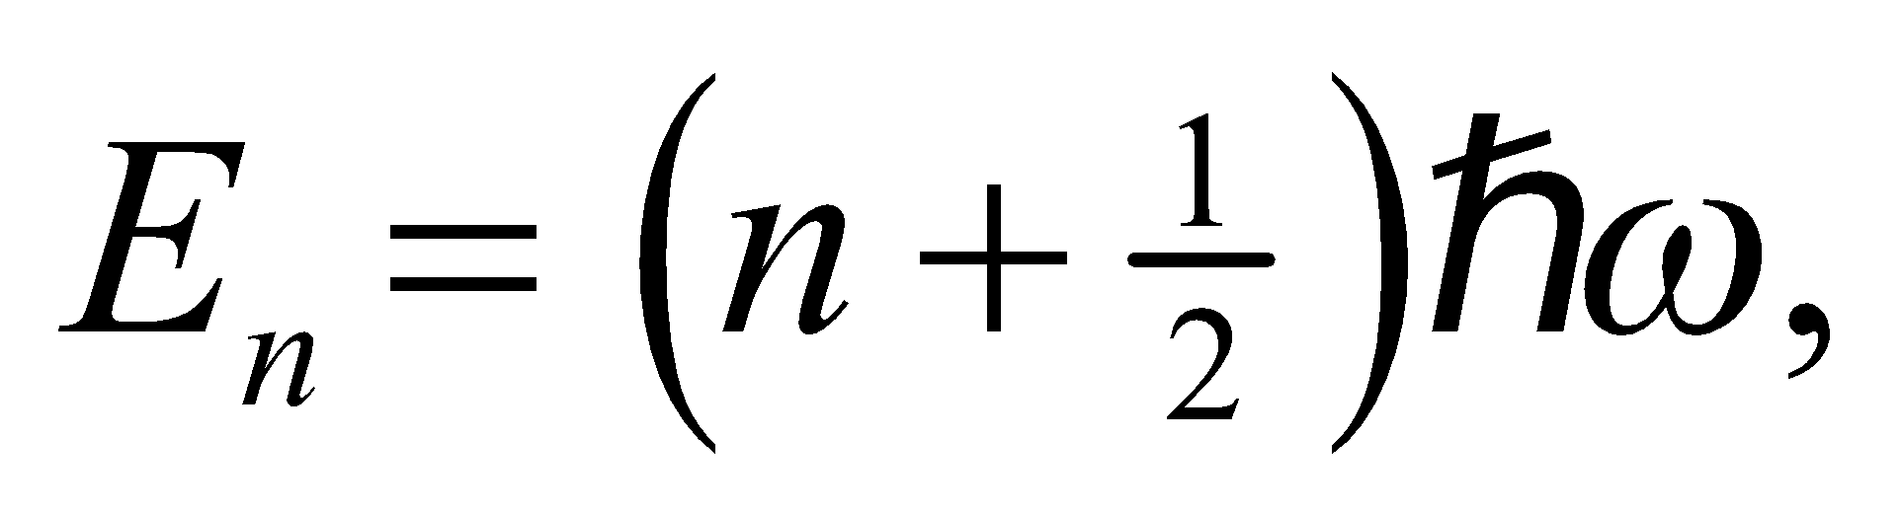 so the separation between levels is  Given that *E*0 = 4.0 eV for *n* = 0, we can solve for 

**Evaluate** The energy spacing  between adjacent levels is

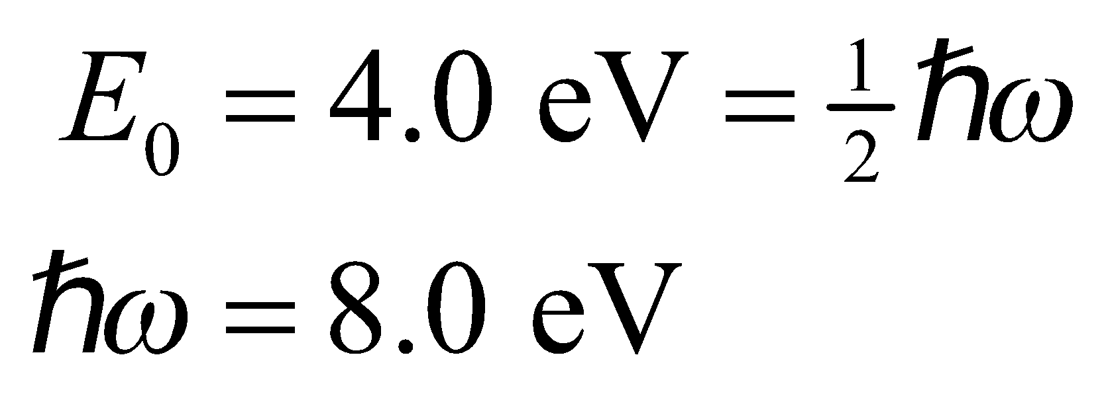

**Assess** Unlike the infinite square well, the energy levels for the harmonic oscillator are linear in *n*.

**26. Interpret** You're trying to convince your roommate that he shouldn't expect quantum mechanical effects in classical physics experiments, like a mass-spring system.

**Develop** The energy levels for a harmonic oscillator are written in Equation 35.7:

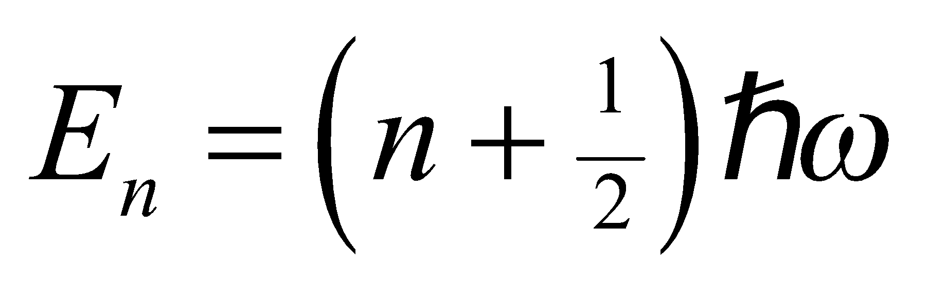

The angular frequency for a mass-spring system is given by Equation 13.7a: 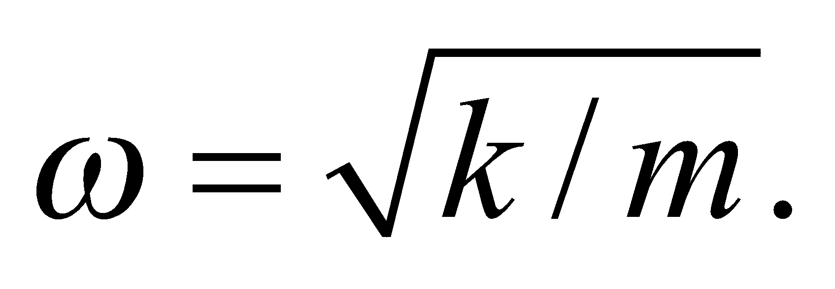

**Evaluate** For two adjacent energy levels, the energy difference is

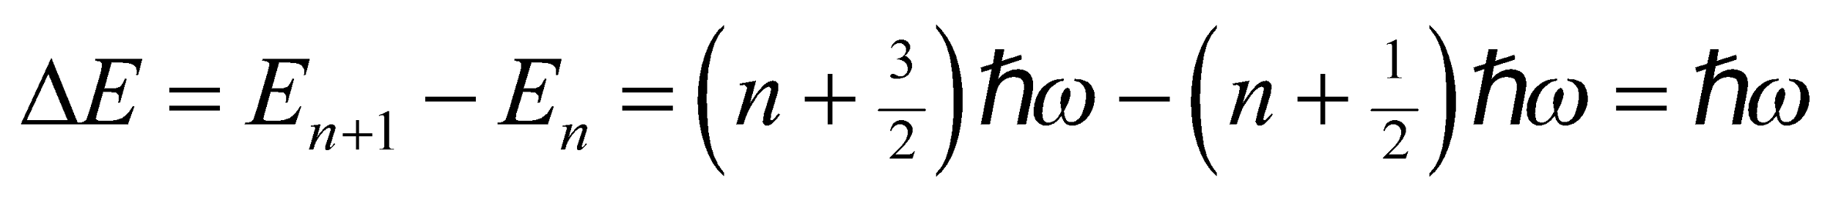

For the mass-spring system being considered,

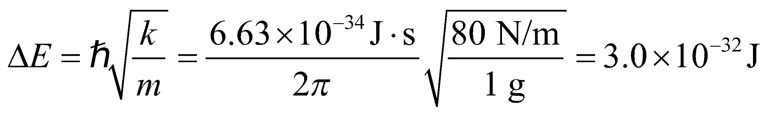

This is far too small to be measurable. This is why your roommate never observes any quantum "jumps" in the energy of the mass-spring systems of Newtonian physics.

**Assess** To further demonstrate how impossible it would be to detect quantum mechanical effects in macroscopic objects, consider the classical energy of a harmonic oscillator: 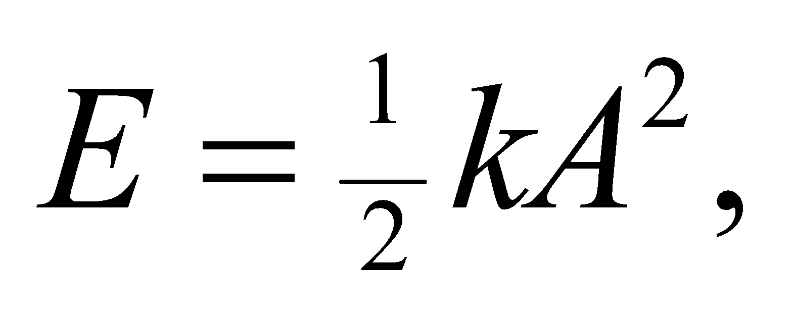 where *A* is the amplitude of the oscillations (see Section 13.5). Taking the derivative, 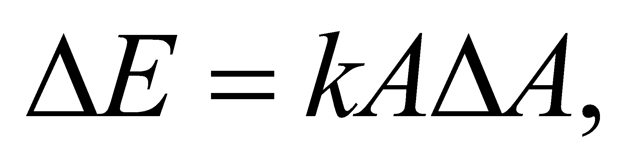shows how the energy changes with changes in the amplitude. If you were going to try to detect energy levels of a mass-spring system, you might observe the amplitude of the oscillations, since they relate to the energy by 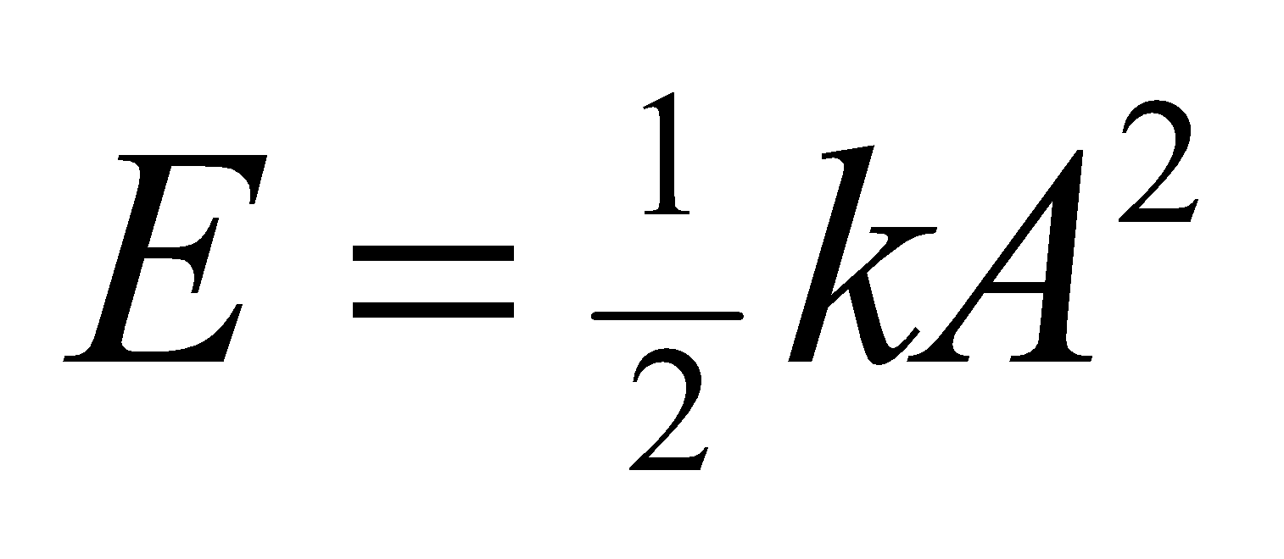 (recall Section 13.5). If you are able to measure the amplitude with nanometer resolution, then the smallest energy level separations that you could measure for the above spring would be around 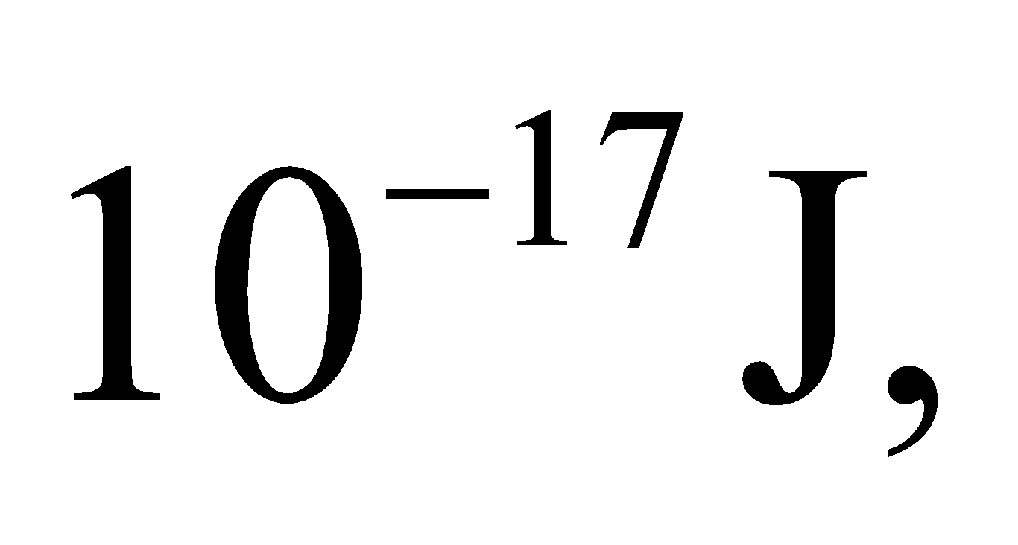which is still a long way from the sensitivity needed.

**Section 35.4 Quantum Mechanics in Three Dimensions**

**27. Interpret** We are to consider a particle three-dimensionally confined in a cubic potential well. If the length of all sides of the box is doubled, how is the particle’s ground-state energy affected?

**Develop** From Equation 35.8, we see that the energy of a particle in a cubical box is inversely proportional to the square of the length of the sides of the box. In the ground state, *n*x = *n*y = *n*z =1, so the ground-state energy is

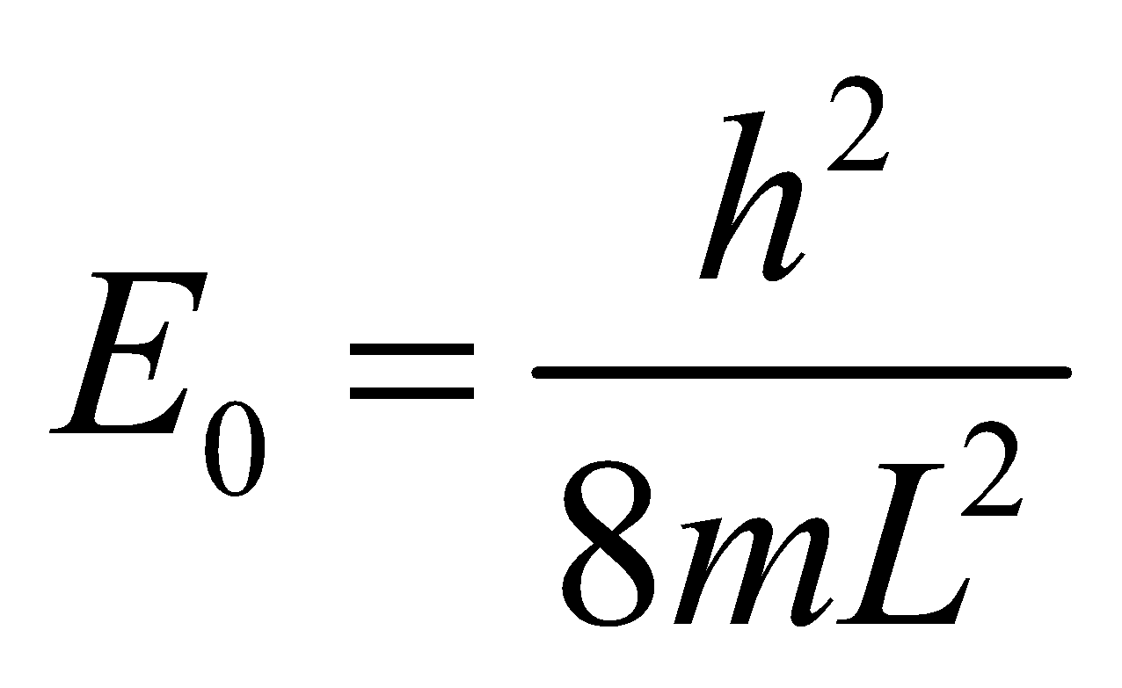

If we double the length, 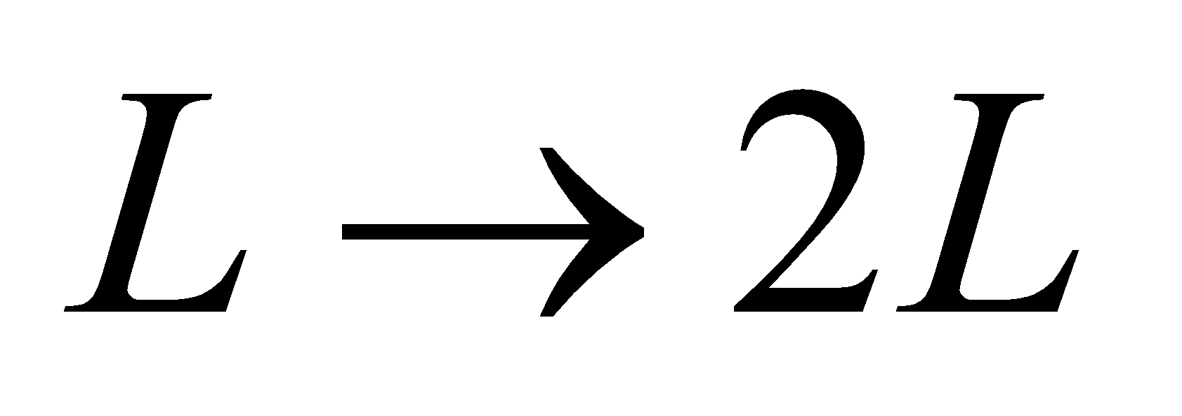, so we can recalculate the new ground-state energy.

**Evaluate** Replacing L by 2L, we find that the ground state energy becomes

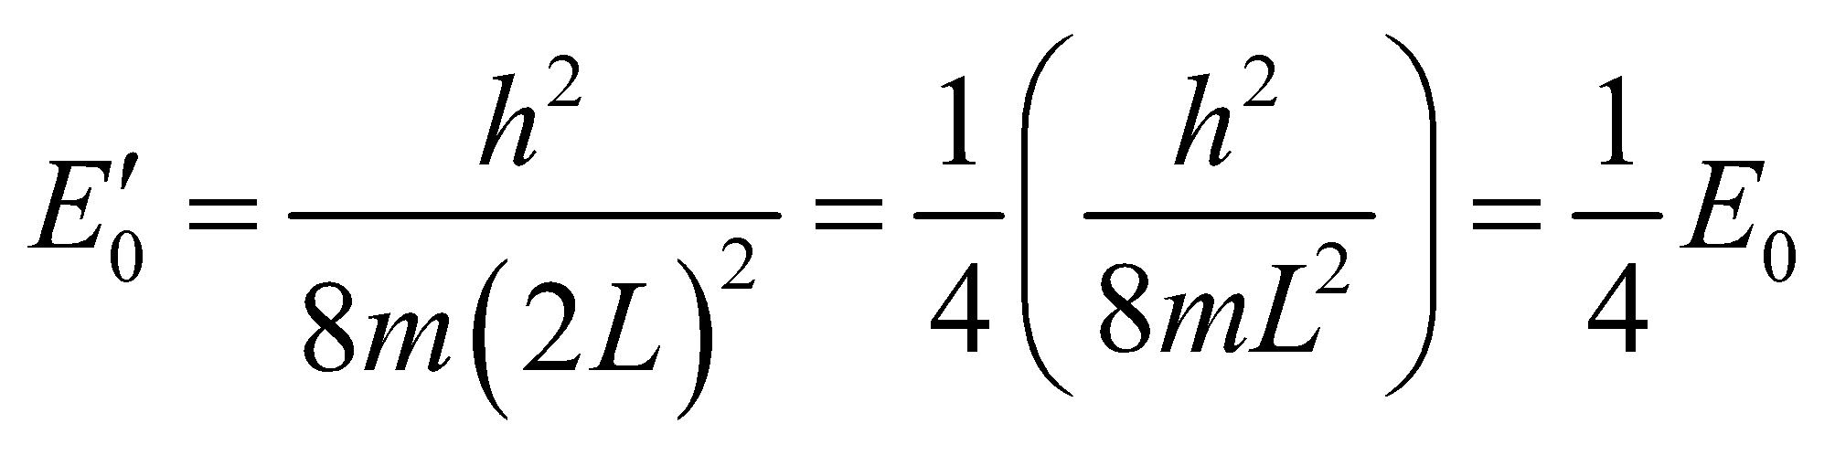

**Assess** The ground-state energy is inversely proportional to *L*2, so doubling *L* reduces the ground-state energy by a factor of *L*2 = 4.

**28. Interpret** This problem explores a crude model of an atomic nucleus in which the nucleus is considered to be a proton confined in a cubical potential well. We are to find the energy difference between the ground state and the first excited state.

**Develop** The energy levels of a particle in a three-dimensional box are given by Equation 35.8:

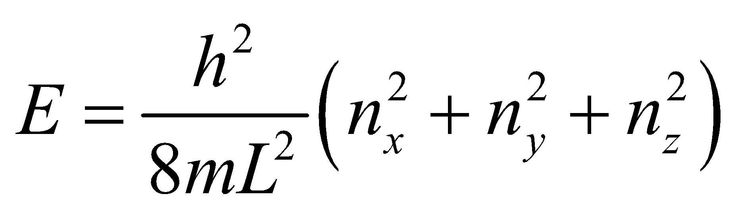

The ground state corresponds to *n*x = *n*y = *n*z =1, whereas the first excited state has one of the quantum numbers equal to 2 (e.g., 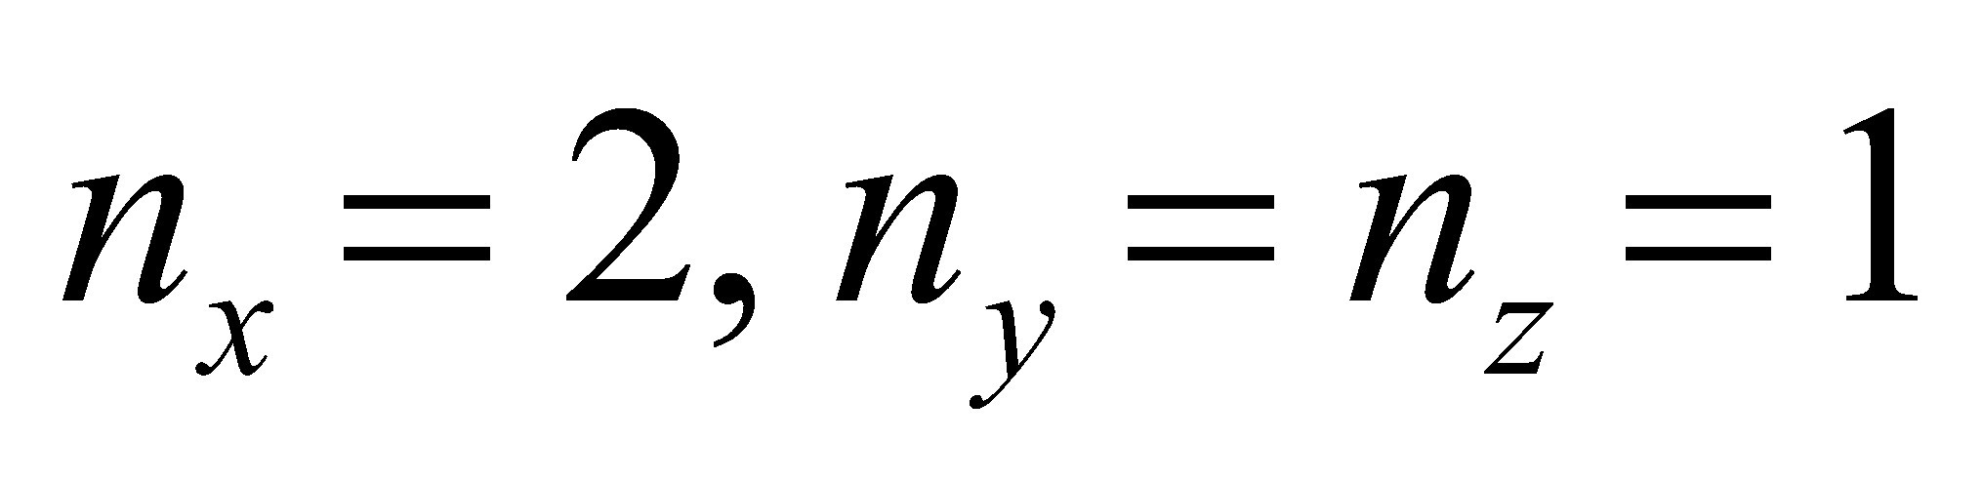).

**Evaluate** The difference in energy between the first excited state and the ground-state for a proton (mass

938 MeV/*c*2) in a cubical box (side length 1 fm) is

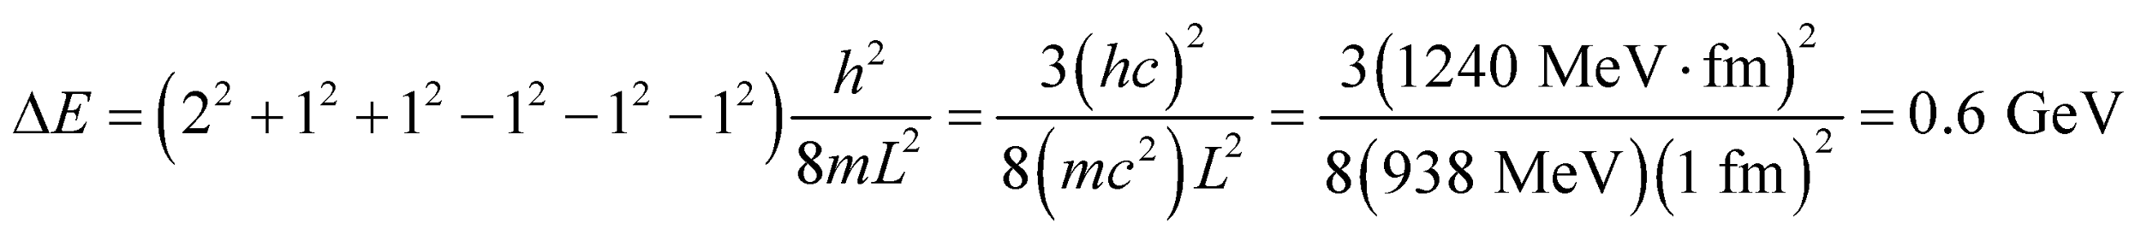

**Assess** Typical gamma-ray energies range from 100 keV to 10 MeV.

**29. Interpret** This problem is similar to the previous problem, except that we are now given energy of the photon emitted by an electron confined to a cubic quantum potential well and are asked for the size of the cube.

**Develop** From the solution to the previous problem, we know that the energy difference between the energy of the ground-state and of the first excited state is

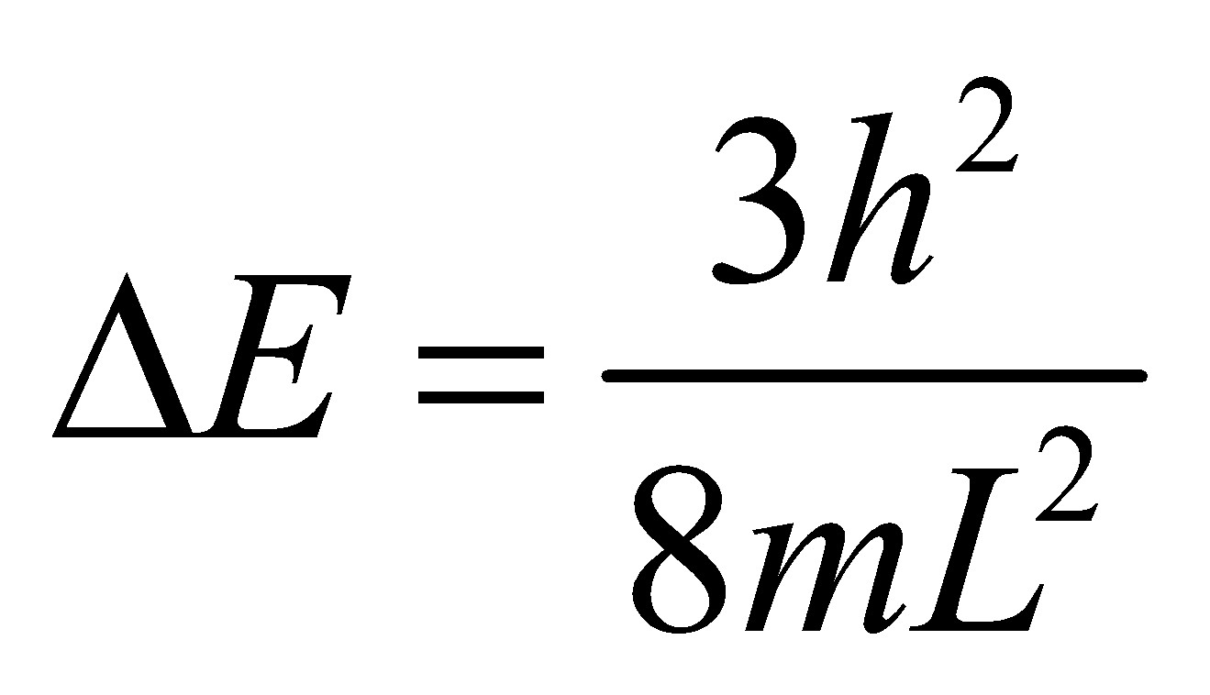

Set this equal to the photon energy (Equation 34.5) *Eγ* = *hf* = *hc*/*λ* to find the cubic box size *L*.

**Evaluate** Inserting the given quantities and solving for *L* gives

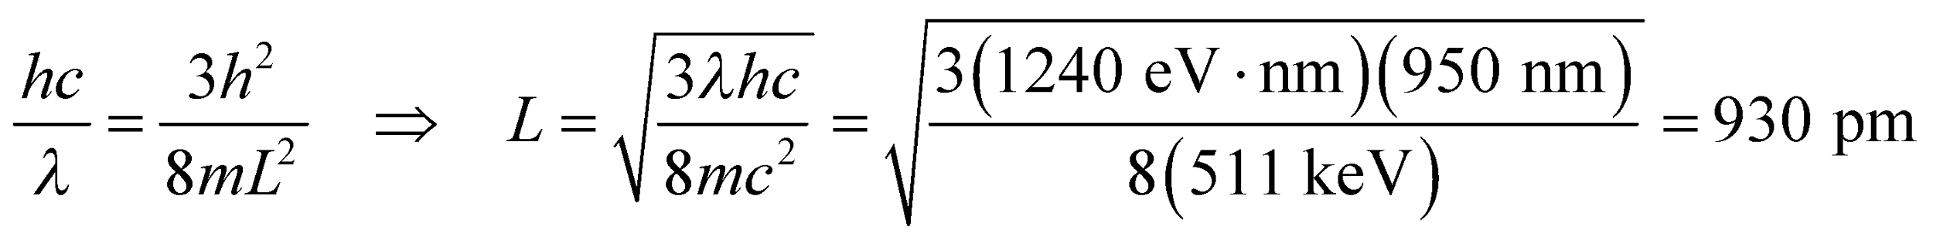

where we have used me = 511 MeV/*c*2.

**Assess** This cubic potential well is about the same size as in the previous problem, but the corresponding energy difference is much less because the electron’s mass is much less than that of the proton.

**Problems**

**30. Interpret** We are to derive the normalization constant of the given wave function with the given boundary conditions.

**Develop** Because the particle under consideration must be somewhere, the probability distribution y integrated over all space must be unity. This leads to the normalization condition of a wave function (Equation 35.3)

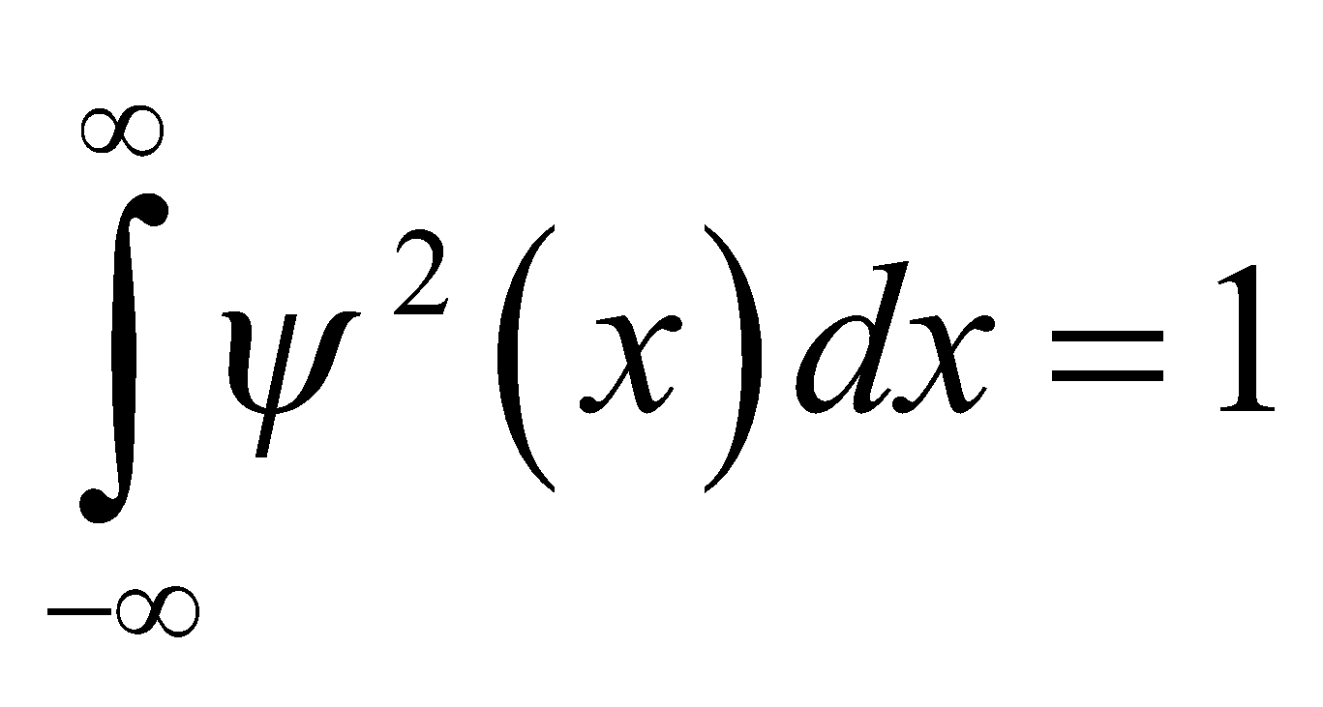

This condition allows us to deduce the form of the normalization constant *A*.

**Evaluate** Inserting the given wave function into the integral leads to

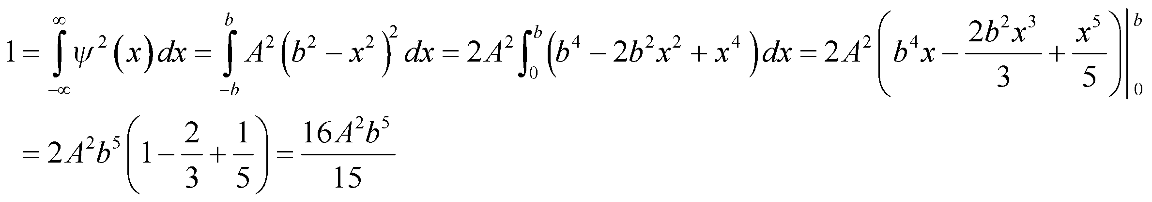

Therefore, the normalization constant is 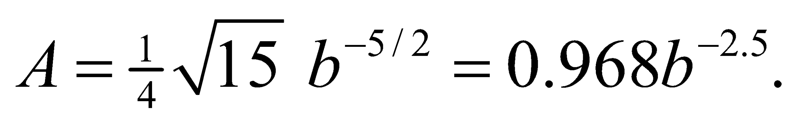

**Assess** The normalization condition implies that *ψ*(*x*) has dimension 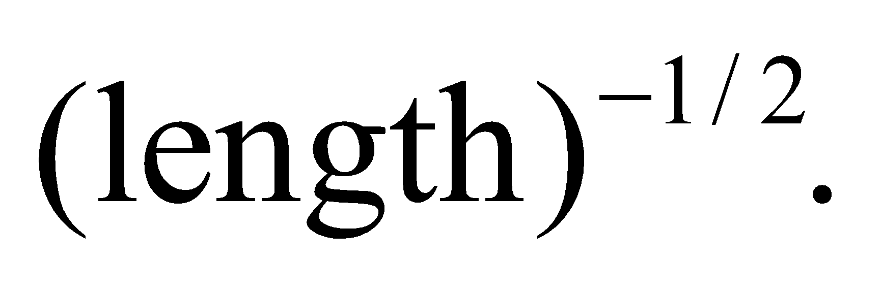 With 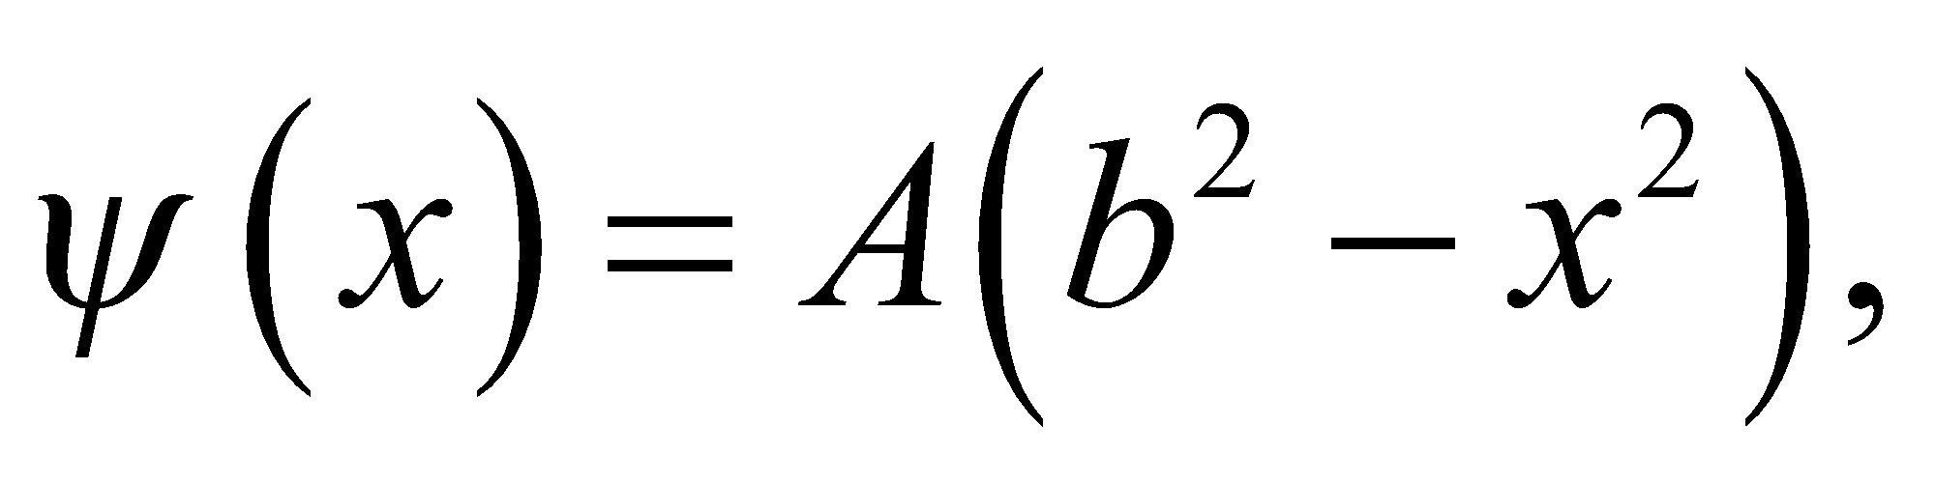 we expect *A* to have dimension 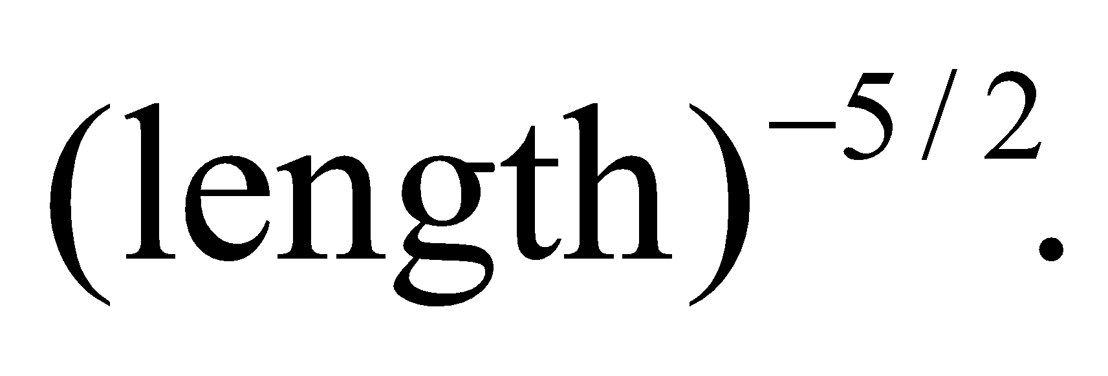 Since *b* also has dimensions of length, we see that our result is consistent with dimensional analysis.

**31. Interpret** For this problem, we are to show that if two wave functions are solutions of the Schrödinger equation, then their linear combination must also be a solution.

**Develop** The time-independent one-dimensional Schrödinger equation is given by Equation 35.1:

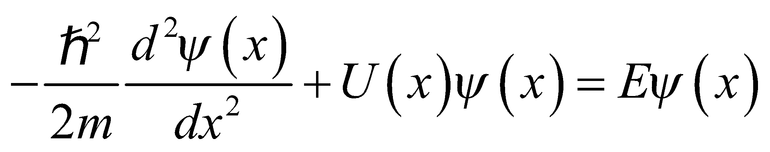

We want to show that for any constants *a* and *b*, 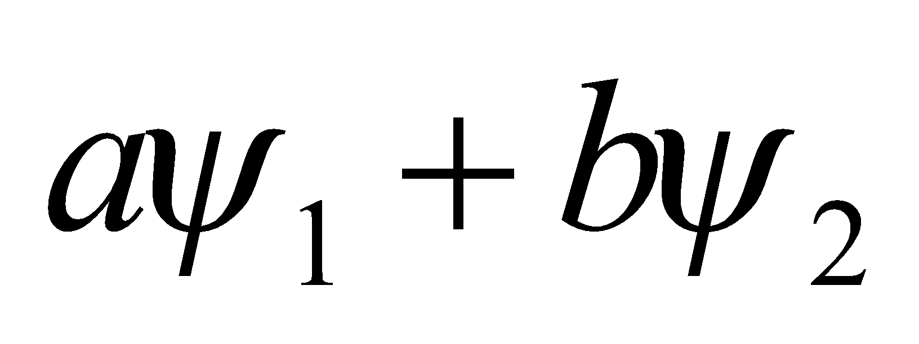 is a solution if 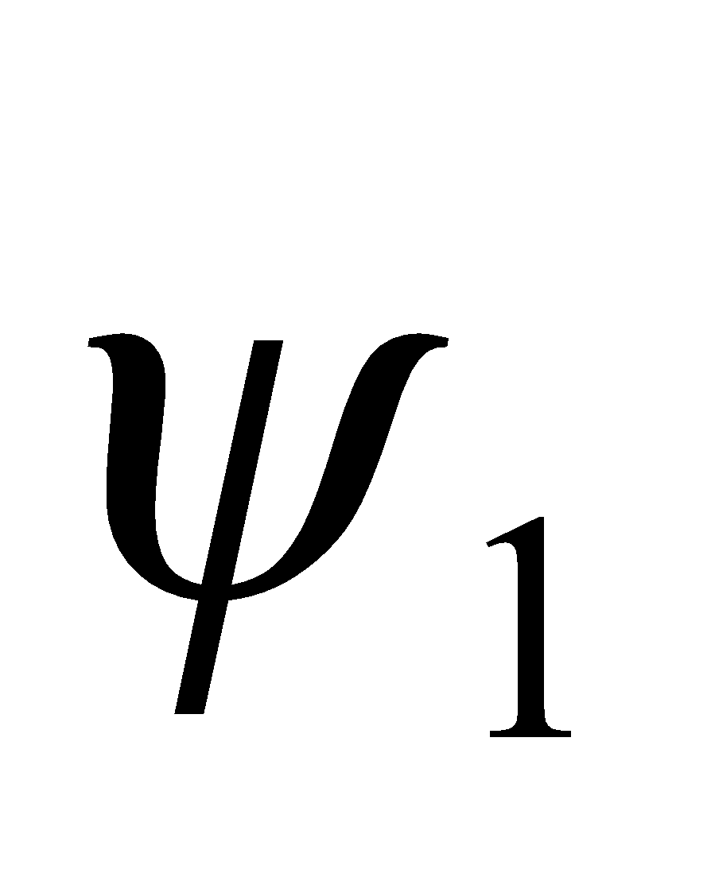 and 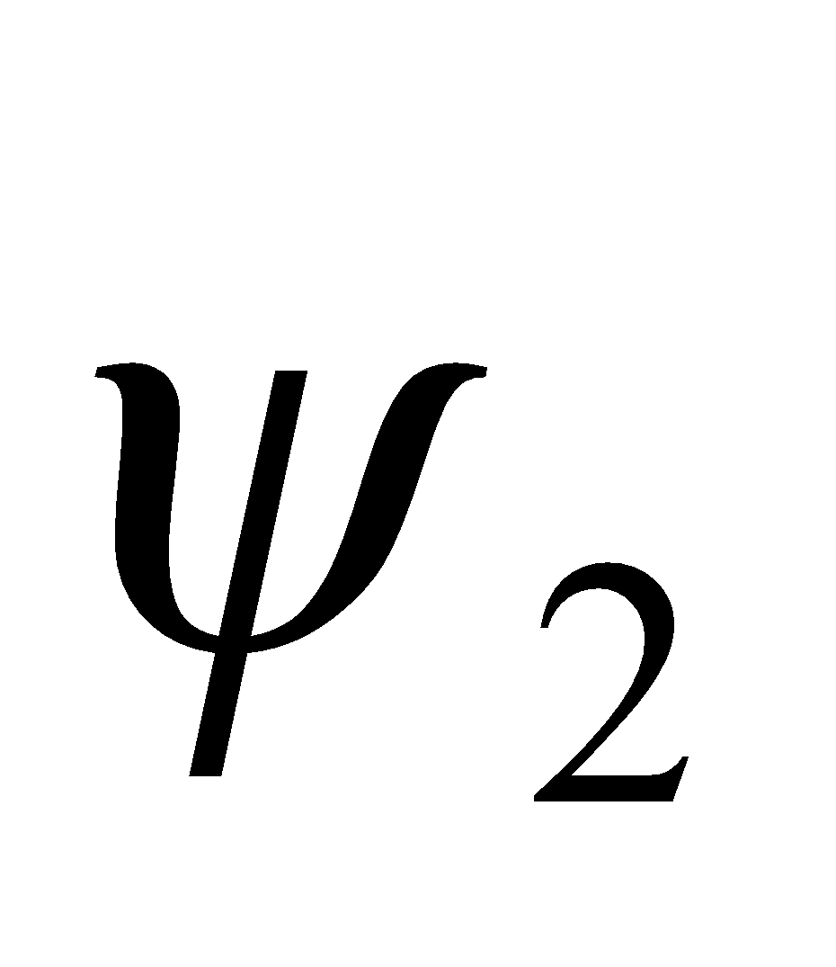 are.

**Evaluate** Substituting 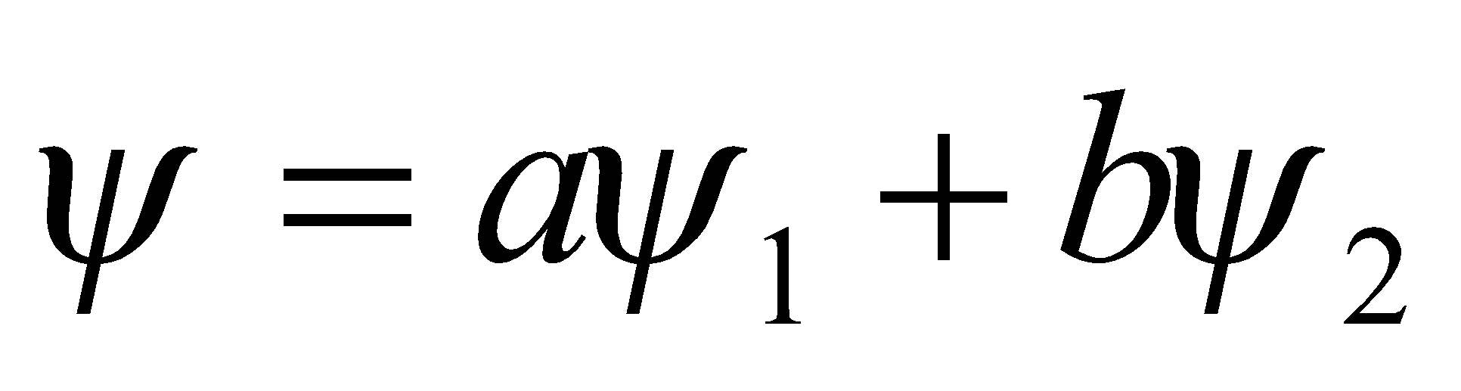 into the Schrödinger equation gives

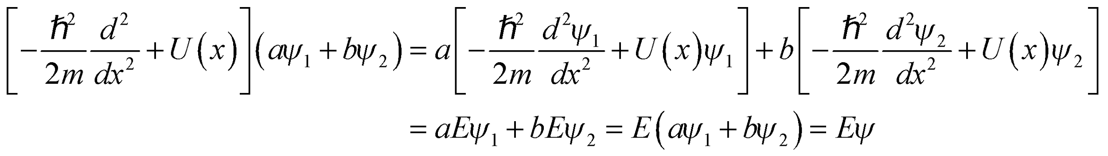

**Assess** The Schrödinger equation is a linear differential equation. Therefore, the result follows directly from the superposition principle.

**32. Interpret** This problem involves an electron trapped in an infinite potential well. We are to find the transition energies associated with the given transitions.

**Develop** From Equation 35.5, we see that the transition energies are

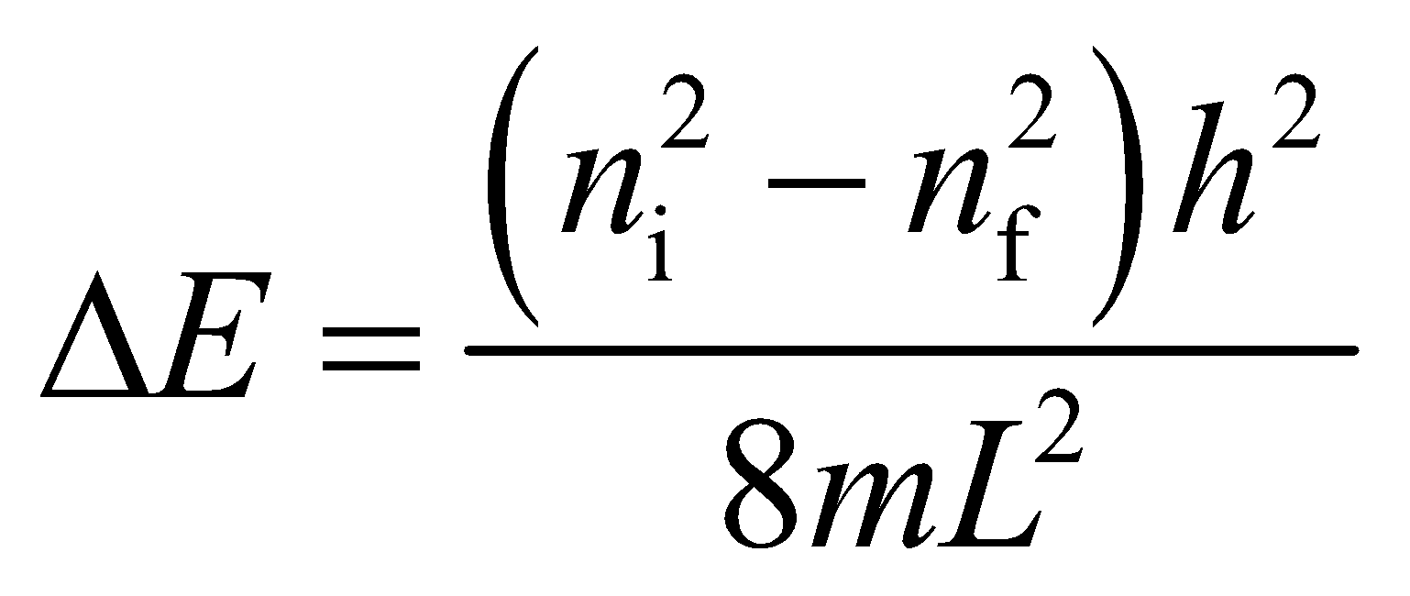

and the wavelengths of the corresponding photons are

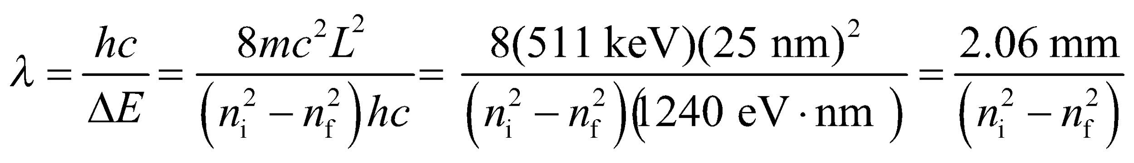

**Evaluate**To two significant figures, we find:

**(a)** For *n*i = 2 and *n*f = 1, *λ* = 0.690 mm.

**(b)** For *n*i = 20 and *n*f = 19, *λ* = 53 μm.

**(c)** For *n*i = 100 and *n*f = 1, *λ* = 210 nm.

**Assess** These wavelengths range from the ultraviolet to the far infrared to the microwave portion of the electromagnetic spectrum.

**33. Interpret** We are to find the energy and wavelength of the photon emitted as an electron trapped in an infinite square well makes a transition to the adjacent energy level.

**Develop** The energy levels for an infinite square potential well are given by Equation 35.5:

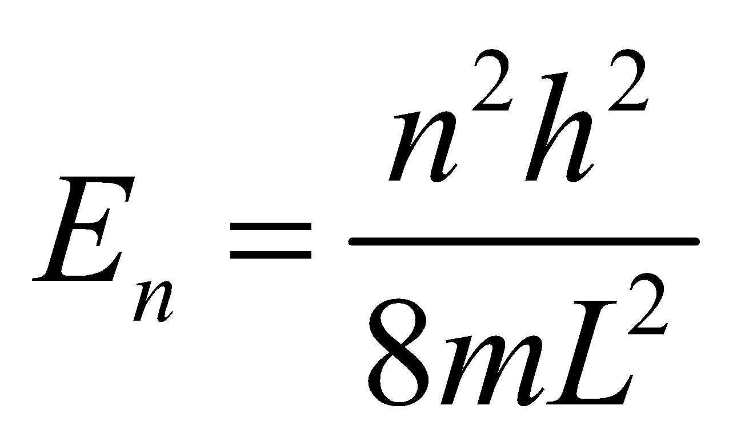

Thus, the energy of the photon emitted when the electron drops from *n*i to *n*f < *n*i is

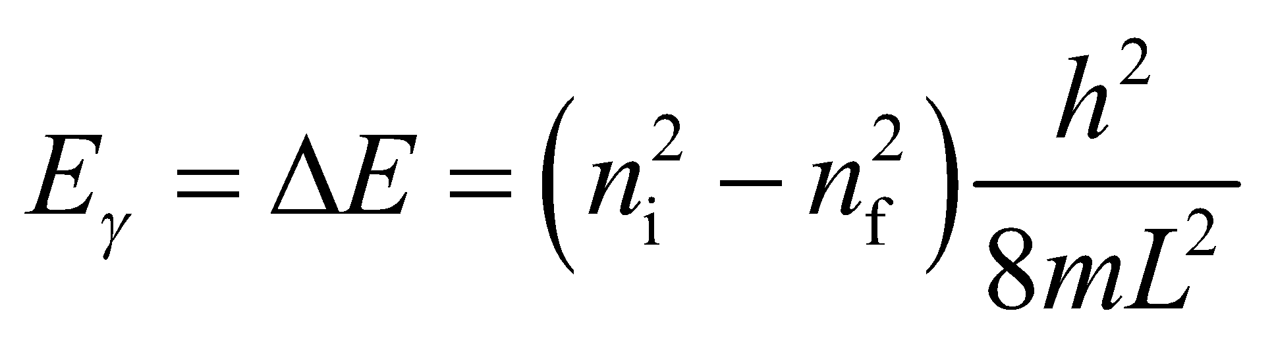

From Equation 34.6, the wavelength of the photon is 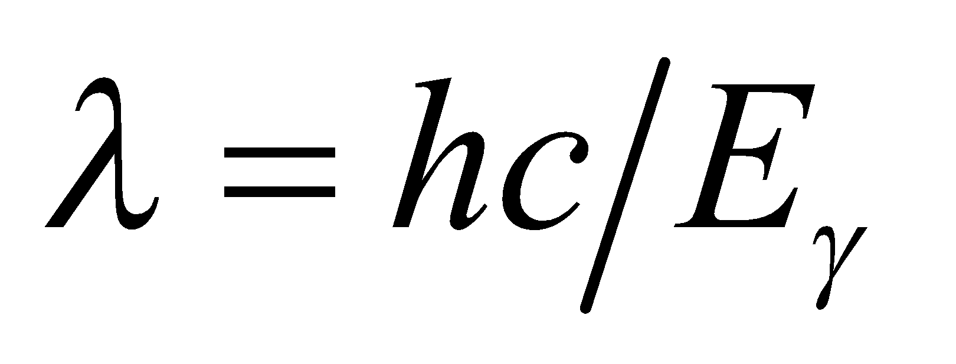.

**Evaluate** **(a)** Substituting the values given, we find

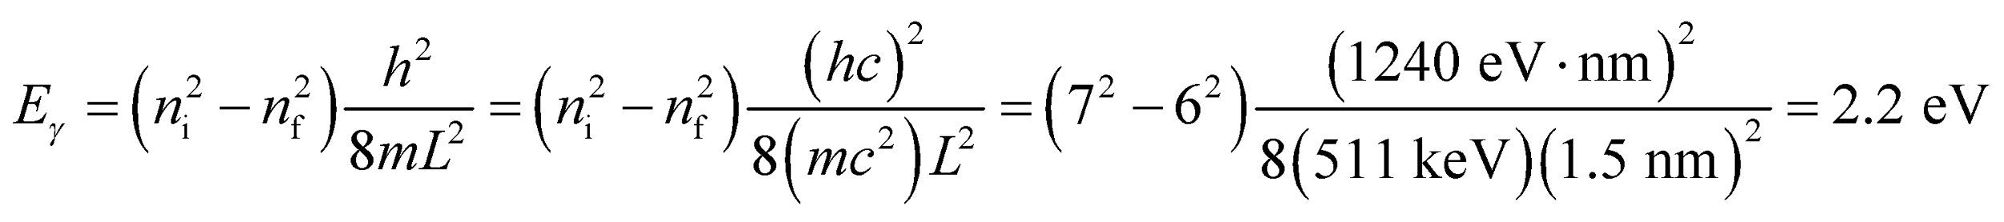

**(b)** The wavelength of the photon is

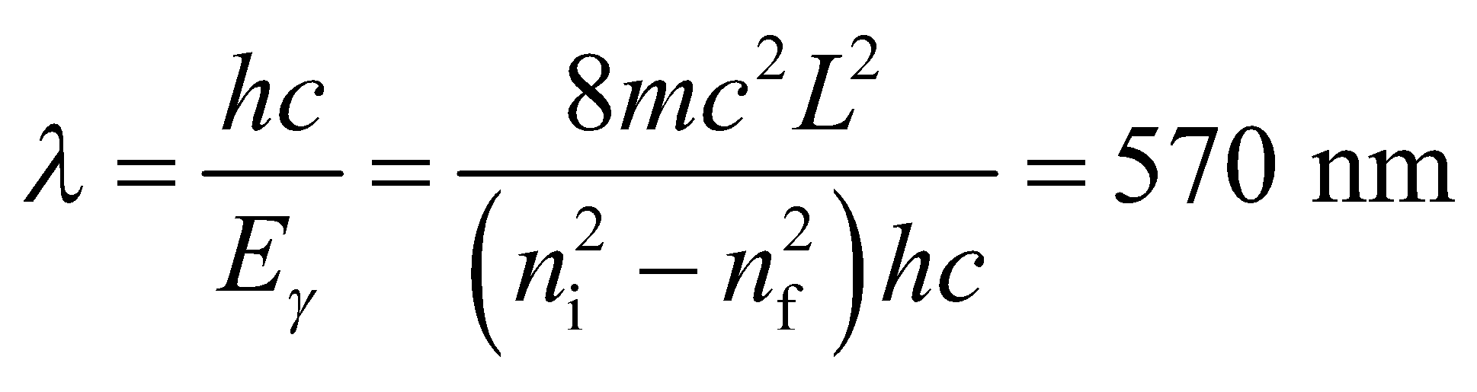

to two significant figures.

**Assess** The wavelength is in the visible region of the electromagnetic spectrum.

**34. Interpret** This problem demonstrates an aspect of the correspondence principle; namely, that as quantum numbers become arbitrarily large, the quantum nature is lost and is replaced by the continuous nature of classical physics.

**Develop** From Equation 35.5, we see that the difference between adjacent levels in an infinite square well is

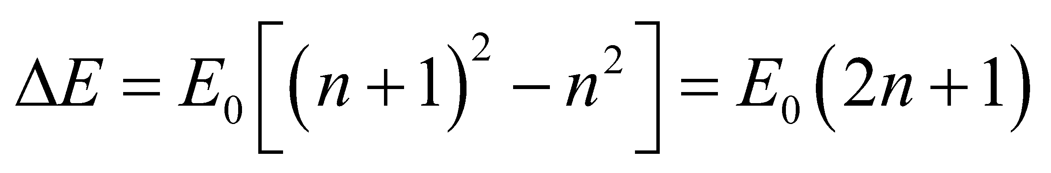

so we can form the ratio between *ΔE* and *En*+1 and take the limit as 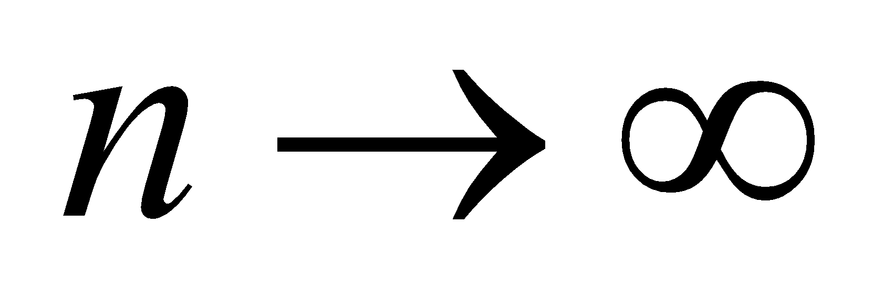.

**Evaluate** Comparing *ΔE* to the original energy level *E*n+1 and letting *n* go to infinity gives

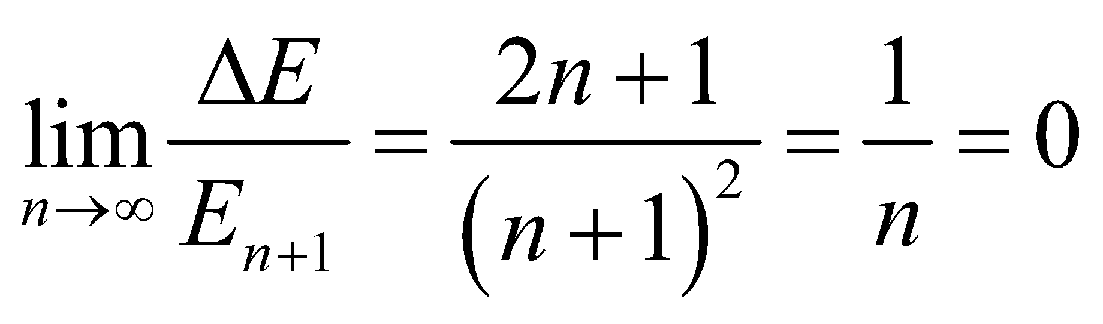

so the energy different *ΔE* is zero.

**Assess** Thus, we have found that the possible energy levels form a continuum of states in the classical limit, in accordance with the correspondence principle.

**35. Interpret** An electron trapped in the given one-dimensional potential well must absorb a photon in order to make a transition from the ground state to an excited state. We want to know the maximum wavelength associated with this transition.

**Develop** Equation 35.5 describes the allowed energy states for a particle trapped in a one-dimensional potential well. The allowed quantum numbers *n* are *n* = 1, 2, 3, …, so the smallest transition energy is to the first excited state (i.e., *n* = 1 to *n* = 2). The energy difference may be found from inserting these quantum numbers into Equation 35.5: so

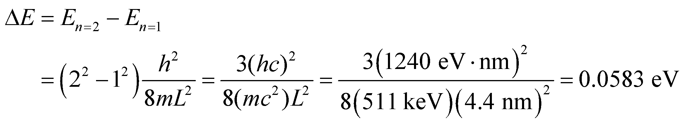

The wavelength that corresponds to this energy is (see Equation 34.6) *Eγ* = *hf* = *hc*/*λ*. Because of the inverse relationship between wavelength and energy, the smallest energy corresponds to the largest wavelength. Therefore, the maximum wavelength that can cause a transition is

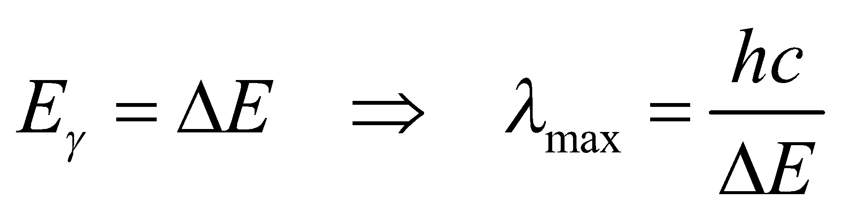

**Evaluate** Thus, the maximum wavelength that can be absorbed is

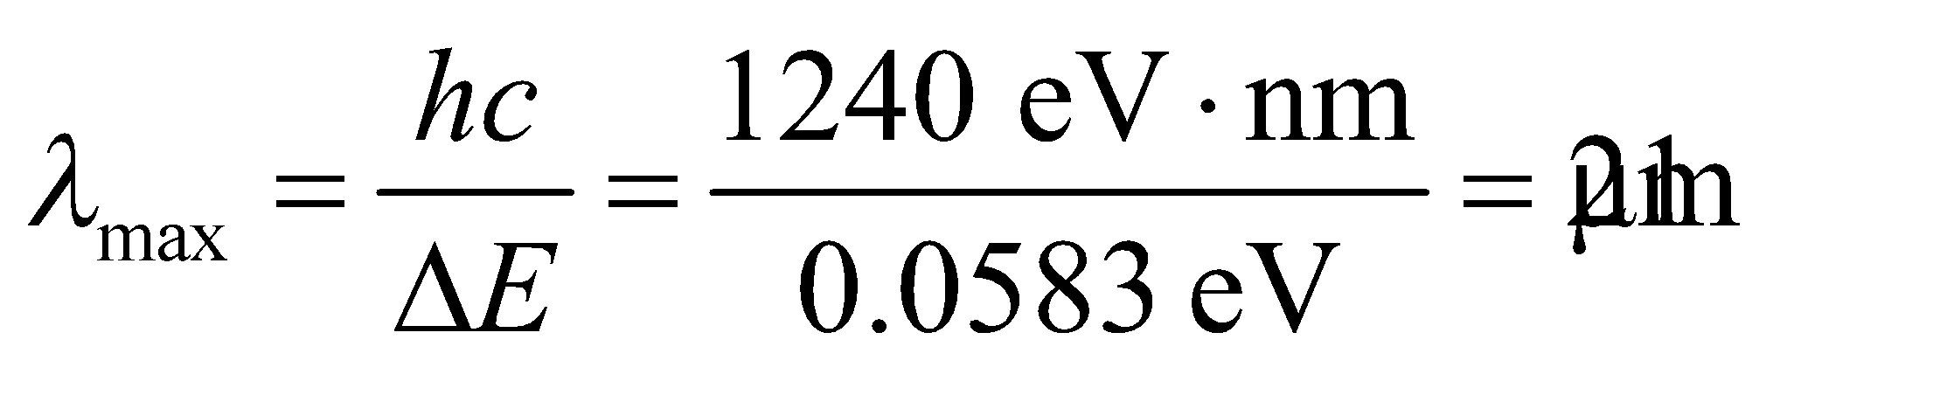

**Assess** The wavelength corresponds to the infrared region of the electromagnetic spectrum.

**36. Interpret** We are to compare the widths of two infinite square potential wells given the ratio of their ground-state energies.

**Develop** Equation 35.5 shows that the energy of a one-dimensional infinite square well is given by

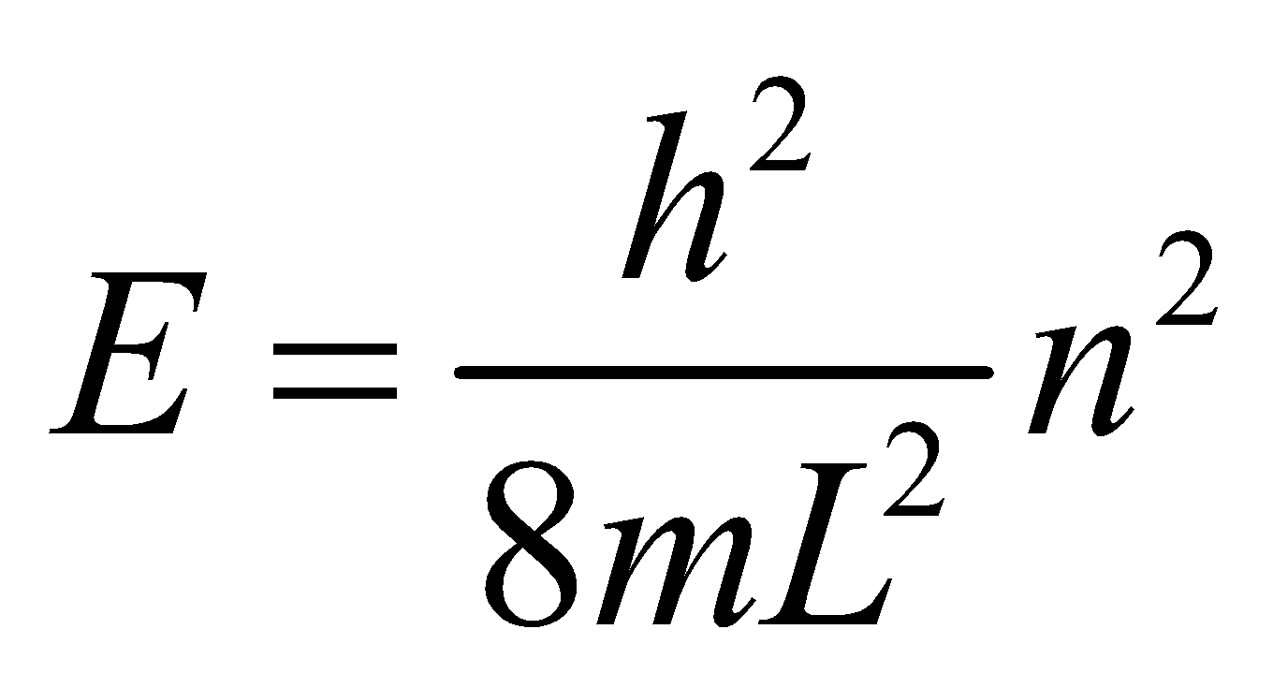

The ground state corresponds to *n* = 1 and the first excited state to *n* = 2. We are given that 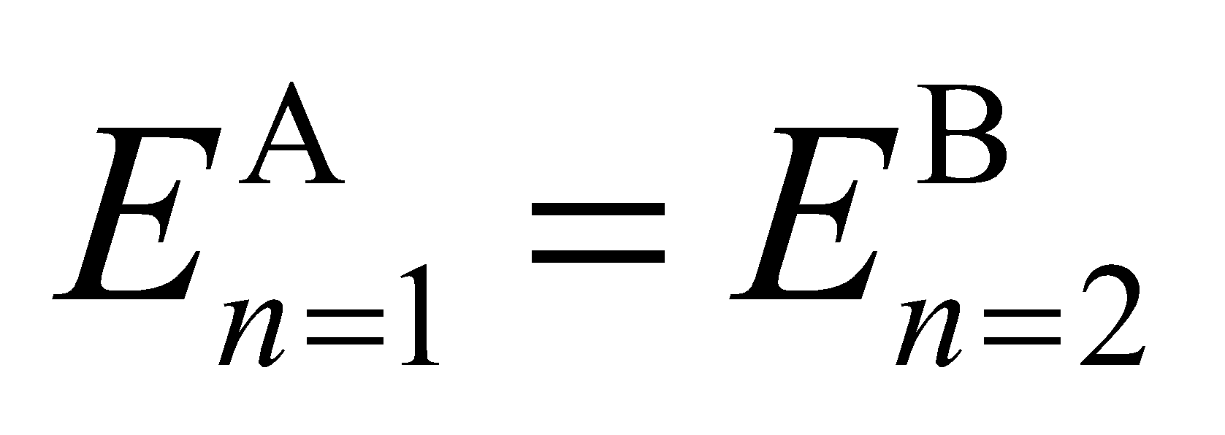, so we can find the ratio of the well widths.

**Evaluate** With 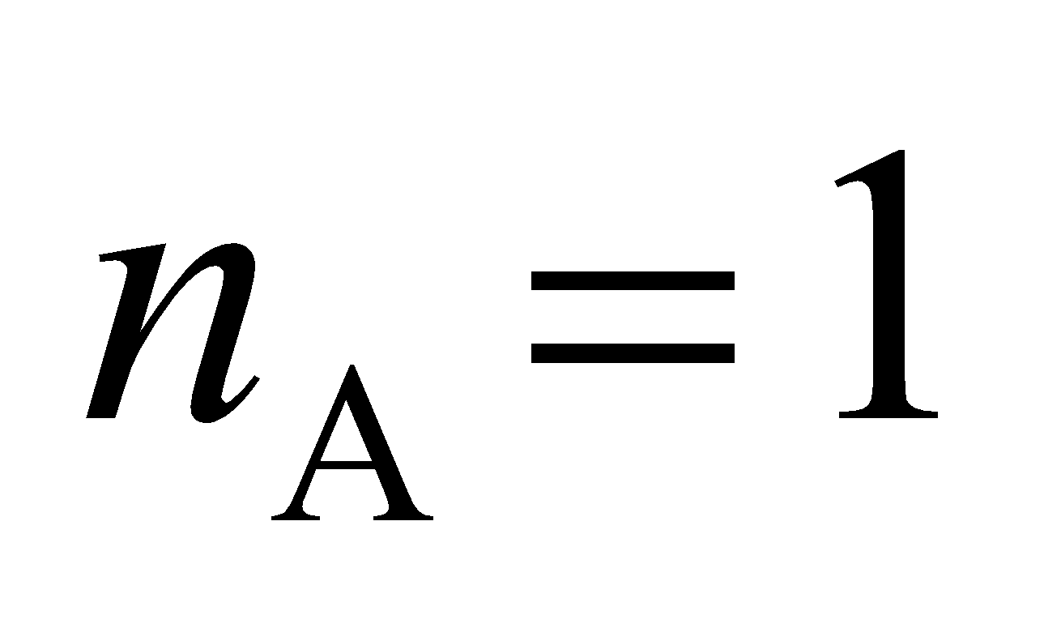 and 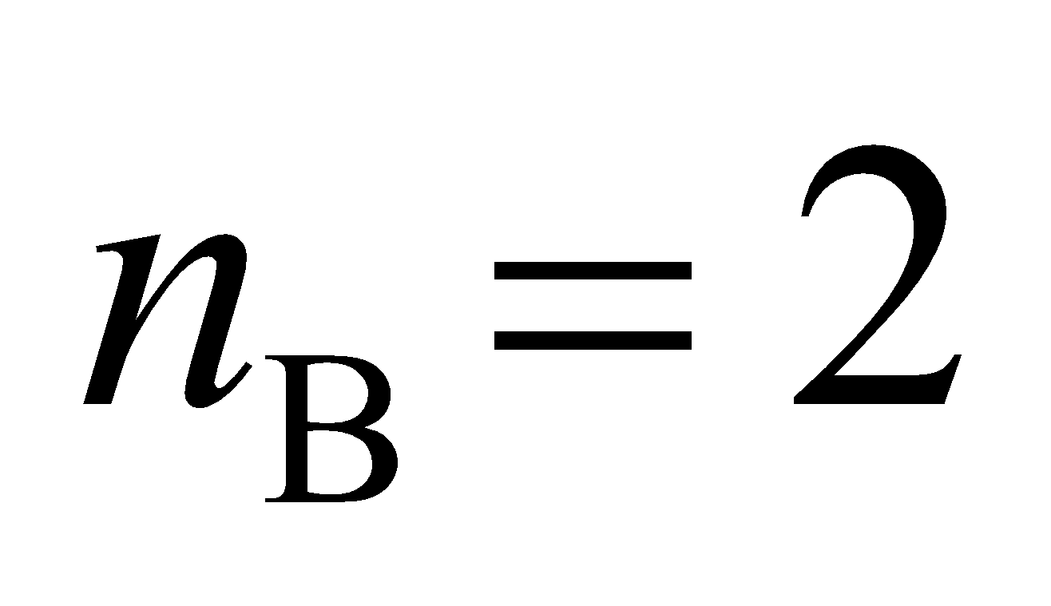,

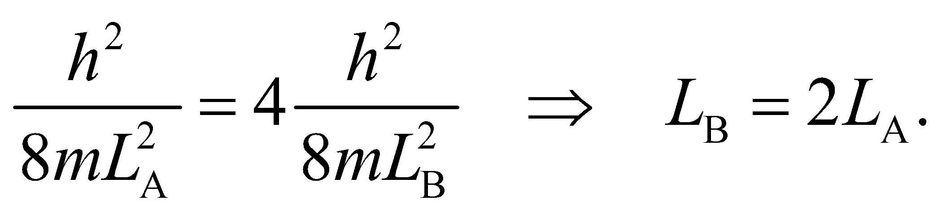

**Assess** The result of this depends on the dimensionality of the square well. For three dimensions, the result is 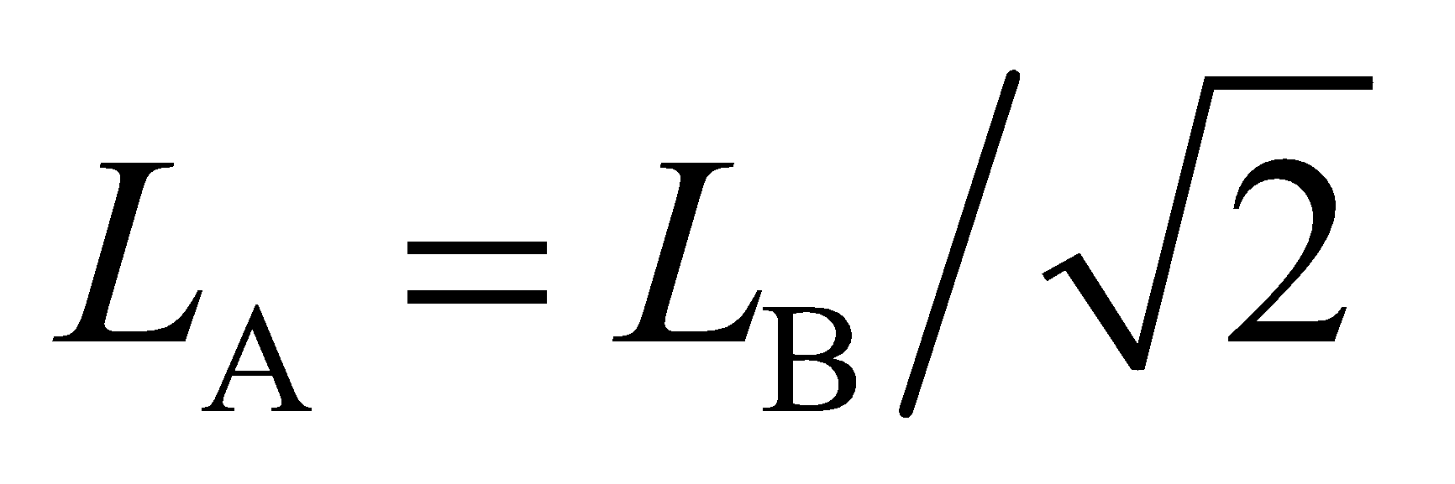.

**37. Interpret** There are various ways for the electron which is initially in the *n* = 4 state to make a transition to the ground state. We want to find the wavelengths associated with all possible spectral lines in this process.

**Develop** The energy levels for a one-dimensional infinite square potential well are given by Equation 35.5:

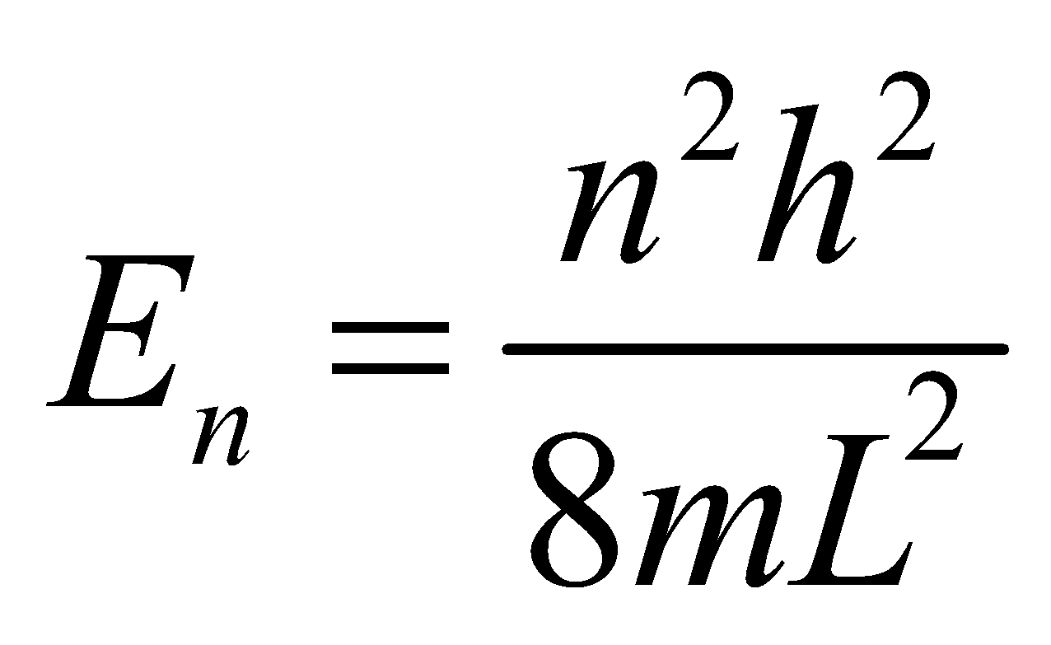

Thus, the energy of the photon emitted when the electron drops from *n*i to *n*f < *n*i is

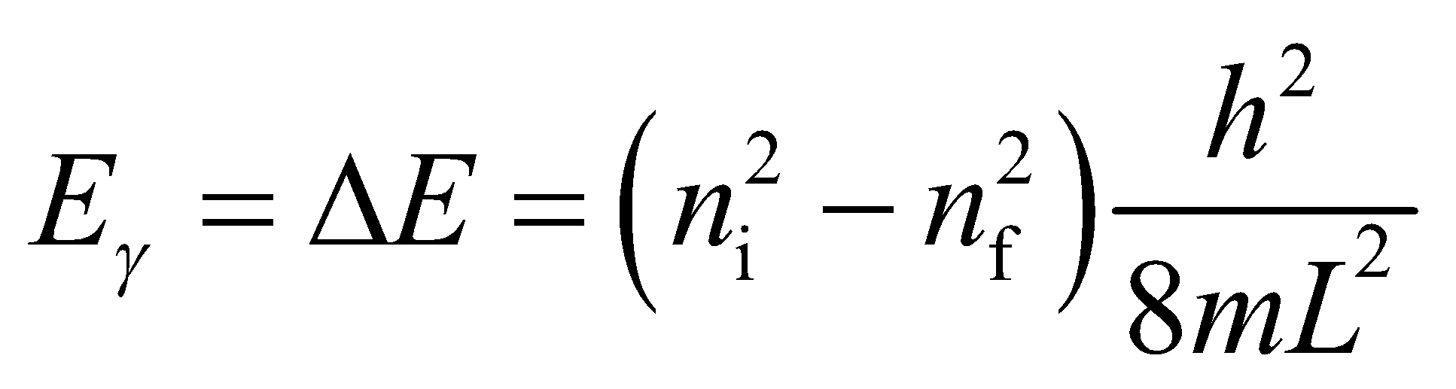

From Equation 34.6, we know that the corresponding photon wavelengths are

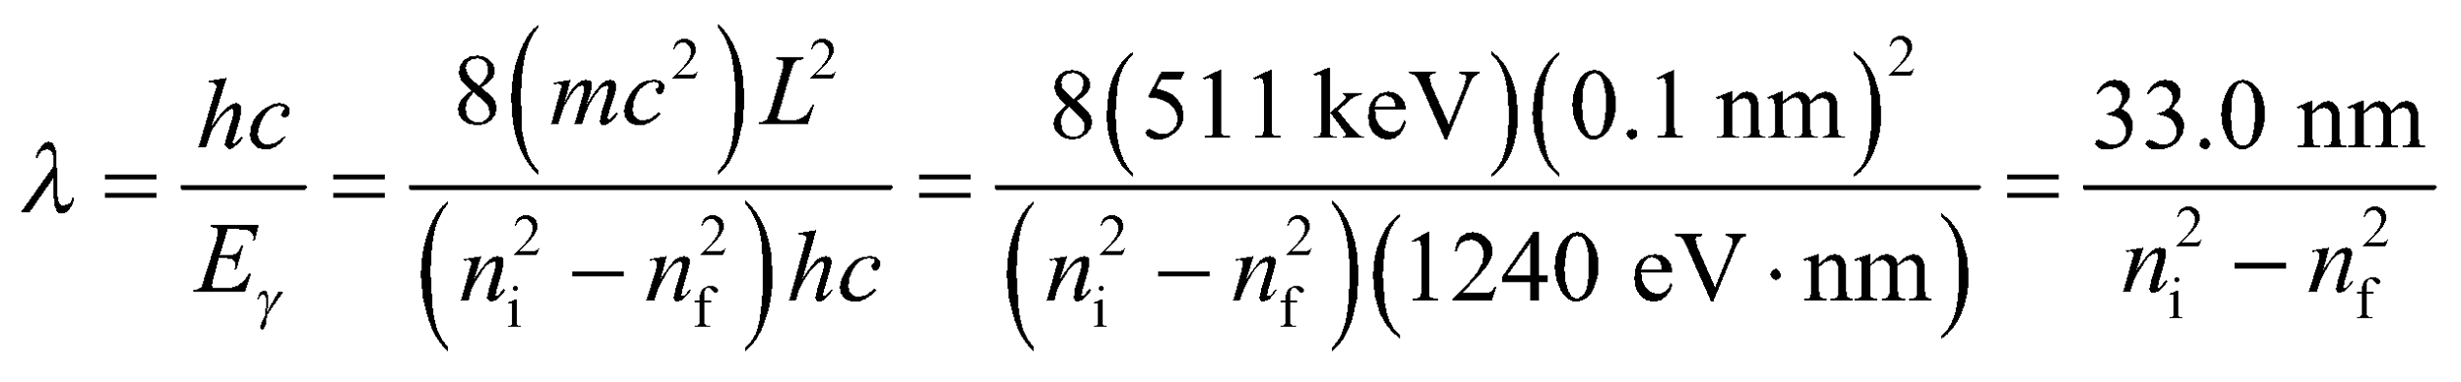

**Evaluate** Starting from the *n* = 4 state, the possible transitions to the ground state are 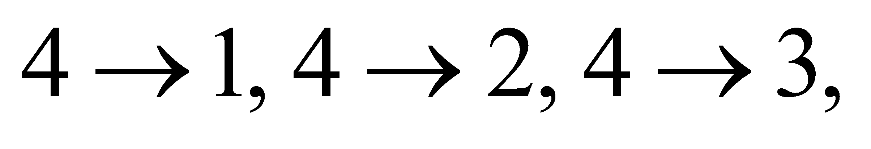

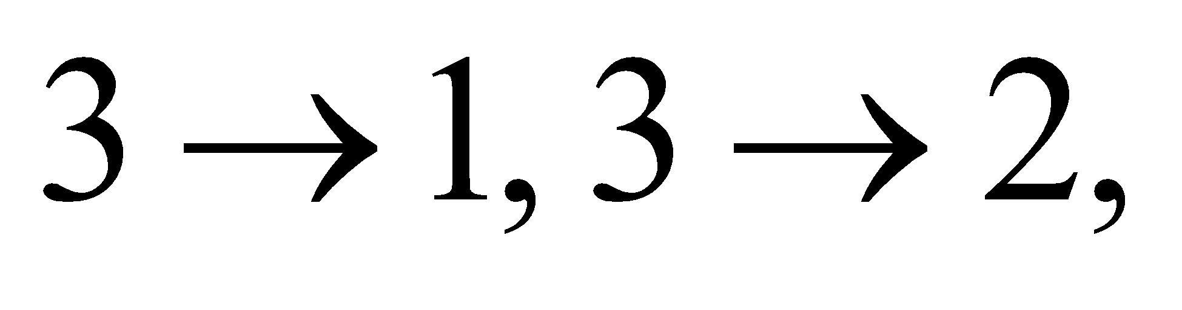 and 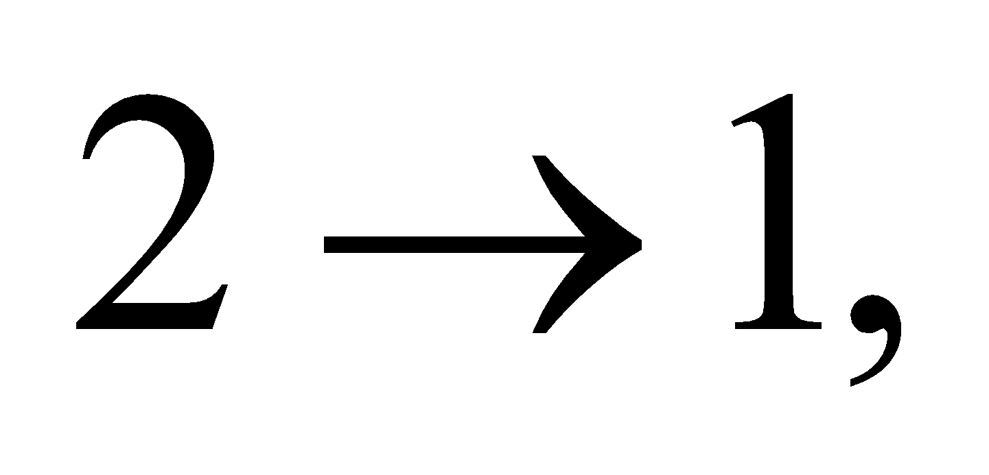 with corresponding wavelengths

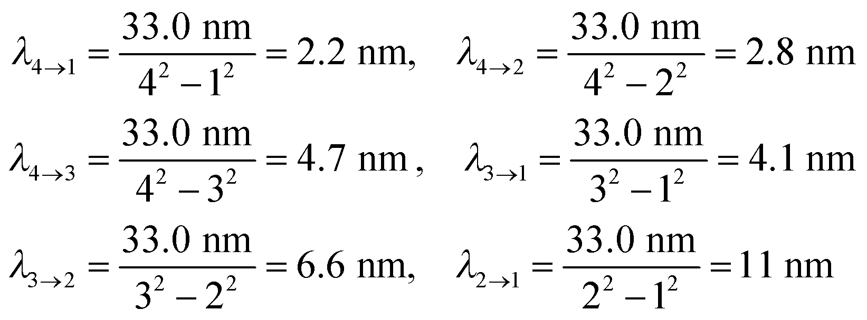

**Assess** Only photons of these discrete wavelengths will be emitted during the transition from *n* = 4 to *n* = 1. The wavelengths correspond to the ultraviolet region of the electromagnetic spectrum.

**38. Interpret** From the graph of the probability density [i.e., ], we are to determine the most likely position of the particle.

**Develop** The probability density for the *n* = 2 state of a one-dimensional infinite square well is 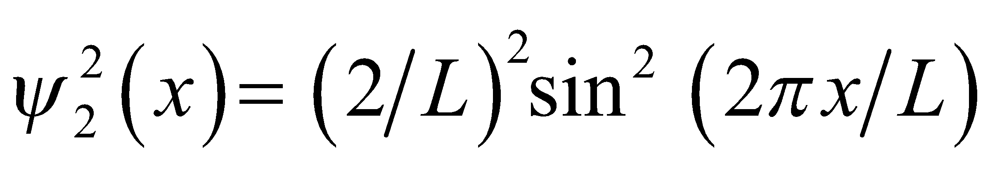 (see Equation 35.6), a graph of which is shown in Fig. 35.8.

**Evaluate** From Figure 35.8, we see that the highest probability for finding the particle is at *x* = *L*/4 and *x* = 3*L*/4.

**Assess** For larger n, the probability for finding the particle becomes equal from *x* = 0 to *x* = *L* (see top panel of Figure 3.58).

**39. Interpret** We are given a potential that is the same as in Fig. 35.5, except that the origin of coordinates is at the center of the well. We want to find expressions for the normalized wave function for even and odd quantum numbers and the corresponding energy levels.

**Develop** The wave function for this well can be found by using Equation 35.6 (which is already normalized), but replacing *x* by 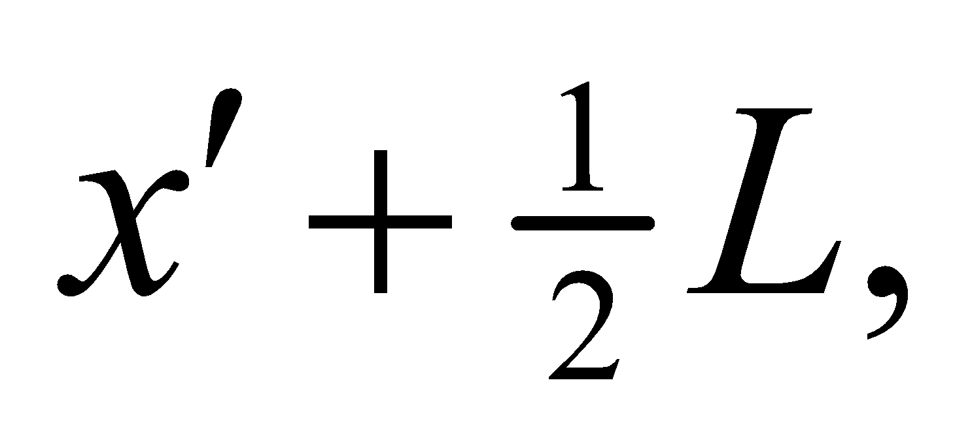 where 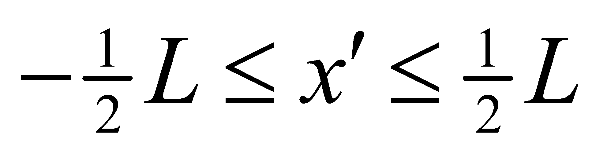. The normalized wave function thus takes the form

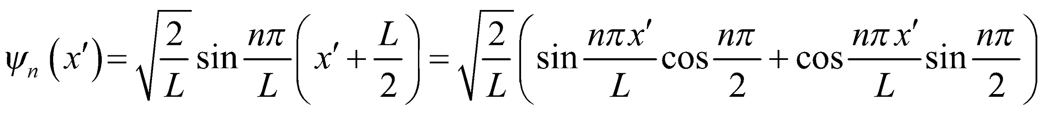

We need to distinguish between even and odd values of *n*.

**Evaluate** **(a)** If *n* is odd, then 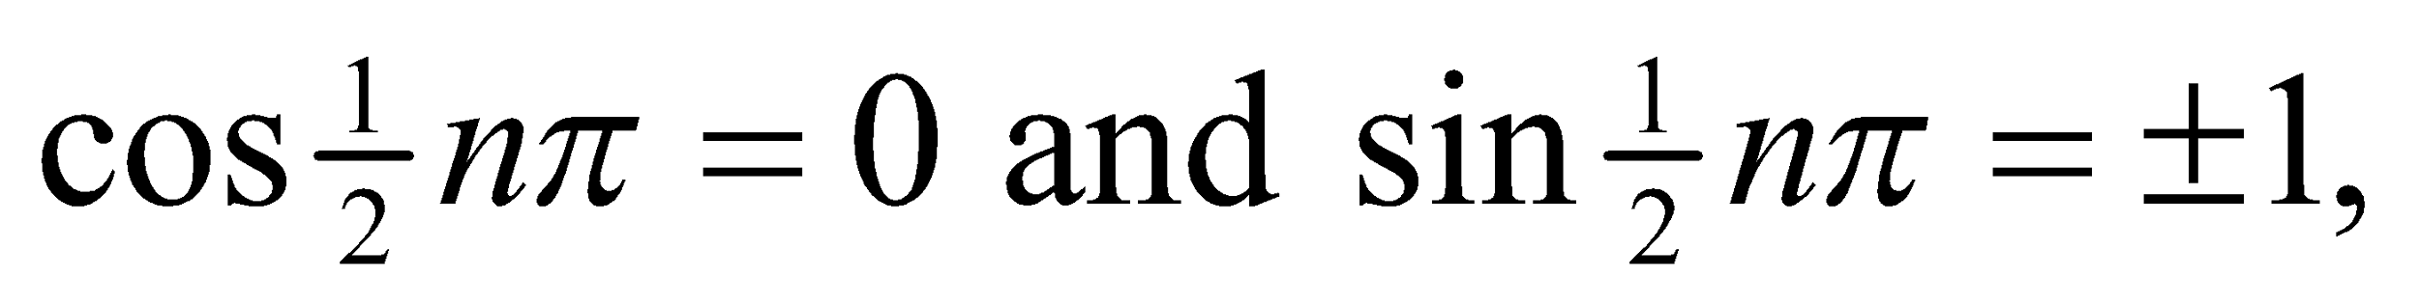 so the wave function is

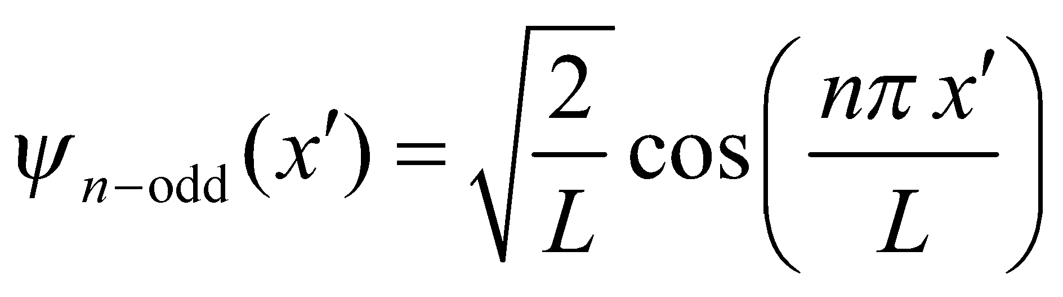

The probability density 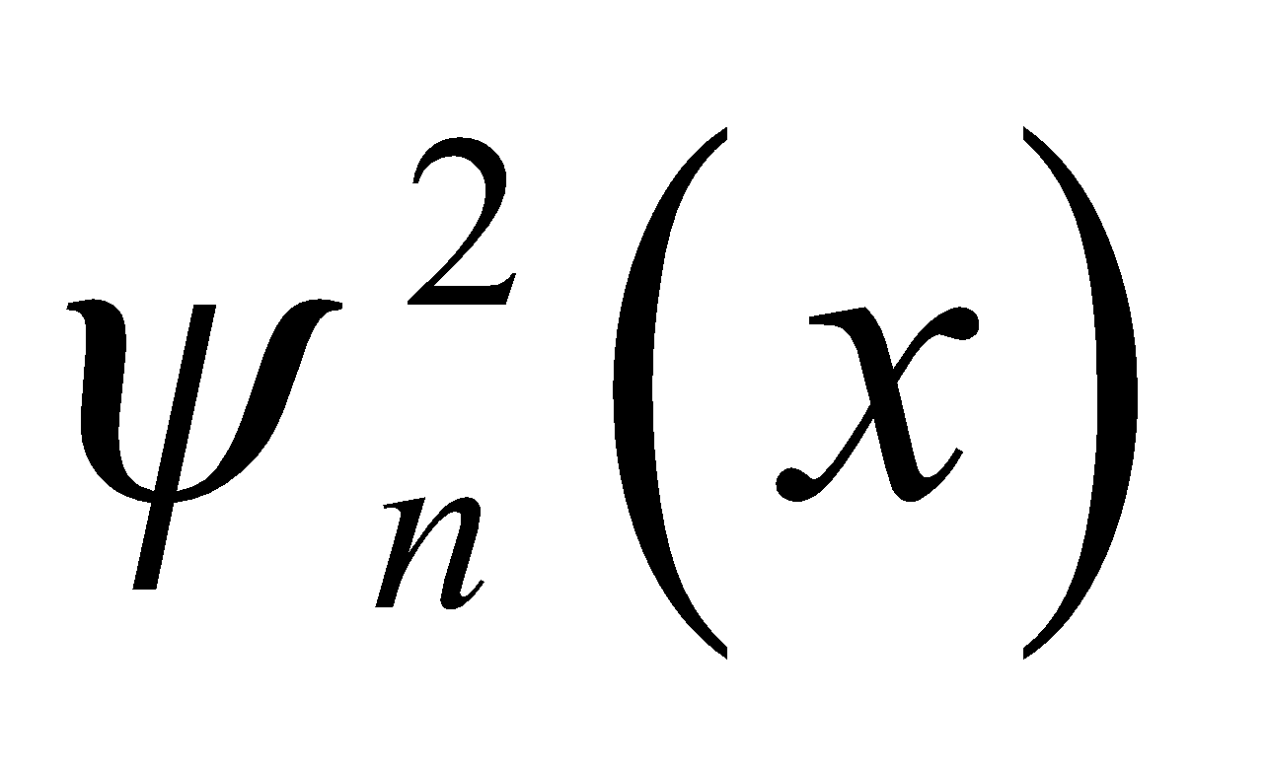 is unaffected by the overall sign of 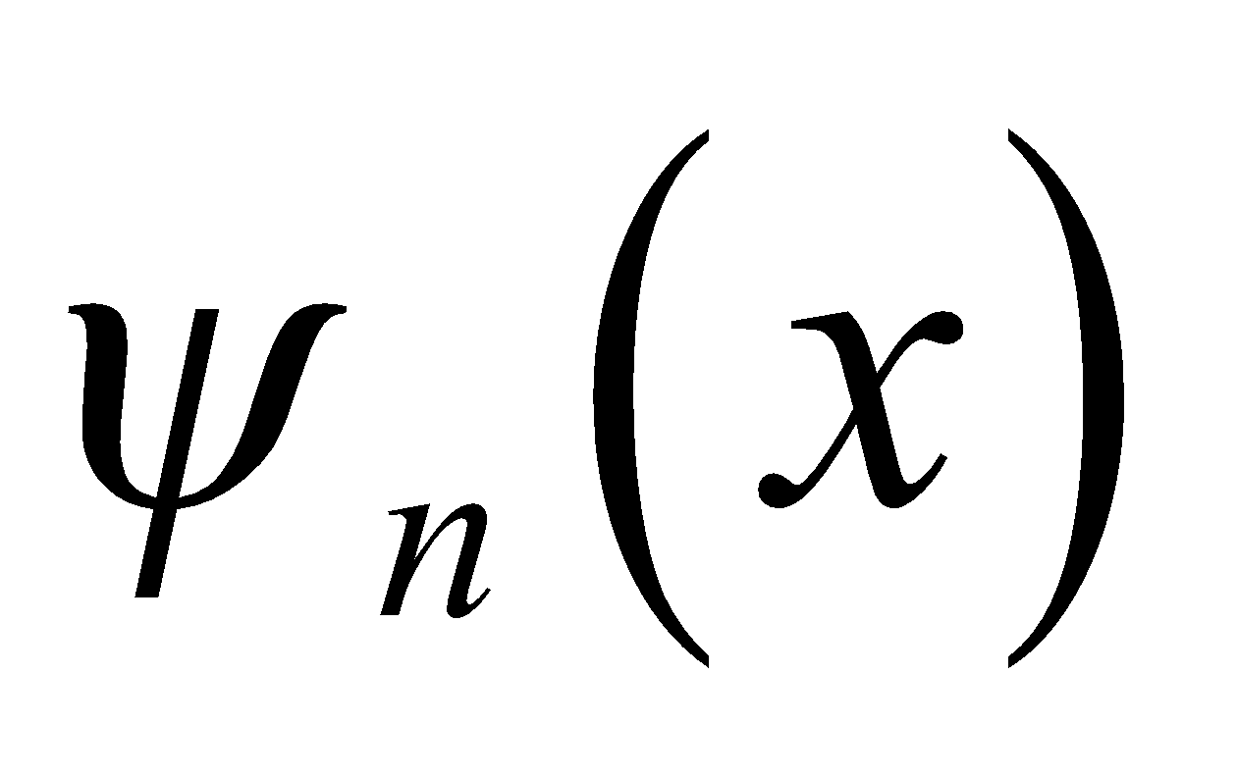, so we choose the sign to be positive. If *n* is even, then 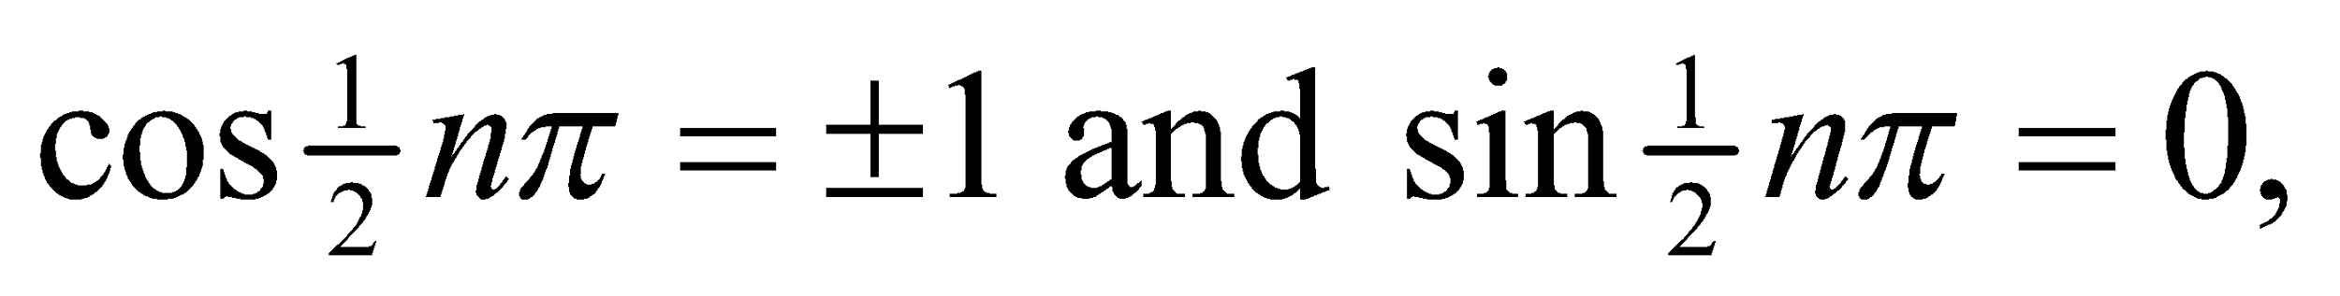 and the wave function is

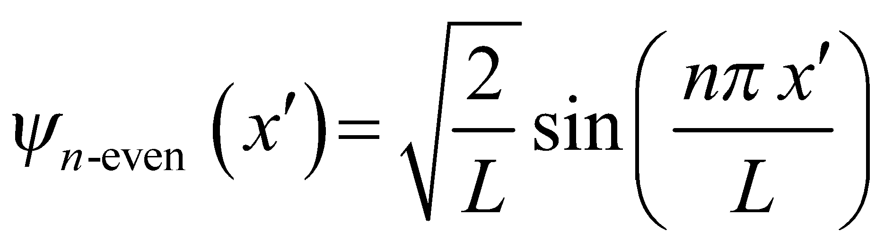

**(b)** The energy levels are the same, 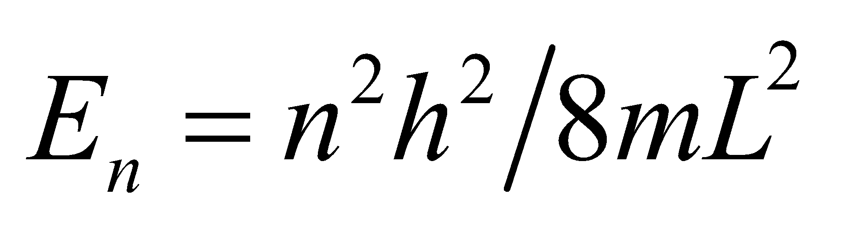 regardless of how the potential is parameterized.

**Assess** These results can be confirmed by direct solution of the Schrödinger equation. For 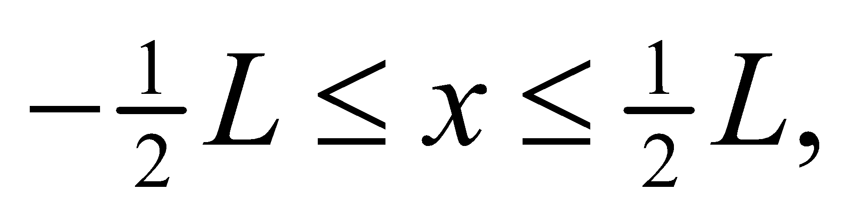 Equation 35.4 has two solutions: 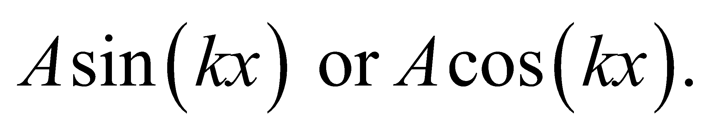 In order for *ψ* to vanish at 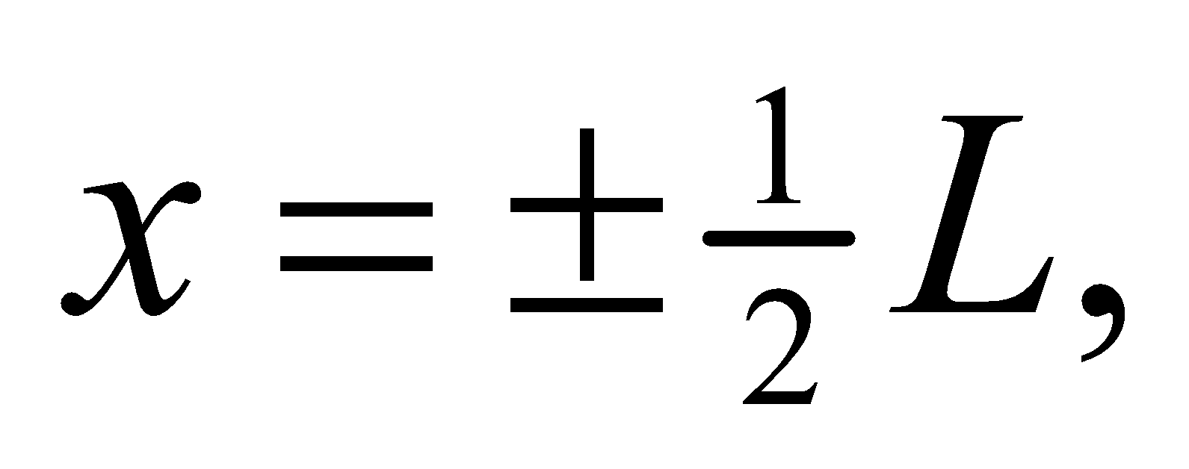 one must use the cosine solution for odd quantum numbers [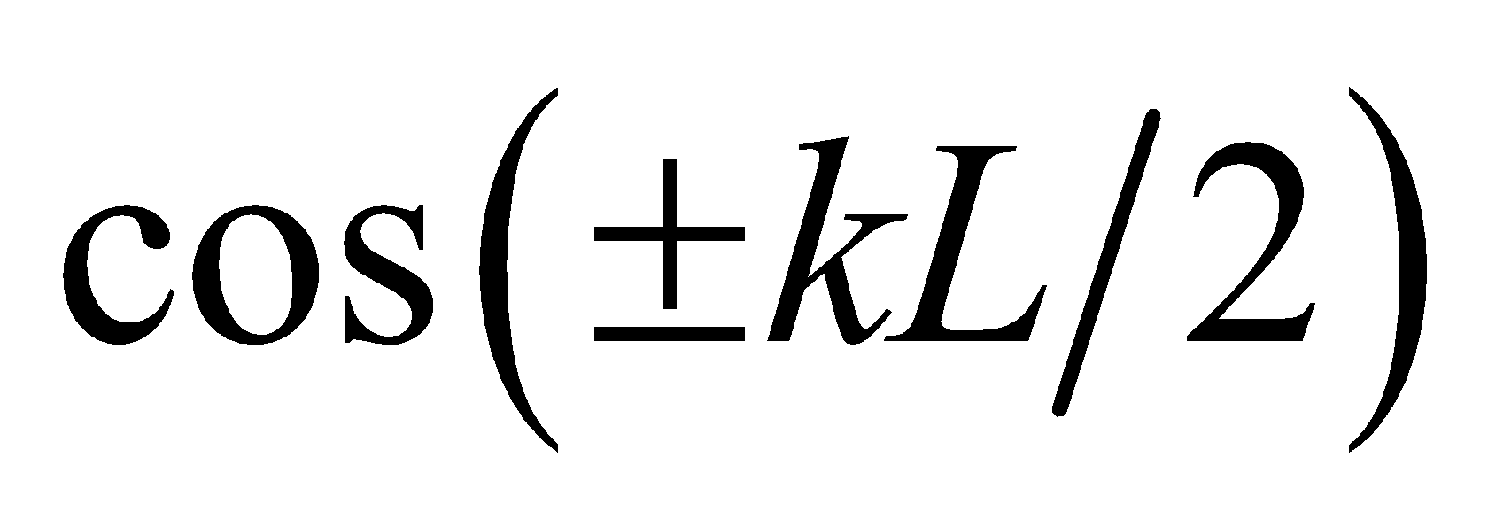] vanishes for *kL* equal to odd multiples of *π* and the sine solution for even quantum numbers [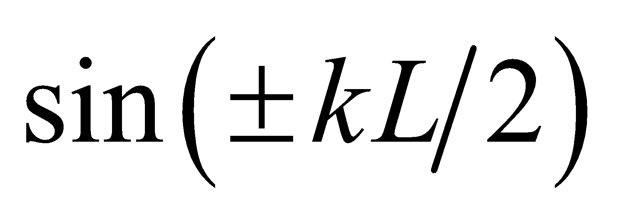] vanishes for *kL* equal to even multiples of *π*. Since the average of sin2 or cos2 over an integer number of half-cycles is ½, the normalization constant is 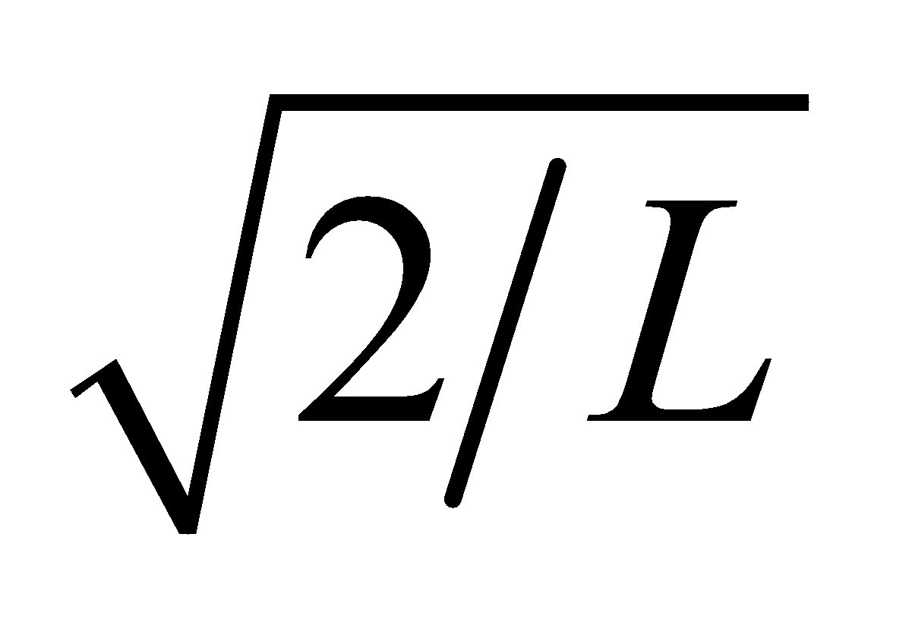for either wave function (or use integrals in Appendix A). Note that these wave functions have even or odd parity about the center of the potential well (see Section 39.2).

**40. Interpret** We are given a particle in a one-dimensional infinite square well, and we are to find the probability that it is located in the left-hand third of the well.

**Develop** The ground-state wave function for an infinite square well is 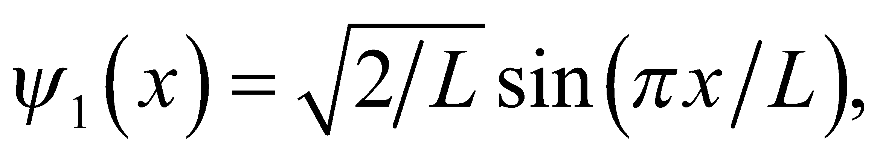 and the left-hand third of the well extends from *x* = 0 to *x* = *L*/3. The probability of finding the particle in this interval is (see Example 35.2):

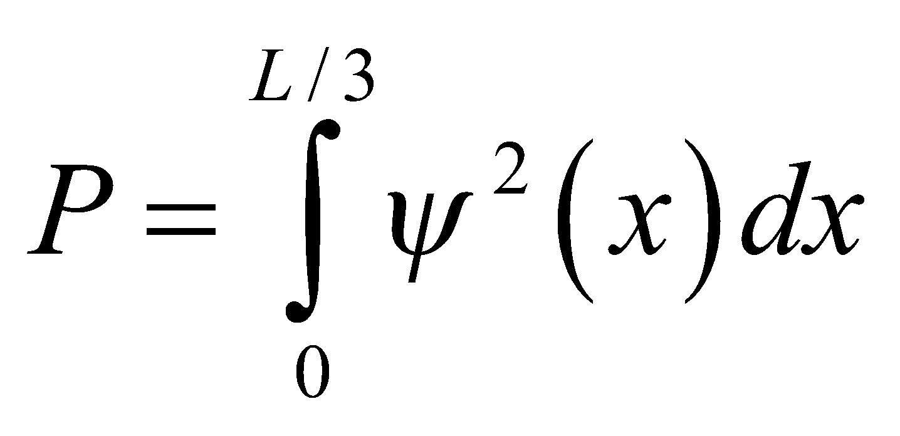

**Evaluate** Evaluating the integral gives

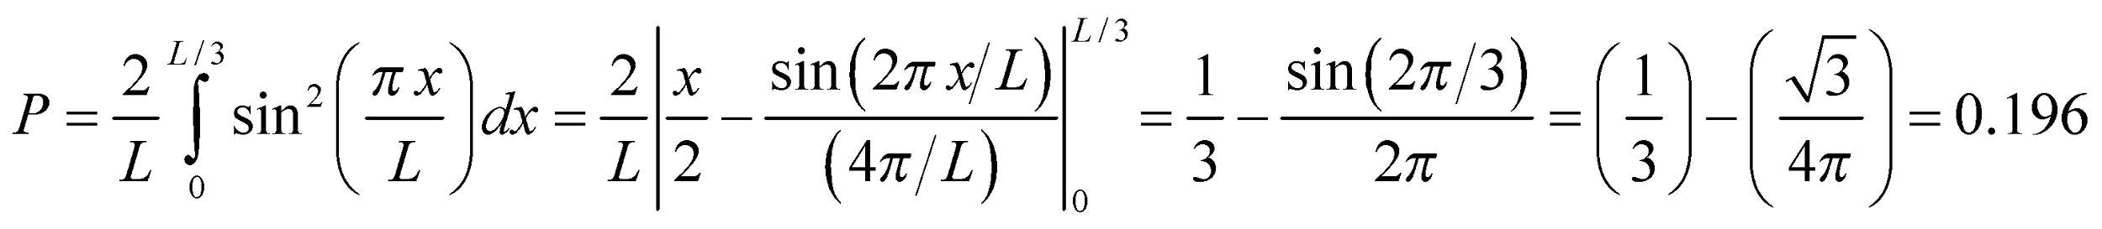

**Assess** Because the function  is even, the probability for finding the particle in the right-hand one third of the well is also 0.196.

**41. Interpret** We’re given the energy of the photon emitted in a transition between adjacent quantum states and asked to find the width of the one-dimensional infinite potential well.

**Develop** The energy levels for a one-dimensional infinite square potential well are given by Equation 35.5:



Thus, the energy of the photon emitted when the electron drops from *n*i to *n*f < *n*i is

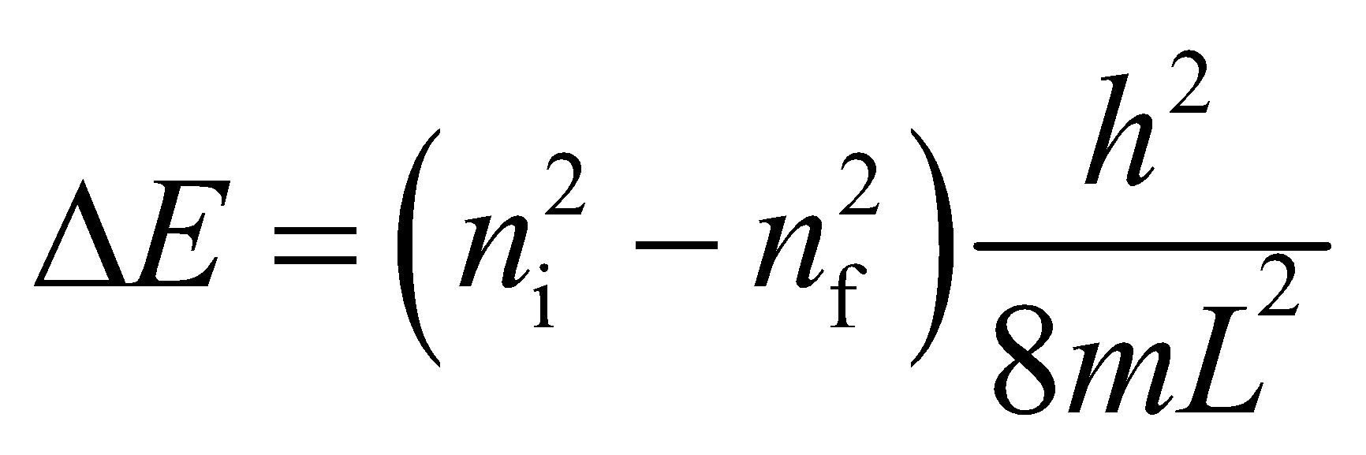

**Evaluate** From the above equation, the energy difference between *n*i = 2 and *n*f = 1 is 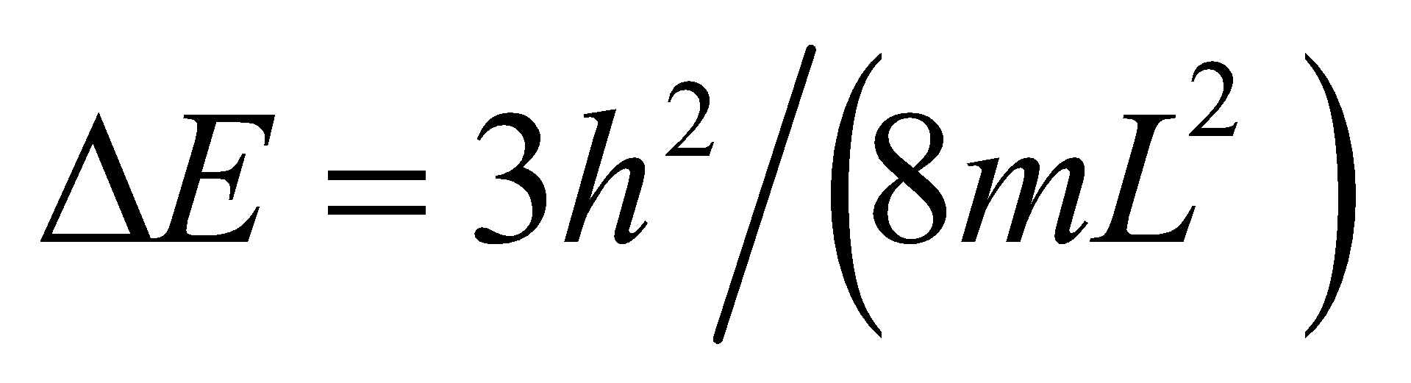, so the width of the potential well is

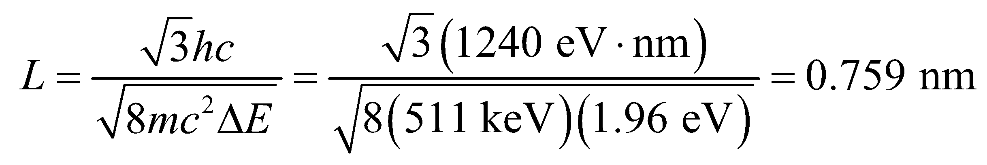

**Assess** The result is consistent with the typical quantum well width (about the size of an atom).

**42. Interpret** This problem involves a particle in a one-dimensional infinite square potential well. We are to find the probability of finding the particle in the middle 80% of the well.

**Develop** From the derivation of Equation 35.5, we see that the ground-state wave function is

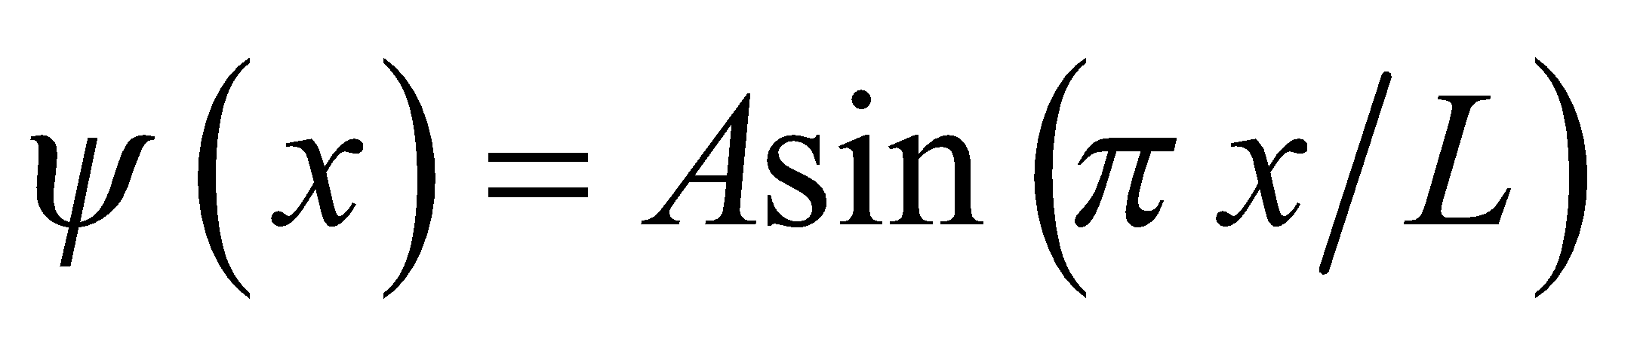

Because the particle must be somewhere, we know that

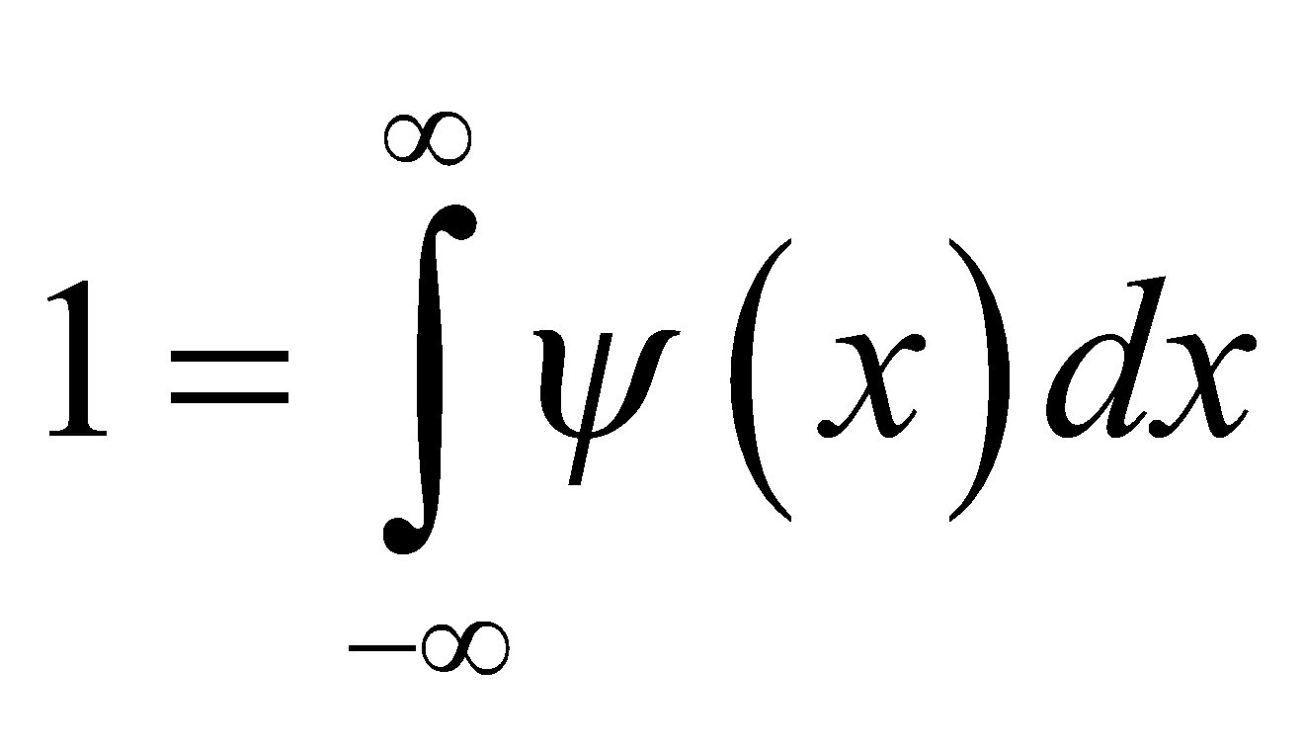

which allows us to find the constant *A*. The result is

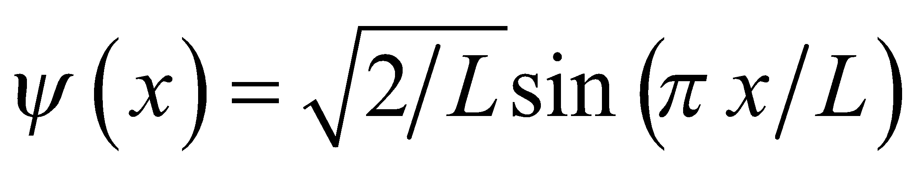

so the probability of finding the particle in the central 80% of the well 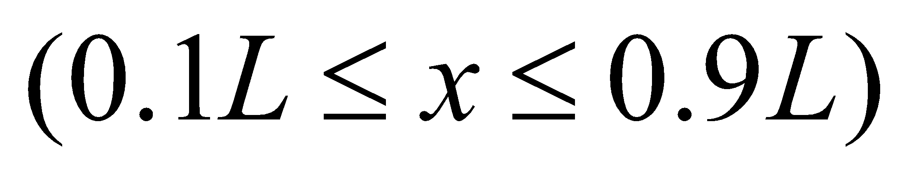 is found, as in Example 35.2, by integrating the wave function squared from 0.1*L* to 0.9*L*.

**Evaluate** Performing the integration gives



**Assess** The probability of finding the particle in either the left- or right-hand 5% of the well is 0.050.

**43. Interpret** The problem asks if quantum mechanics should be considered for macromolecules trapped inside a biological cell.

**Develop** We will treat the biological cell like a one-dimensional square well, so that the energy levels are given by Equation 35.5: 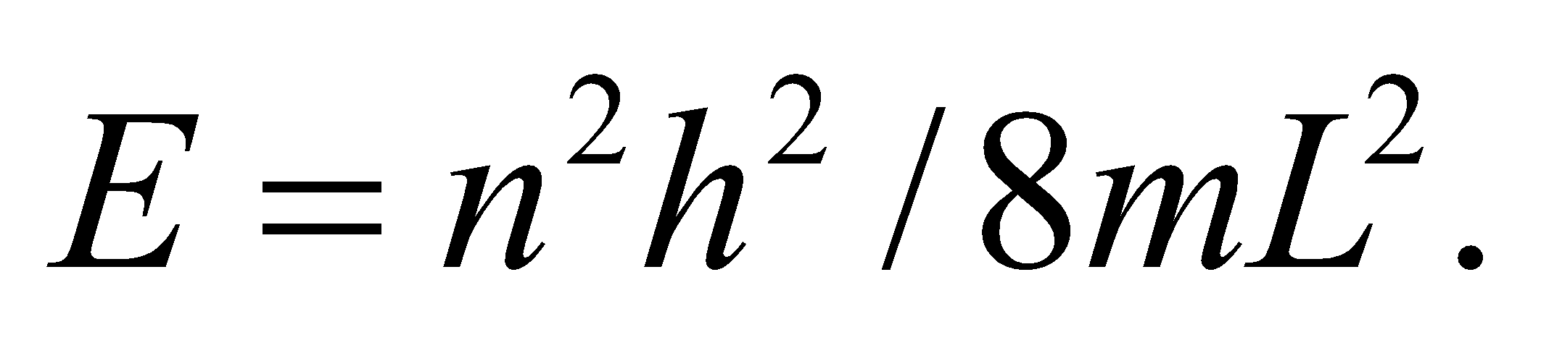

**Evaluate** The energy difference between the ground state and the first excited state is

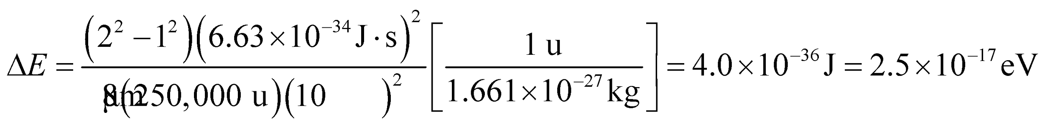

This is so much smaller than the energy of biochemical reactions (1 eV) that quantization is not relevant.

**Assess** Quantization is rarely considered in biology because the objects of interest are too large. One exception is photosynthesis, where the conversion of sunlight into chemical energy appears to exhibit some quantum effects.

**44. Interpret** You model the hydrogen in hydrogen chloride as a mass on a spring. Accordingly, the spring constant can be determined from the energy separation between the ground state and first excited state.

**Develop** In terms of a simple harmonic oscillator, the energy difference between the ground state and first excited state is 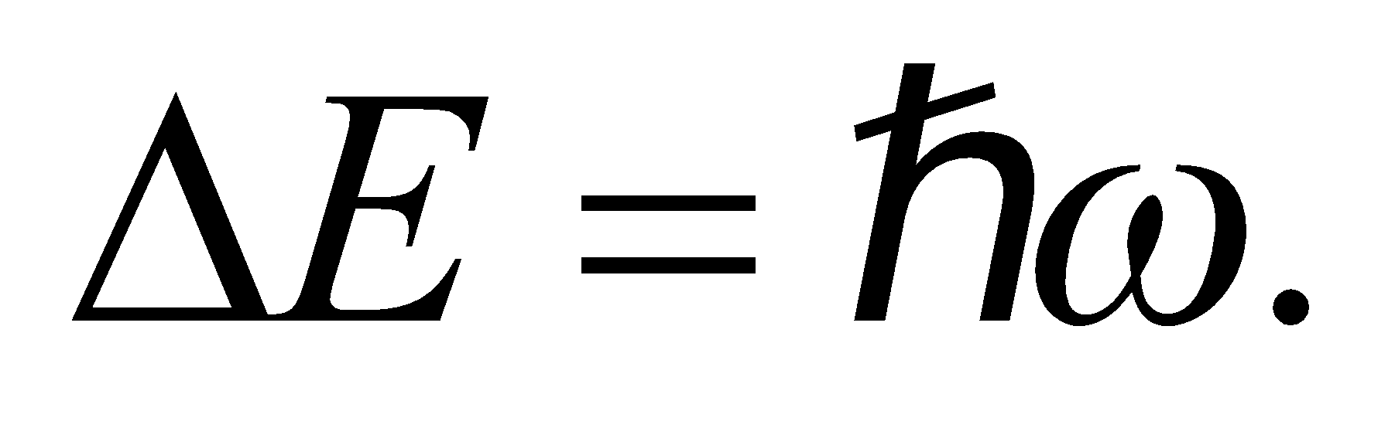 The angular frequency for the mass-spring system is  In this case, the mass is that of the hydrogen atom: 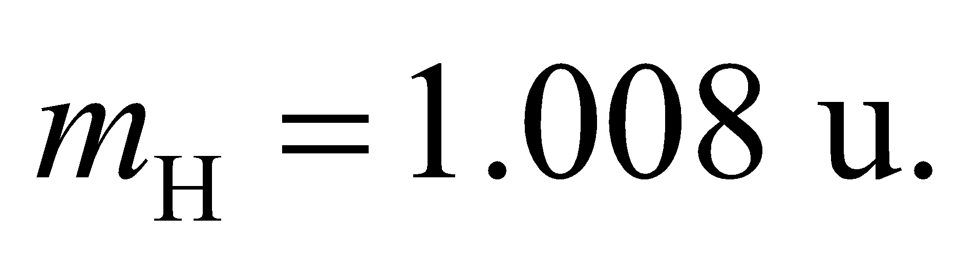

**Evaluate** Combining the above equations, the spring constant in the model for HCl is

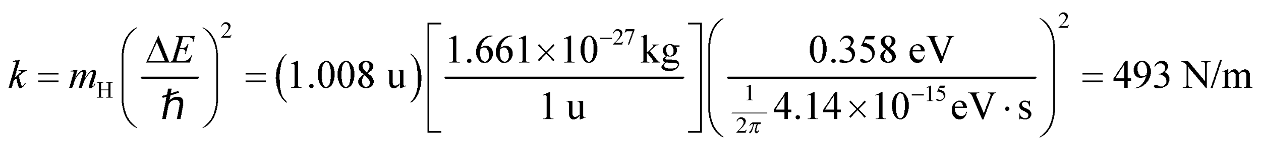

**Assess** You can try to estimate the size of this molecule using the relation between the energy of a spring and the amplitude of its oscillations: 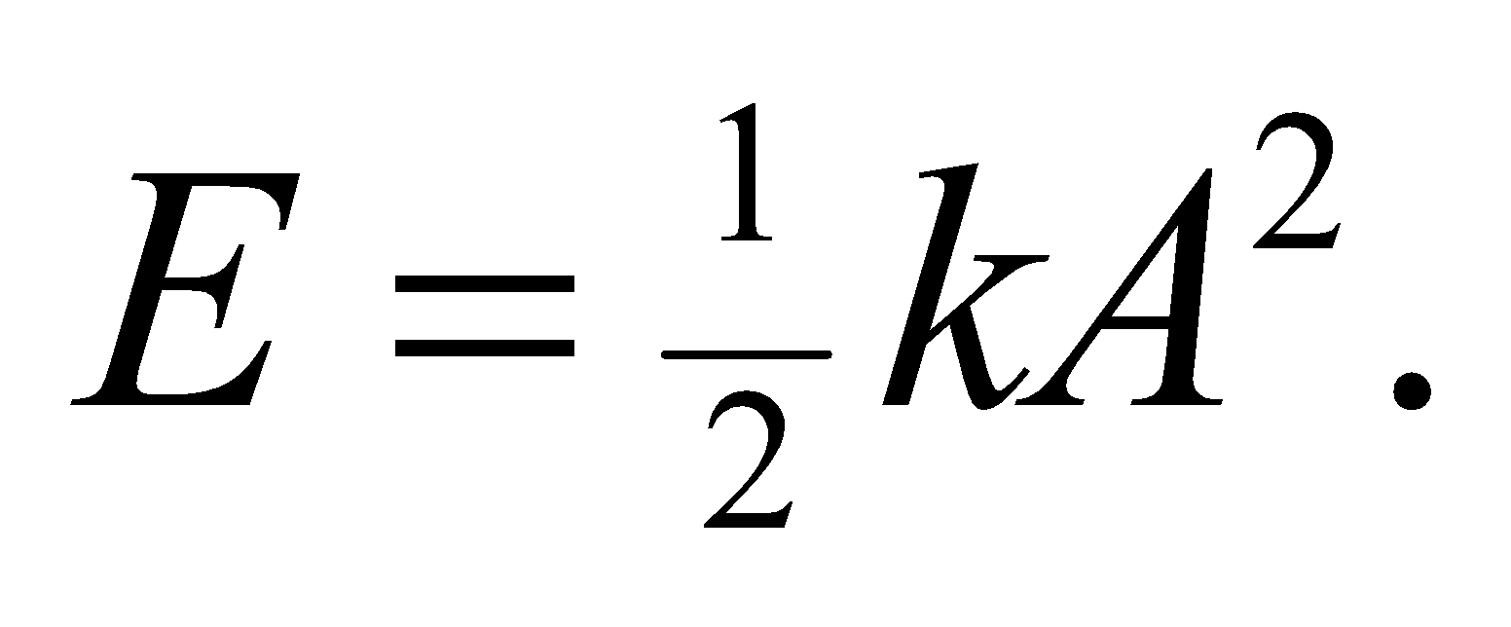 Using the energy of the first excited state, the amplitude of the above system is roughly:

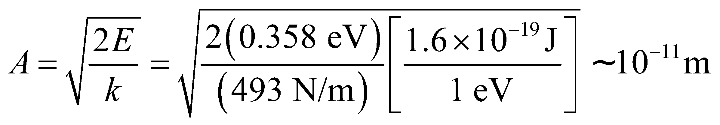

This is about an order of magnitude too small, but it gives an idea of the size of the HCl molecule.

**45. Interpret** This problem concerns a particle in a one-dimensional infinite square potential well. We are asked to find the probability that the particle will be found within a given ranged centered at two different points in the square well.

**Develop** As in Problem 42, the probability of finding the particle between *x*1 and *x*2 (where 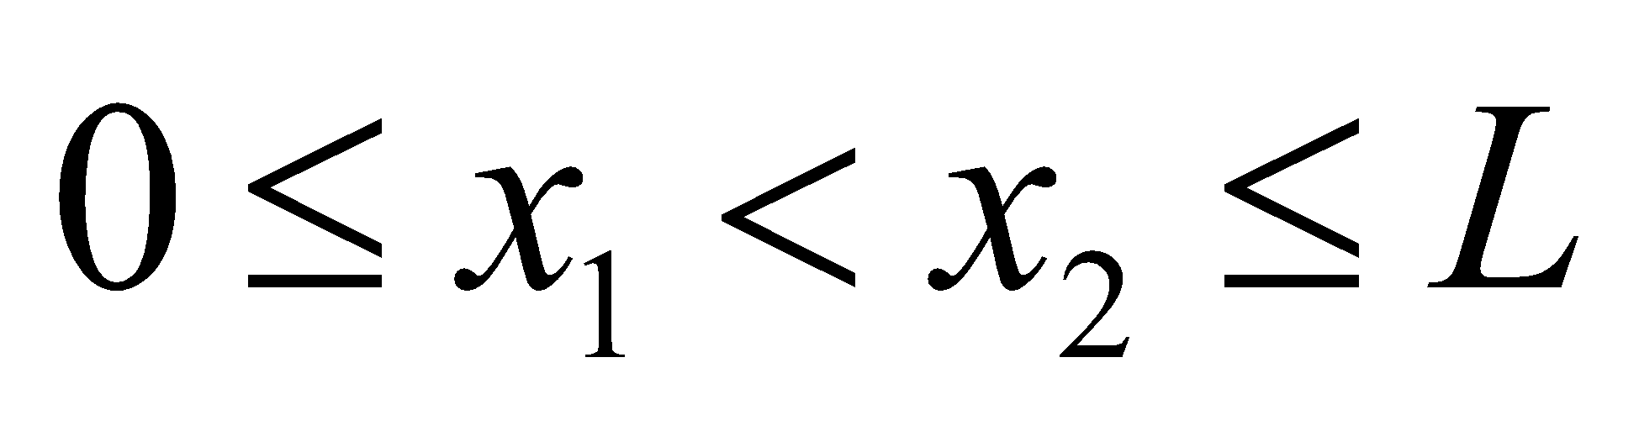) is

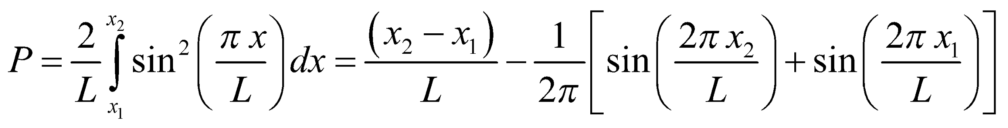

We shall evaluate this probability function for the two ranges given.

**Evaluate** (a) The probability *P* of finding the particle between *x*1 = 0.500*L* − 0.075*L* = 0.425*L* and *x*2 = 0.500*L* +0.075*L* = 0.575*L* is



(b) The probability *P* of finding the particle between *x*1 = 0.250*L* − 0.075*L* = 0.425*L* and *x*2 = 0.250*L* + 0.075*L* = 0.575*L* is



Assess The probability is greater for the particle to be found in the center of the well than near the edges, which is reasonable in view of the probability distribution function (see Figure 35.7).

**46. Interpret** We are to calculate the probability of finding a particle in the central quarter of an infinite square well for various energy states and compare our answers with the classical probability.

**Develop** From the discussion preceding Equation 35.5, we see that the wave function for the infinite square well is 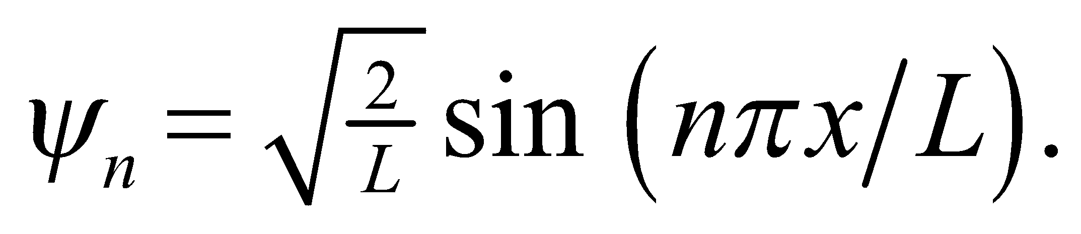 The region in which we are interested is the central fourth: 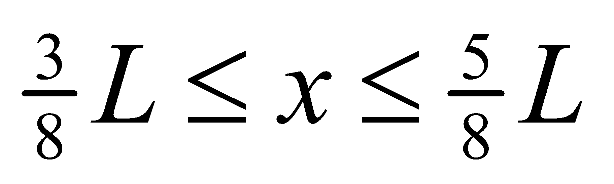. We will calculate the probability by integrating 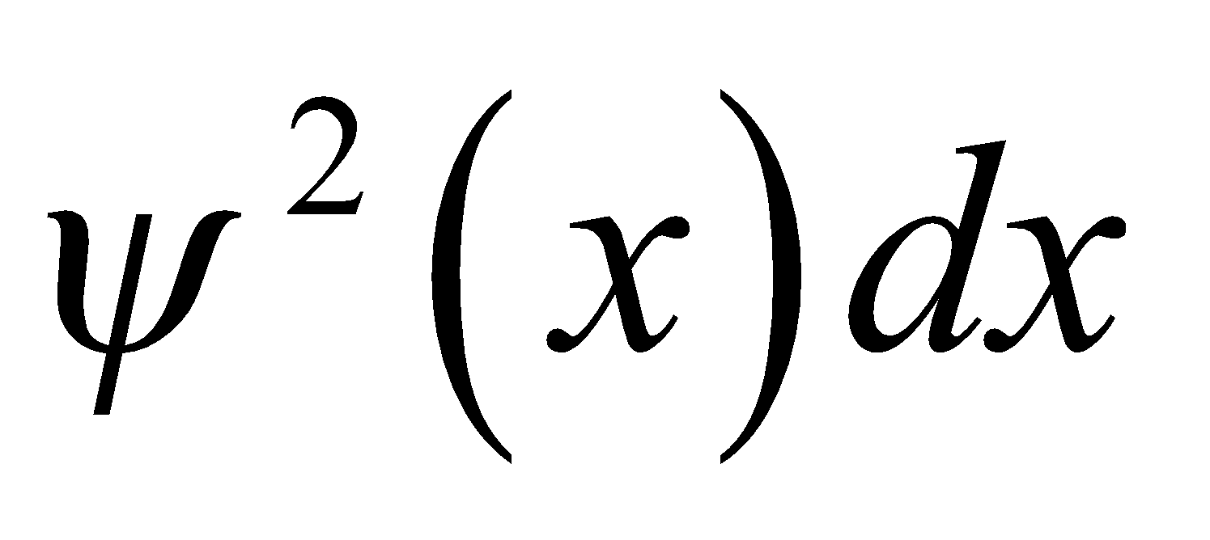 from *x* = 3*L*/8 to *x* = 5*L*/8.

**Evaluate** First, we find the general solution for any value of *n*:

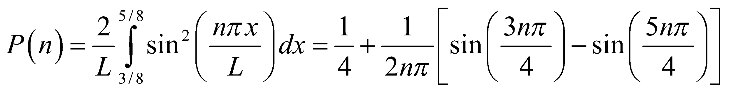

**(a)** 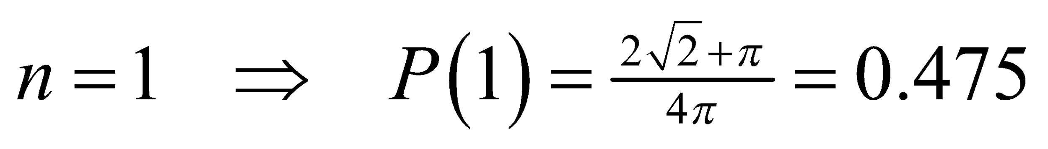

**(b)** 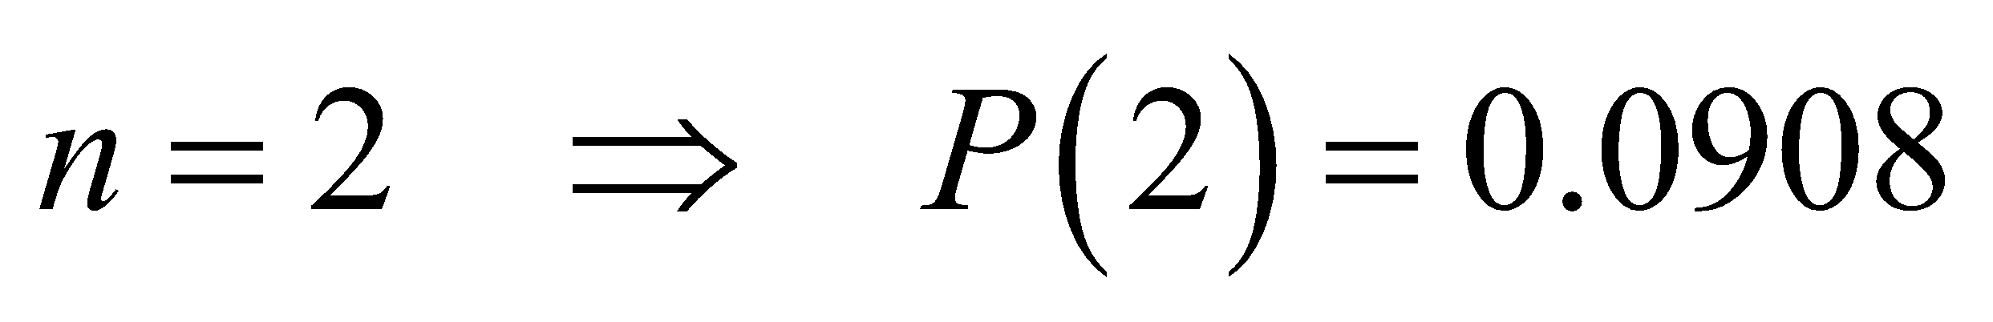

**(c)** 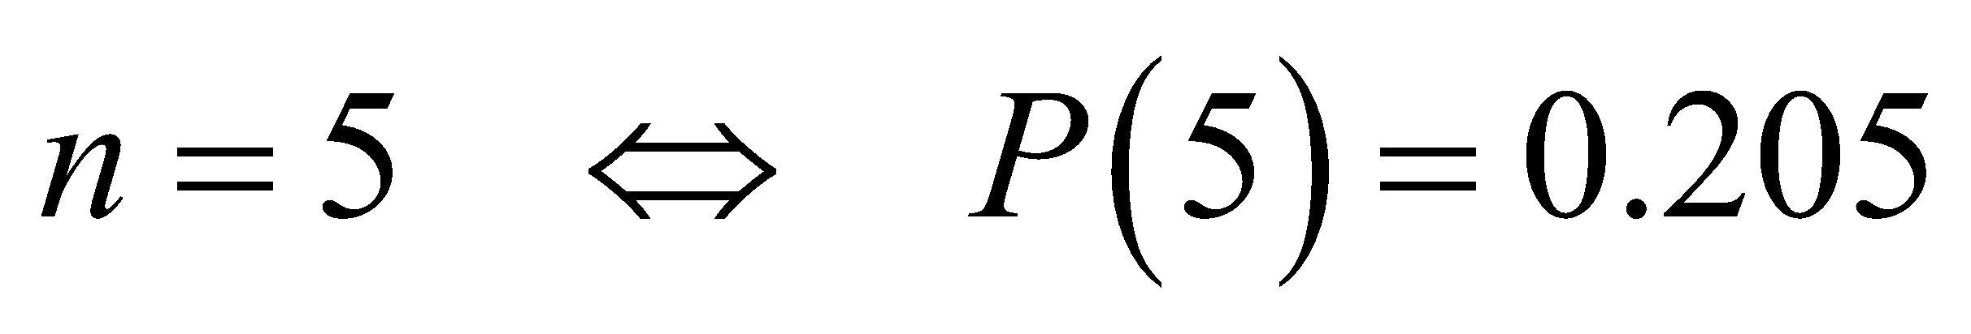

**(d)** 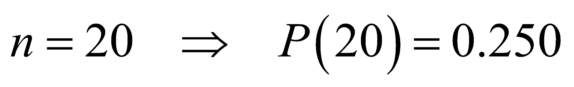

**(e)** The classical model predicts that the particle would be anywhere in the box with equal probability, so the total probability of being in the central ¼ of the box is 0.25.

**Assess** Note that as *n* becomes higher, the quantum probability becomes closer to the classical probability.

**47. Interpret** We are to show that the Schrödinger equation has nonzero solutions in classically forbidden regions where *E* < *U*.

**Develop** We are given solutions of the form 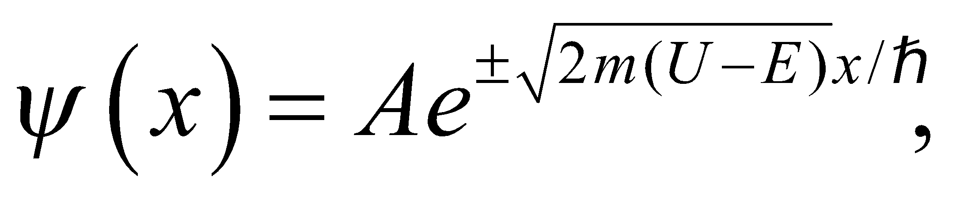 so all we need to do is substitute this wavefunction into the time-independent Schrödinger equation

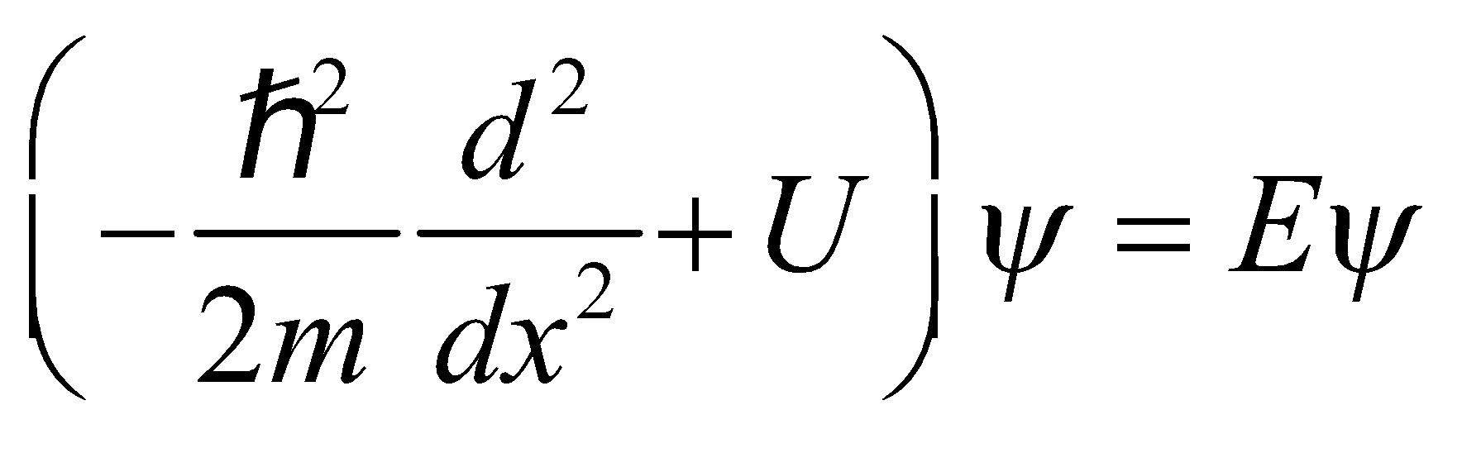

(see Section 35.3) and see if it fits.

**Evaluate** Inserting the trial solution into the Schrödinger equation gives

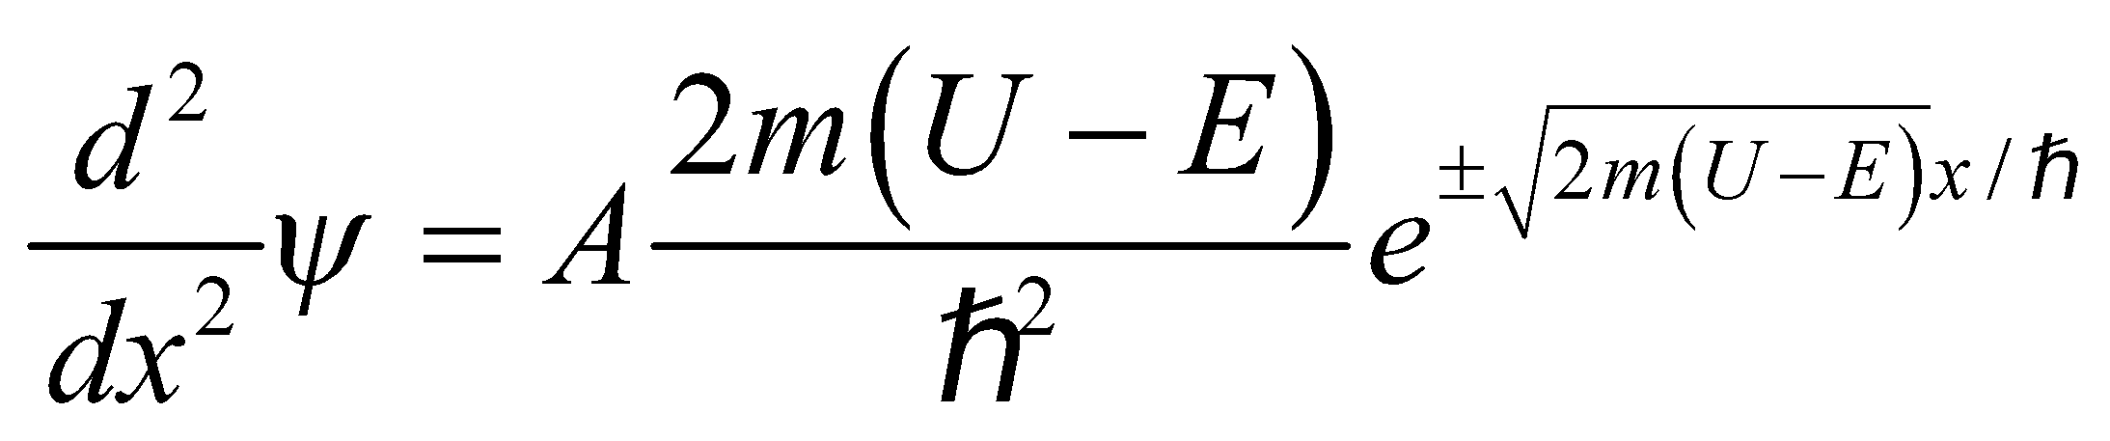

Substitute this into the time-independent Schrödinger equation:

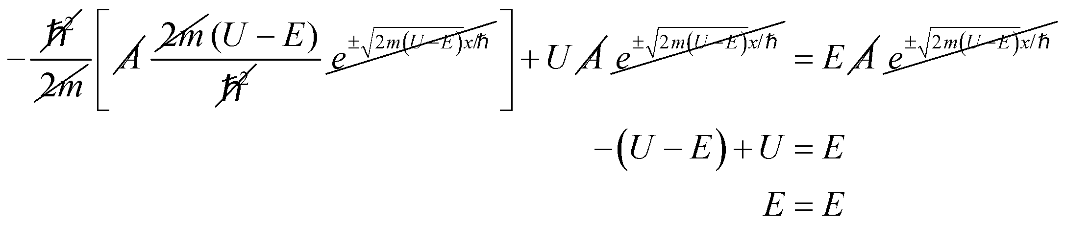

Thus, we have shown that the proposed solution is a valid solution for the time-independent Schrödinger equation.

**Assess** This form of 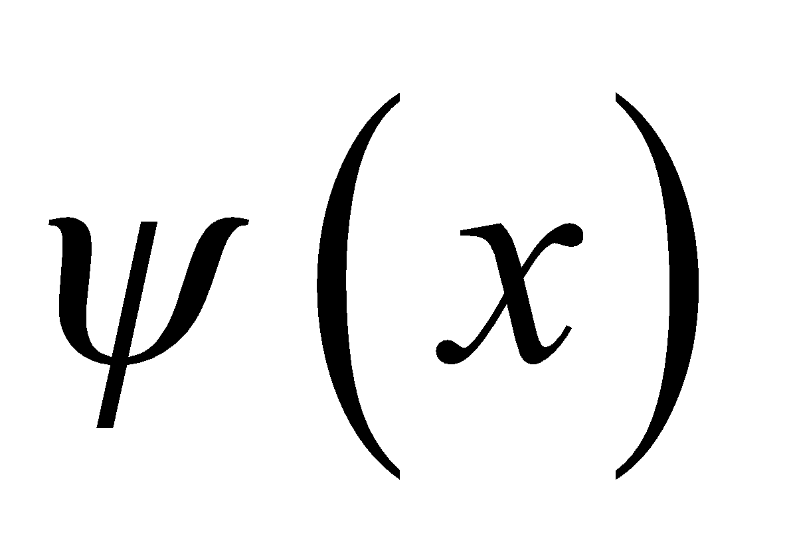 is a solution to the time-independent Schrödinger equation. Note that this form of solution is not “wave like”: it exponentially decays (or increases) instead of oscillating.

**48. Interpret** This problem involves quantum mechanics in a three-dimensional cubical box. We are to make an energy diagram and show the degeneracy of each level.

**Develop** The energy levels of a particle in a three-dimensional box are given by Equation 35.8:



The ground state corresponds to 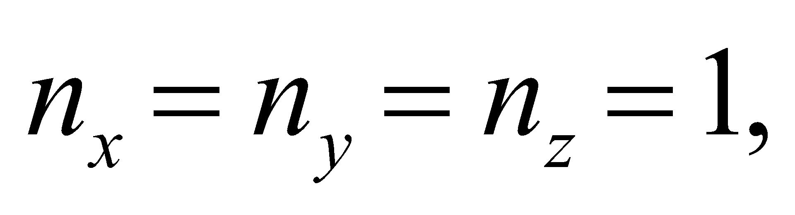 while the first excited state has one of the quantum numbers equal to 2 (e.g.,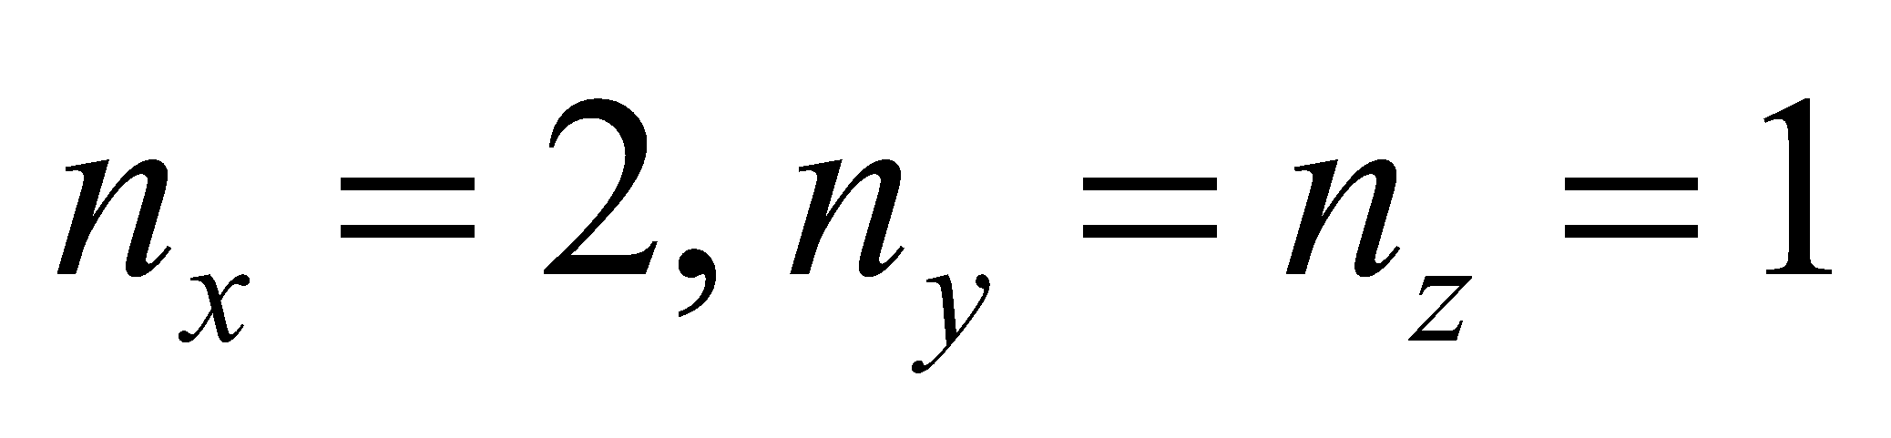).

**Evaluate** The quantum numbers, energy, and degeneracy of the first six levels in the three-dimensional infinite square well are summarized below:

| **Energy level** |  |  | **Degeneracy factor** |
| --- | --- | --- | --- |
| 1 | (1,1,1) | 3 | 1 |
| 2 | (2,1,1), (1,2,1), (1,1,2) | 6 | 3 |
| 3 | (2,2,1), (1,2,2), (2,1,2) | 9 | 3 |
| 4 | (3,1,1), (1,3,1), (1,1,3) | 11 | 3 |
| 5 | (2,2,2) | 12 | 1 |
| 6 | (1,2,3), (1,3,2), (2,1,3)  (2,3,1), (3,1,2), (3,2,1) | 14 | 6 |

The energy-level diagram looks similar to that shown in Fig. 35.6.

**Assess** In general, degeneracy arises from symmetry in the system. In our case, the symmetry is due to the fact that we have a cube with 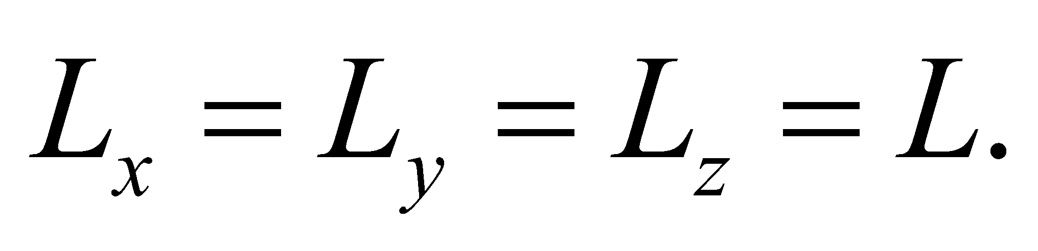

**49. Interpret** We are to verify that the given wave function is a solution to the three-dimensional Schrödinger equation and that the derived energy levels match those given by Equation 35.8.

**Develop** For the given wave function 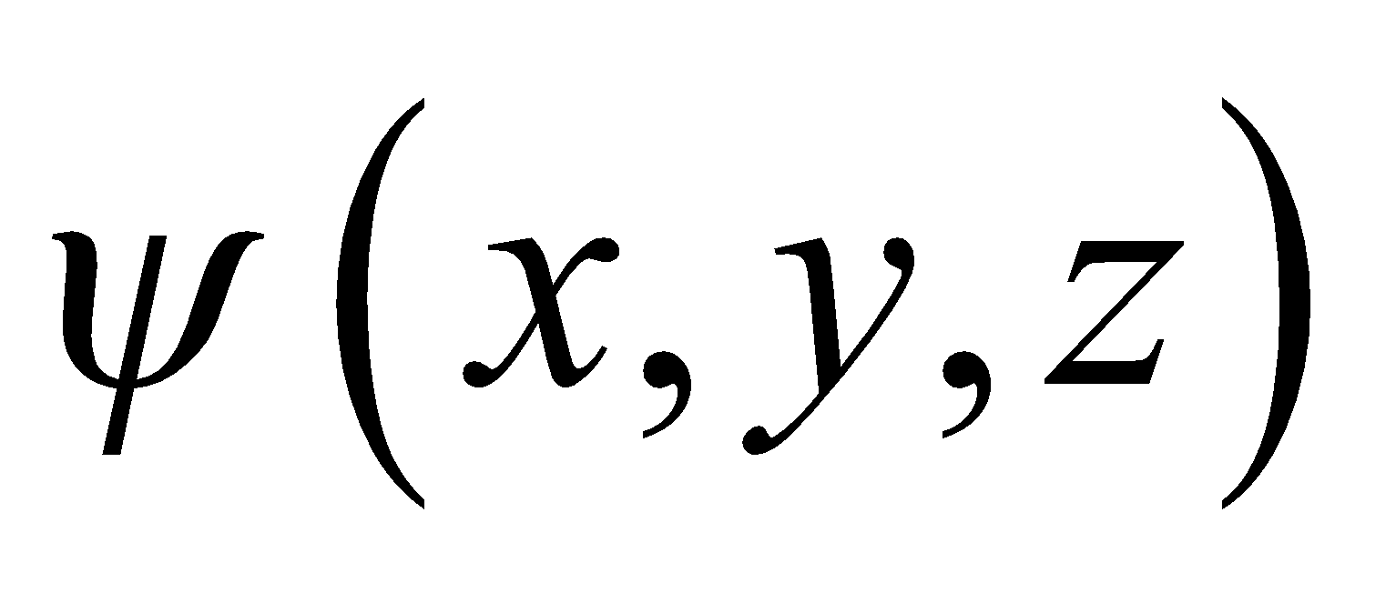 the second partial derivatives are

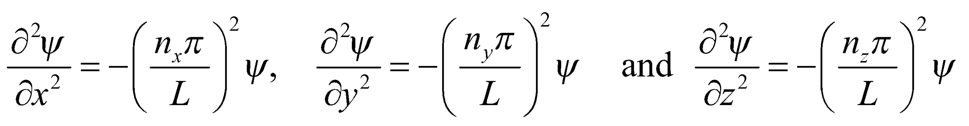

Substituting into the Schrödinger equation, with a potential for a cubical box (U = 0 inside and 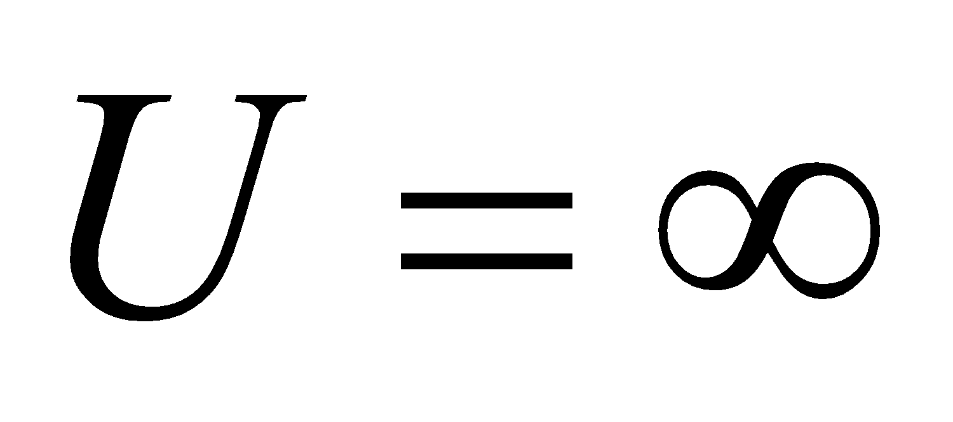 outside), we find

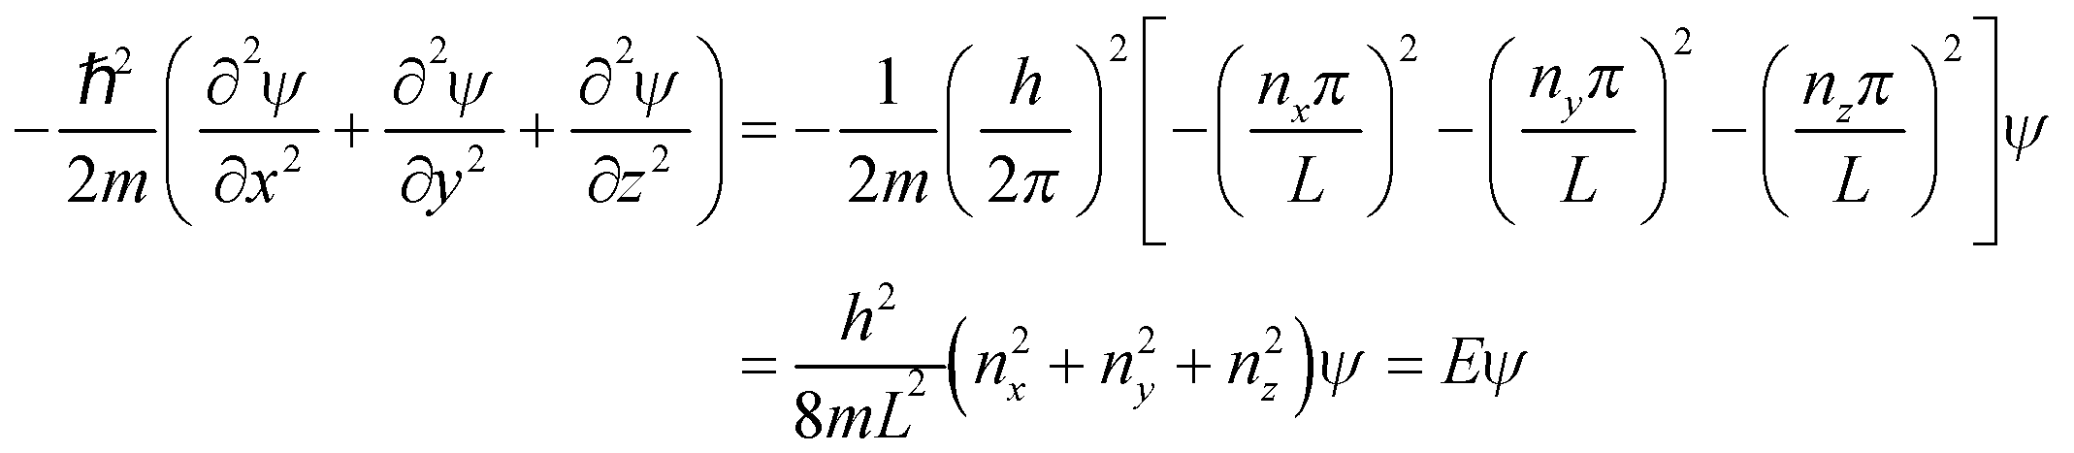

**Evaluate** The above derivation **(a)** demonstrates that  is a solution, and **(b)** shows that the energy levels match those given in Equation 35.8.

**Assess** This wave function also satisfies the boundary conditions appropriate for confinement  which are points where 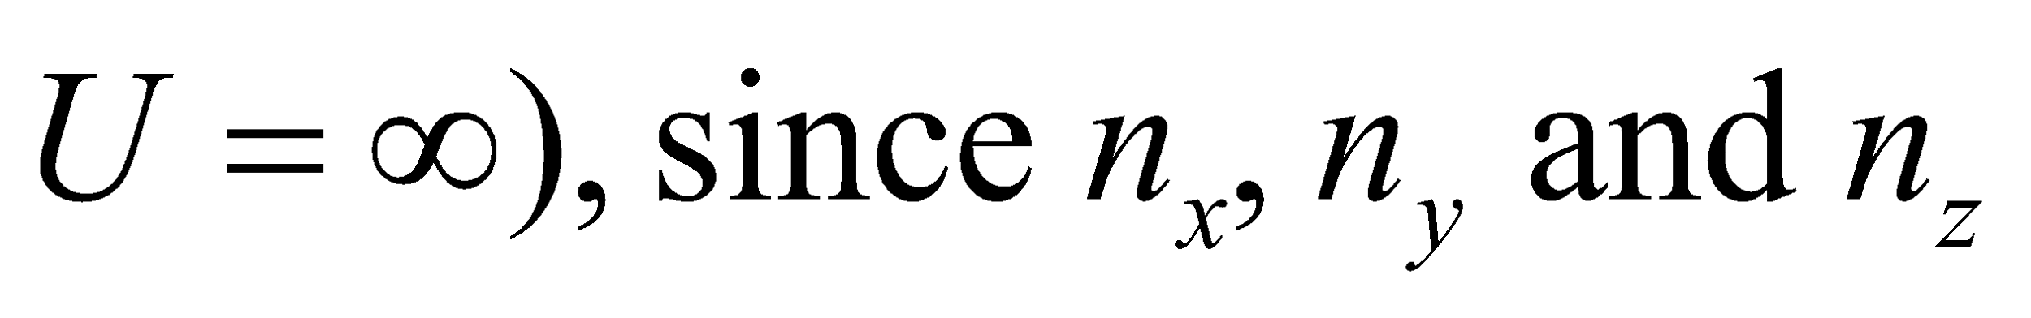 are integers.

**50. Interpret** We are given the number of photons per unit time that impinge upon an ensemble of electrons in quantum wells of the given size. Each photon is of sufficient energy to raise an electron to the first excited state, and we are to find the total number of electrons thus excited in a given time.

**Develop** The energy levels of a one-dimensional infinite quantum well are given by Equation 35.5, 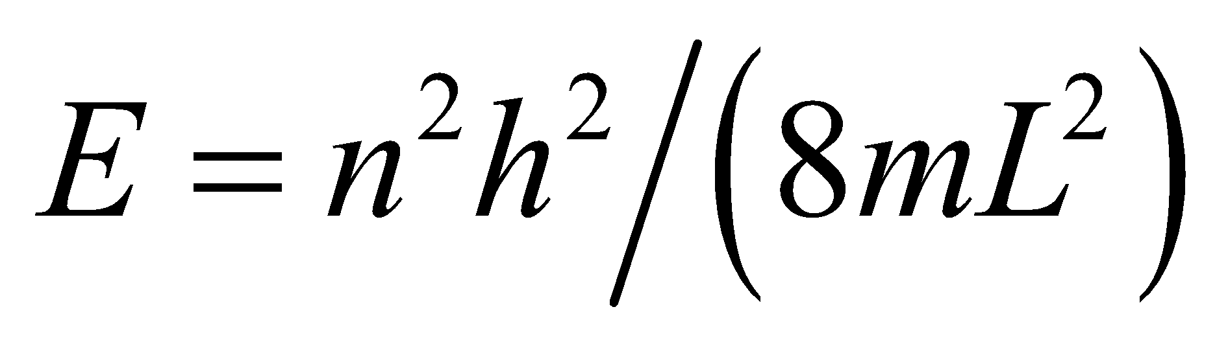. The ground state has *n* = 1 and the first excited state has *n* = 2, so the energy difference between the two is

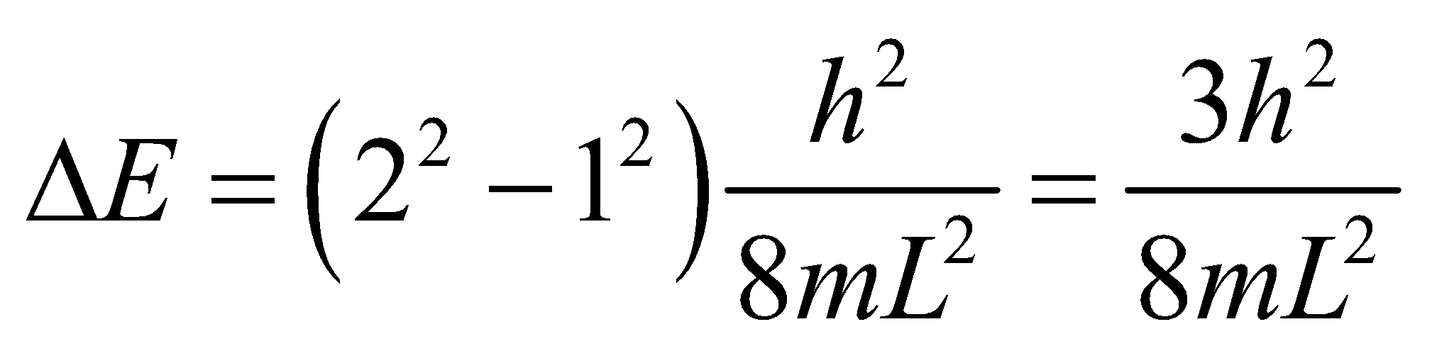

This is the energy required of the photon to excite an electron from the ground state to the first excited state. The average power in the light beam corresponds to a number of photons *N* per unit time of

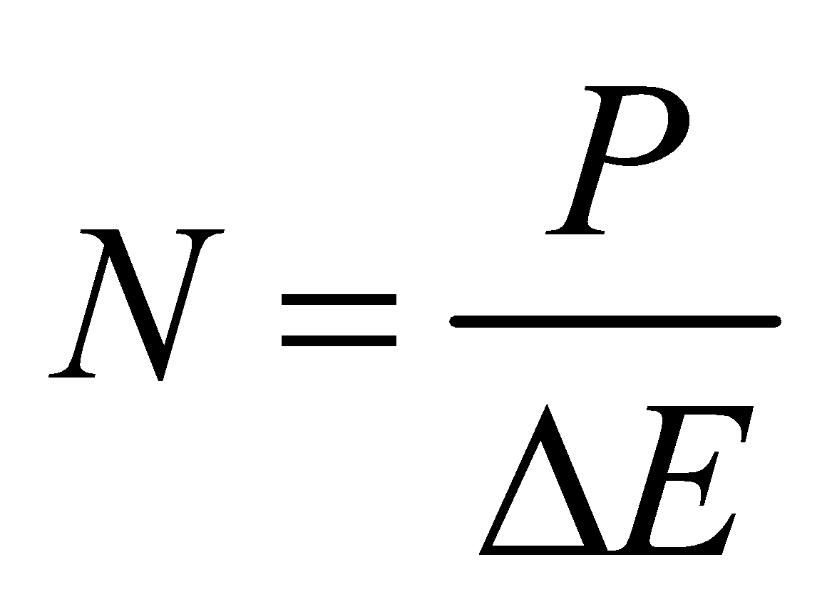

The number of electrons *Ne* excited to the first excited state in a time *Δt* is *Ne* = N*Δt*.

**Evaluate** Evaluating the expression for *Ne* gives



**Assess**  The ensemble contains many more electrons (i.e., 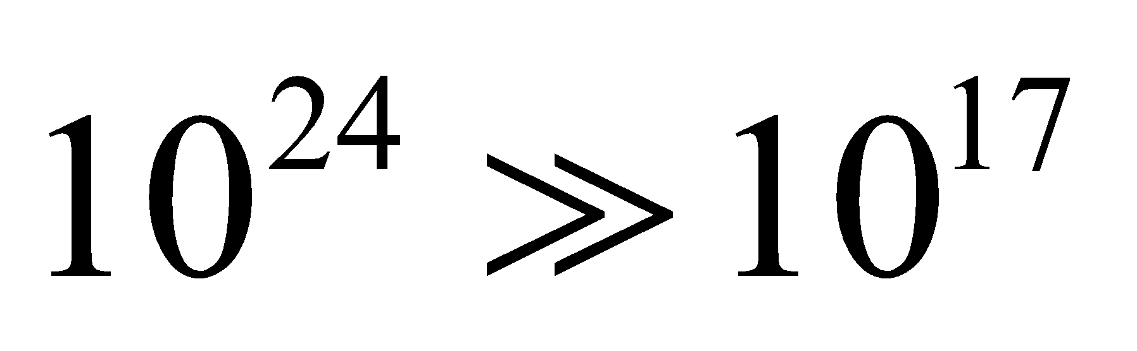) than are excited. Since the photon energy is insufficient to excite transitions other than the first transition, the result we found is also the maximum number of electrons that can be excited.

**51. Interpret** When transitioning to lower states, electrons emit photons to release energy. We are interested in all the visible photon wavelengths associated with all possible electronic transitions in the given quantum well.

**Develop** The energy levels for an infinite square potential well are given by Equation 35.5:



Thus, the energy of the photon emitted when the electron drops from initial state *n*i to final state *n*f < *n*i is



The possible photon wavelengths are

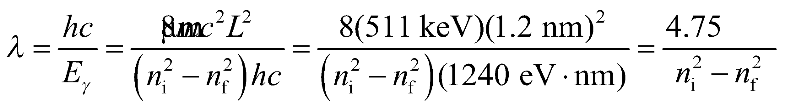

**Evaluate** **(a)** Visible photons fall within the wavelength range  or



There are four transitions satisfying this condition: 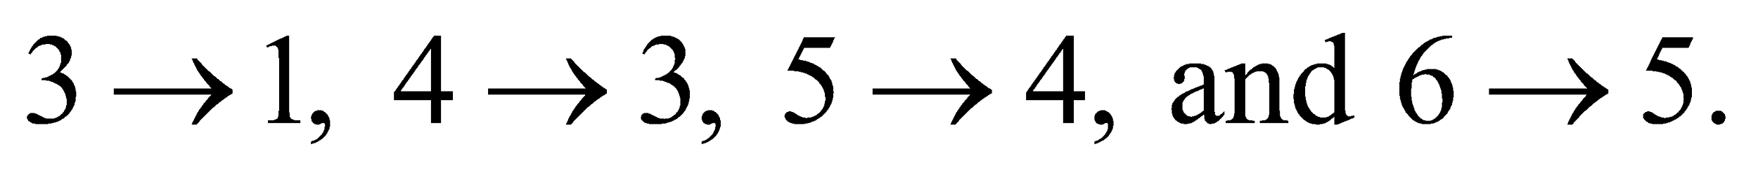

**Assess** Since energy is quantized, only photons with wavelengths that satisfy the above condition will be emitted during the transitions.

**52. Interpret** Since this is a question about probability, we analyze 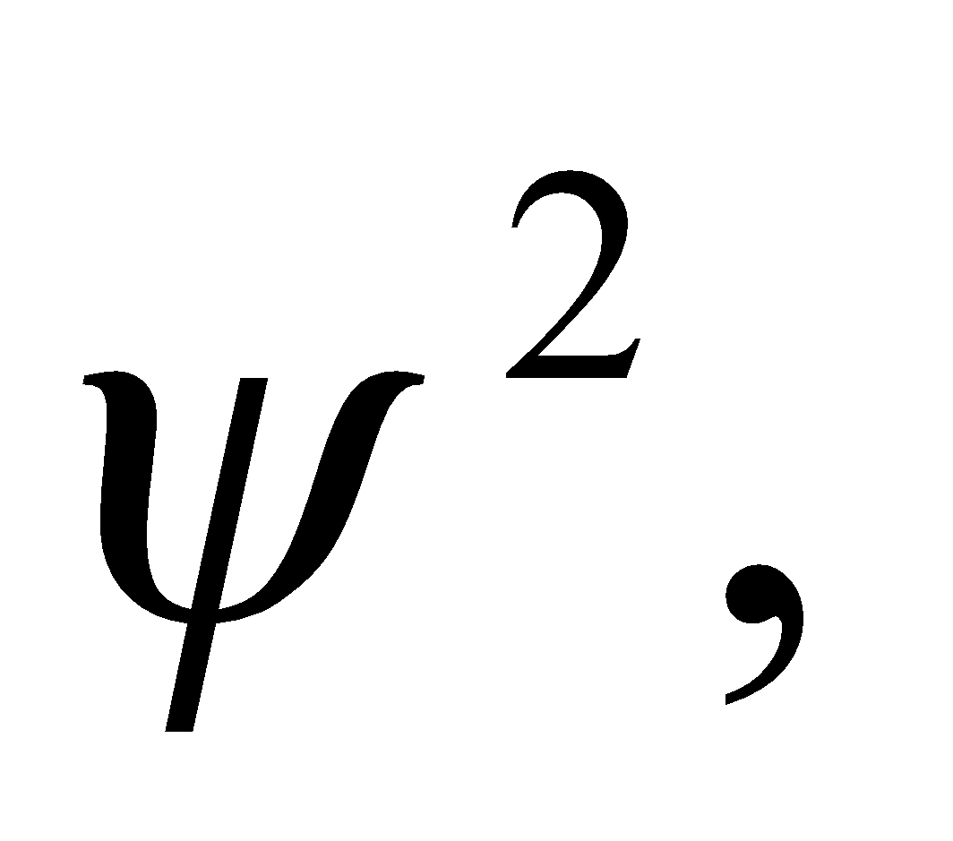 which represents the probability density. The result here is a generalization of that in Example 35.1.

**Develop** The wave function for the *n*th quantum state of a square potential is given in Equation 35.6:

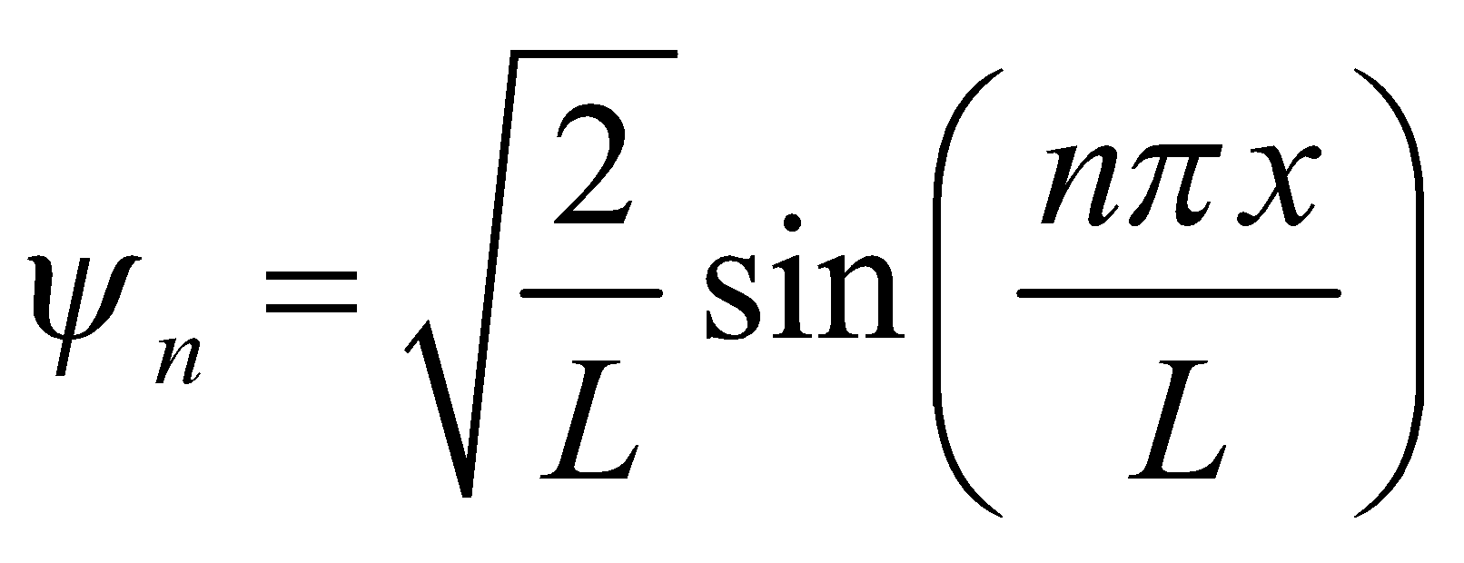

To find the probability that a particle will be found in the left-hand quarter of the well, we square the wave function and integrate from 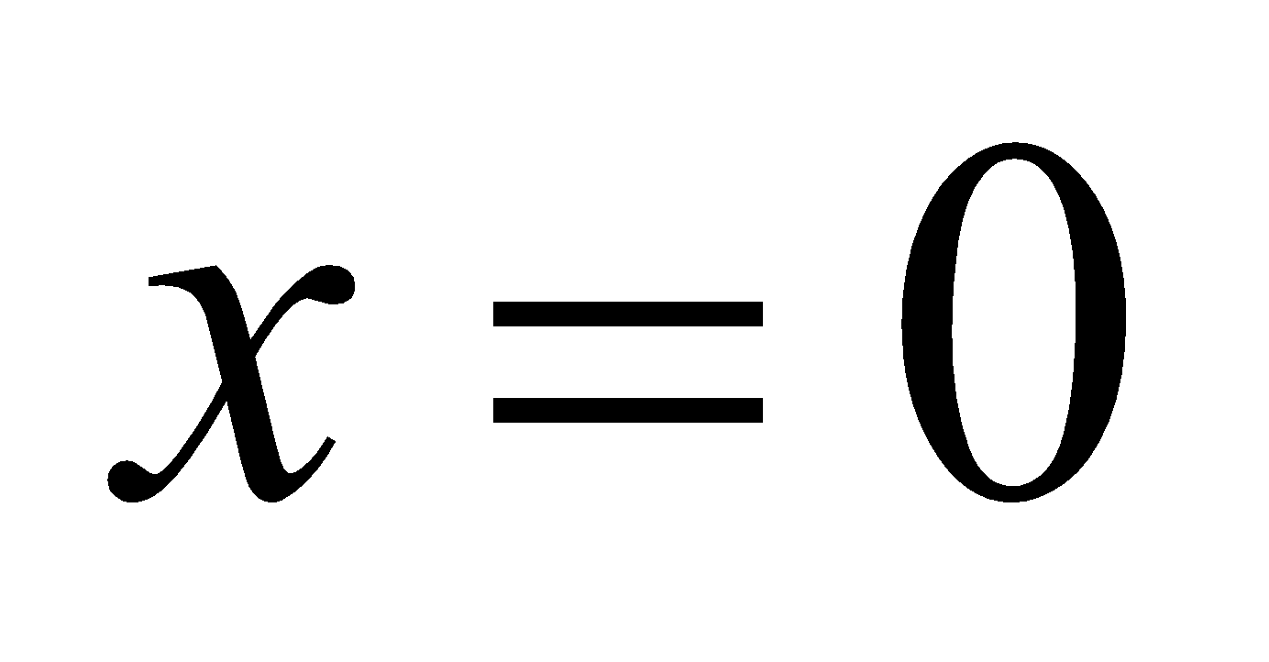 to 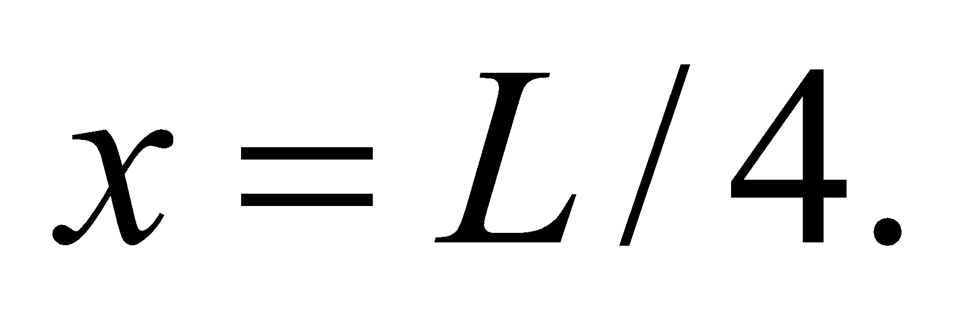

**Evaluate**  (a) We use the integral for the sin2-function from Appendix A to solve for the probability:

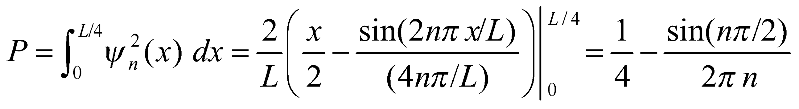

(b) If *n* is odd, then 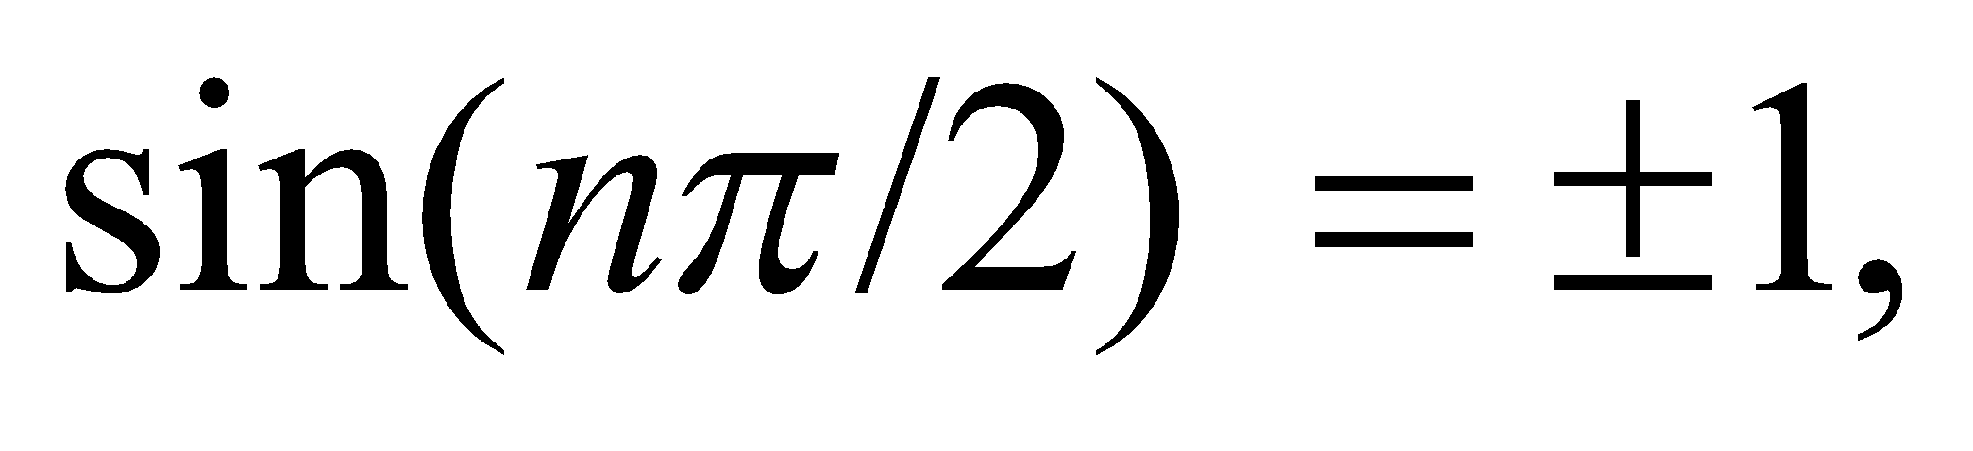 and the probability reduces to:

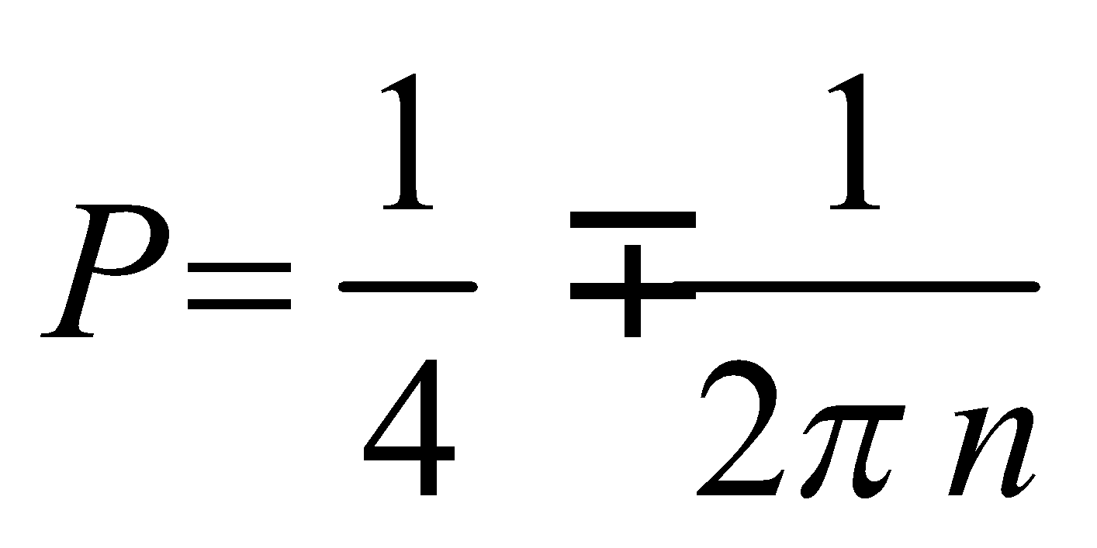

As 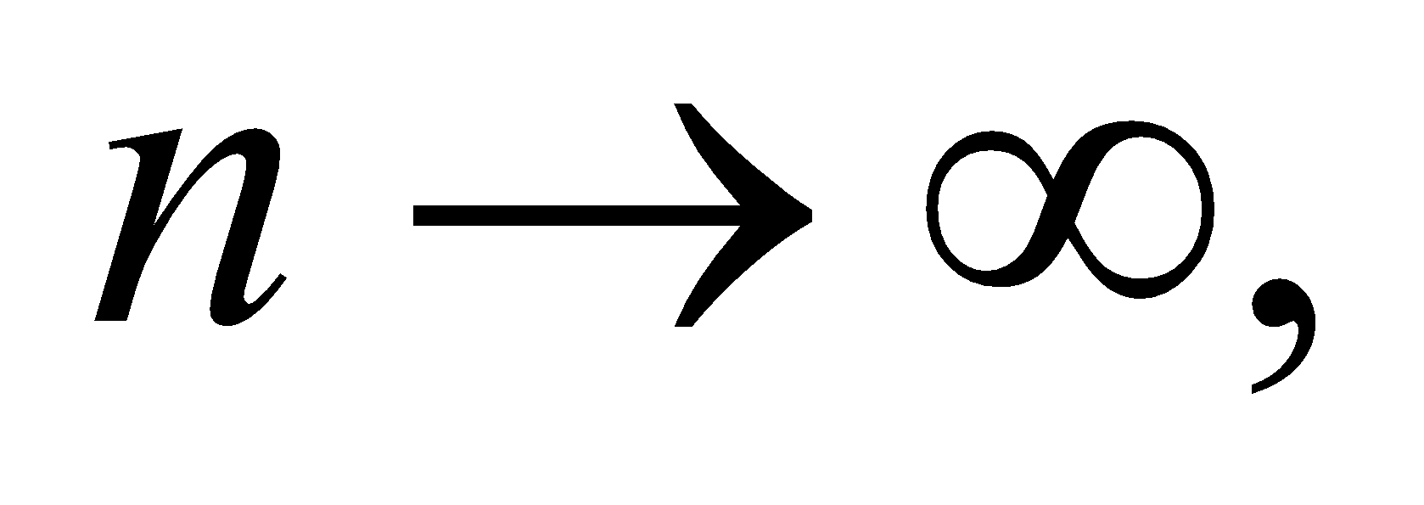the second term disappears, and the probability approaches ¼. Notice that the probability is exactly equal to ¼ when *n* is any even integer.

**Assess** The classical case can be thought of as a ping-pong ball in a box. If you shake the box randomly, the probability that the ball is in the left-hand quarter is 25%.

**53. Interpret** You're asked to develop the Schrödinger equation and the ground state wave function for the simple harmonic oscillator.

**Develop** You start with the time-independent Schrödinger equation:



**Evaluate** (a) Plugging in the potential energy of a harmonic oscillator, you arrive at

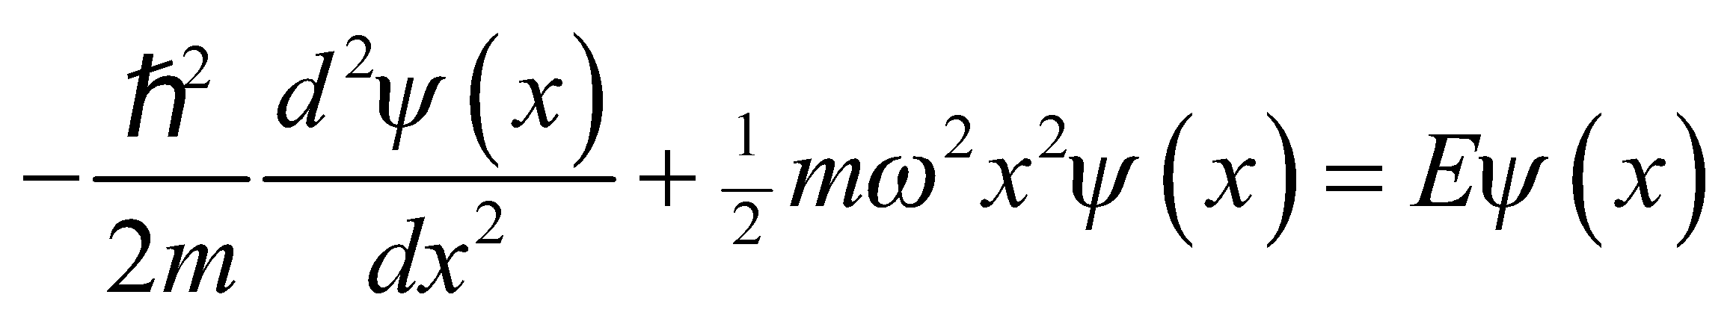

(b) For 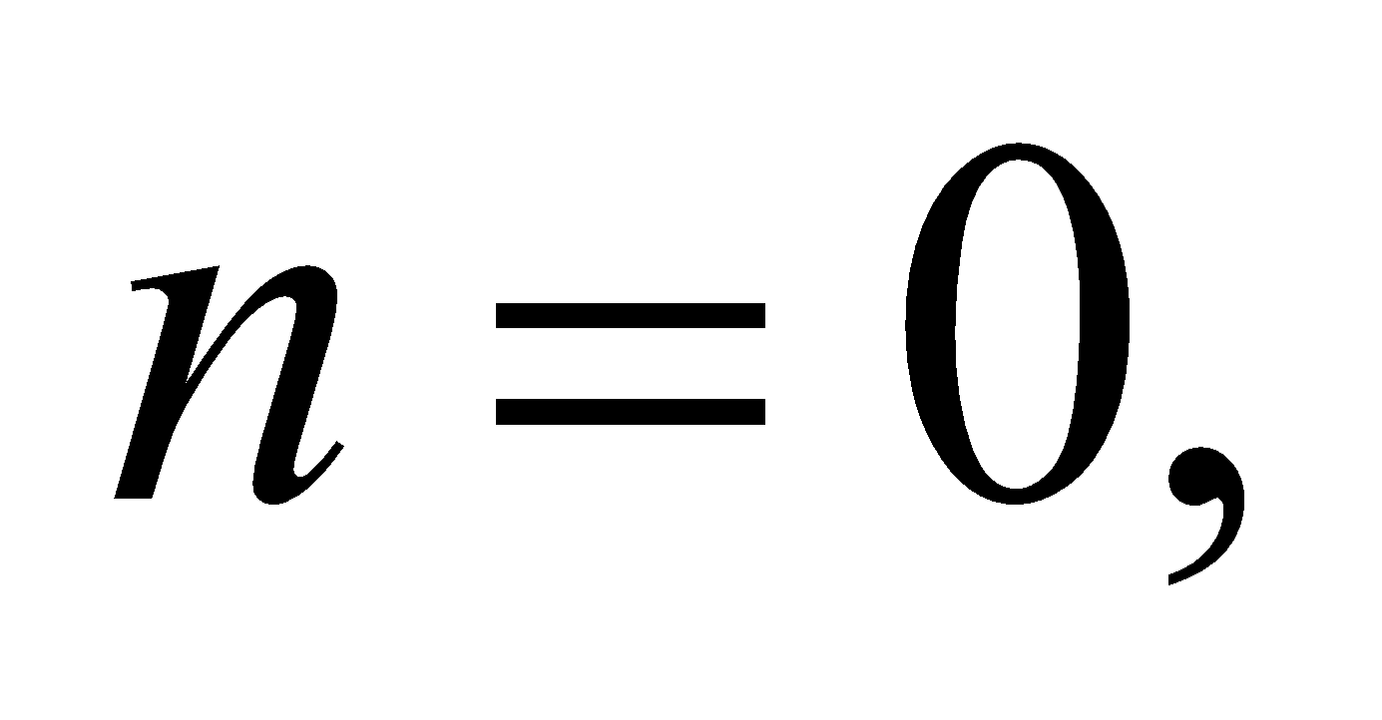the energy is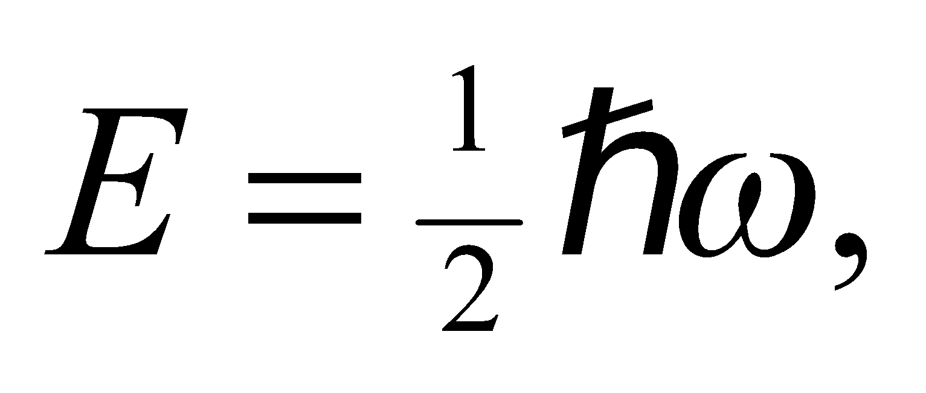 and the Schrödinger equation reduces to:

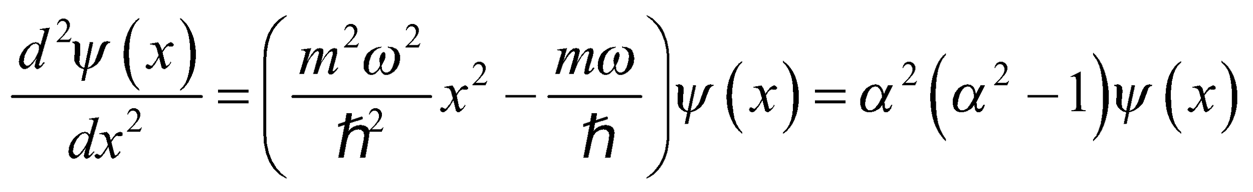

where 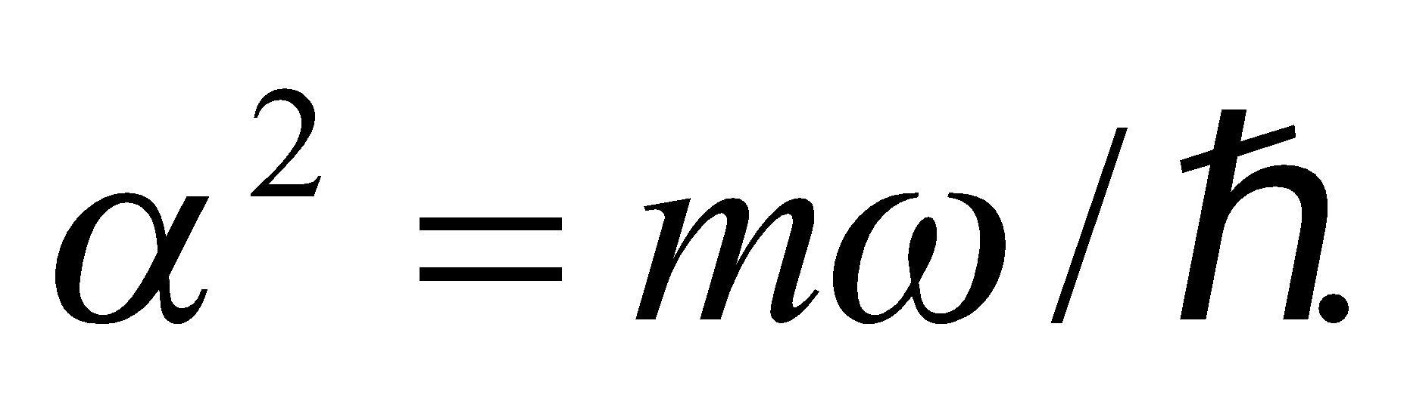If 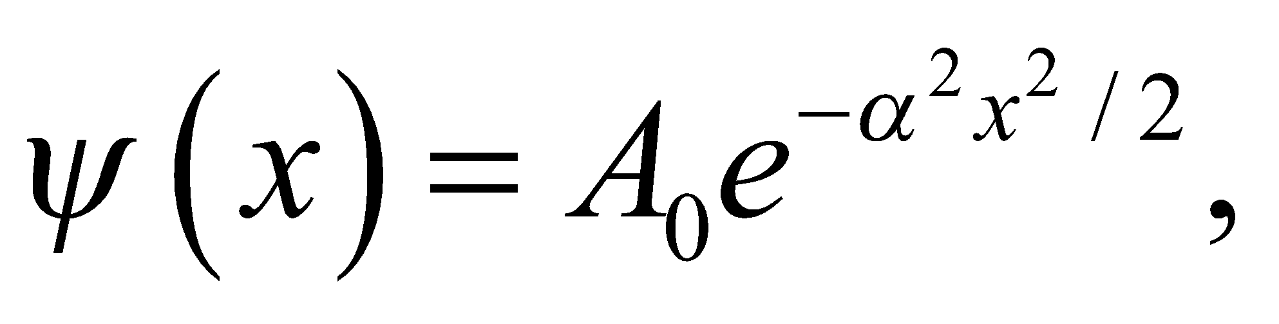then the first derivative is 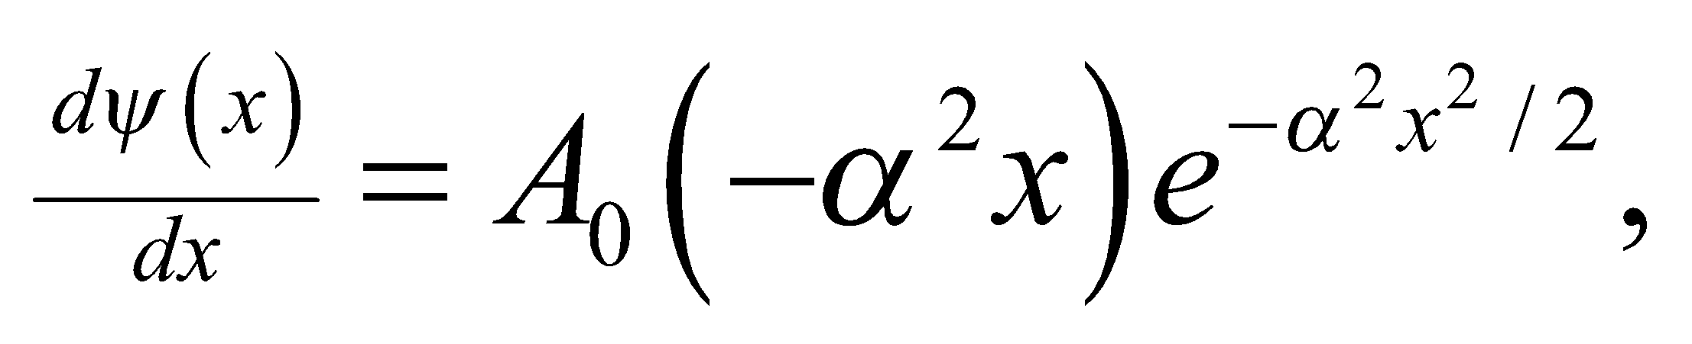and the second derivative is

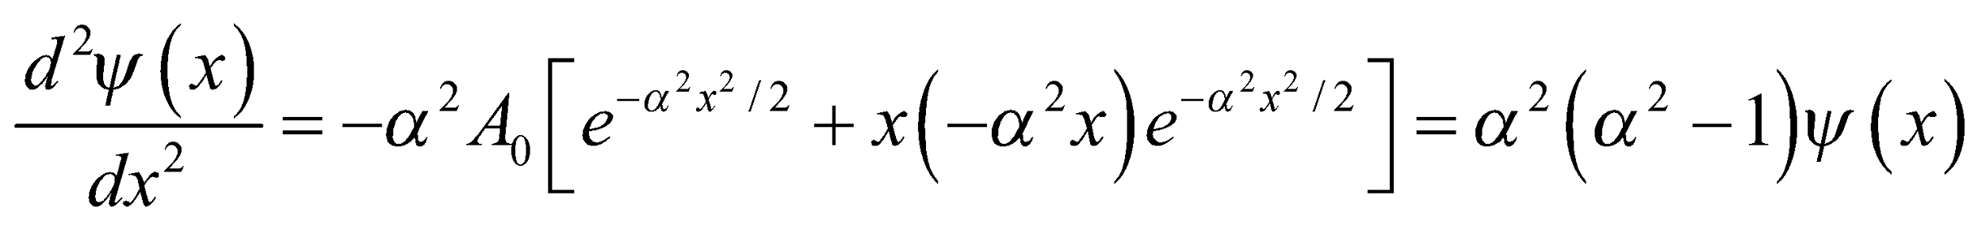

This proves that 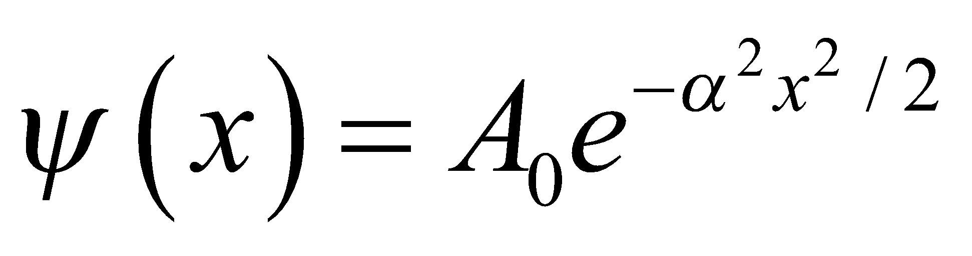is a solution to the ground state.

(c) To find the normalization constant, we use the normalization condition (Equation 35.3):

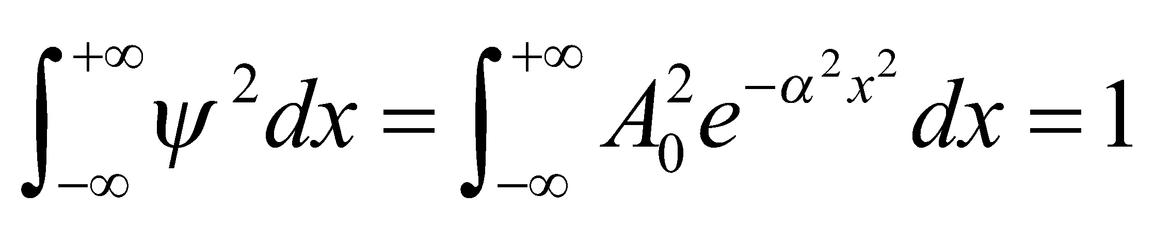

The integral is a Gaussian. One can find the value in an integral table, but we will give a short derivation here. We first define 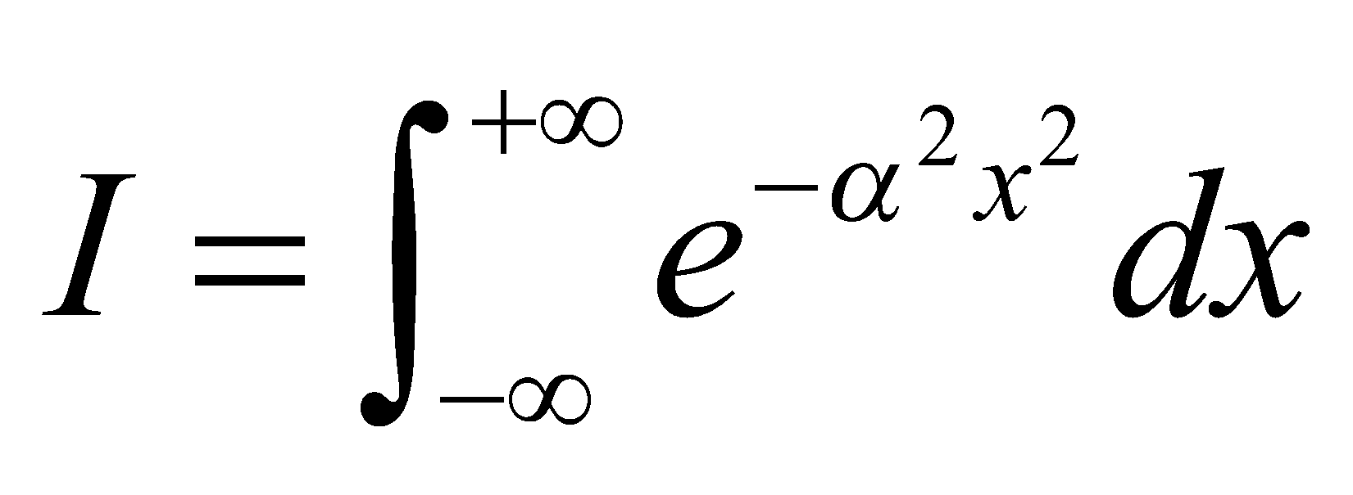and then square both sides. We combine the right-hand side into a single exponent and then change to polar coordinates, which puts the integral into a more solvable form:

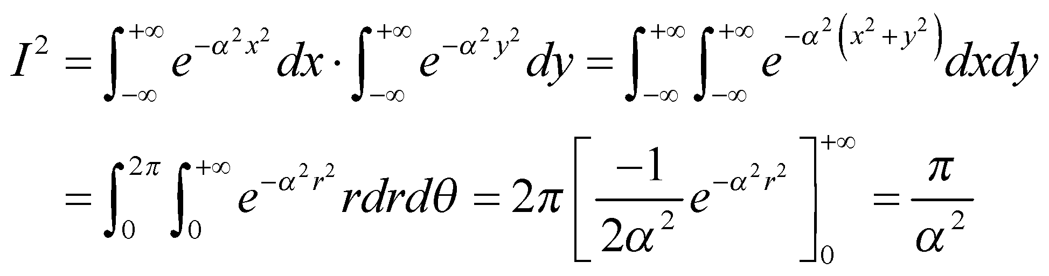

Therefore, 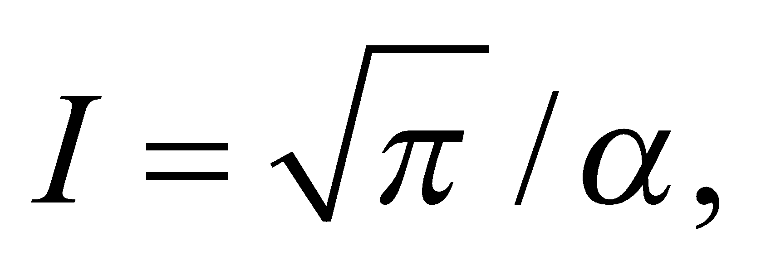 and the normalization constant must be 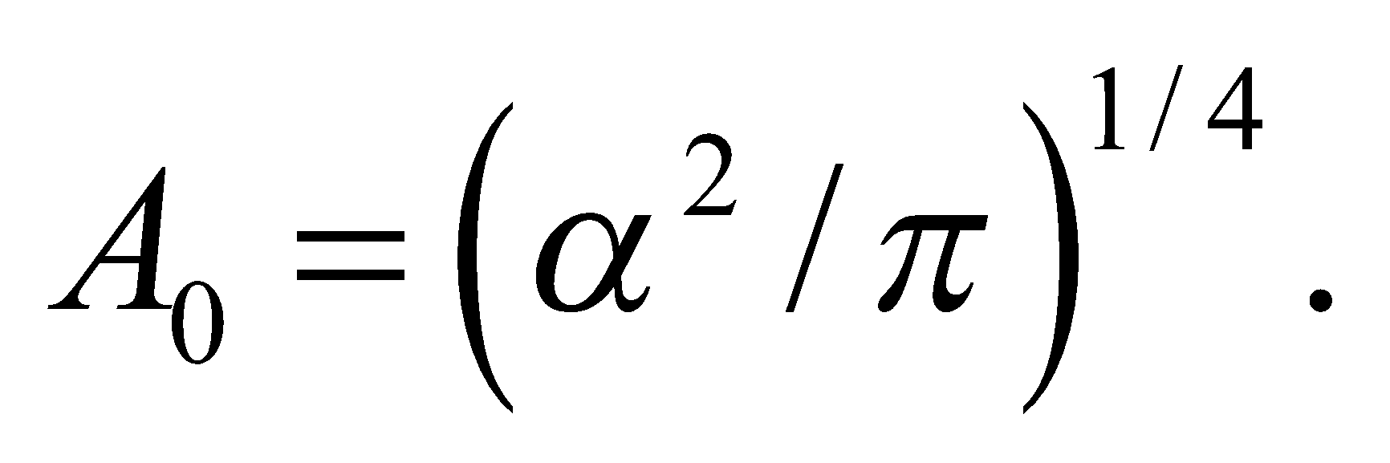 In summary, the normalized ground state wave function of the simple harmonic oscillator is

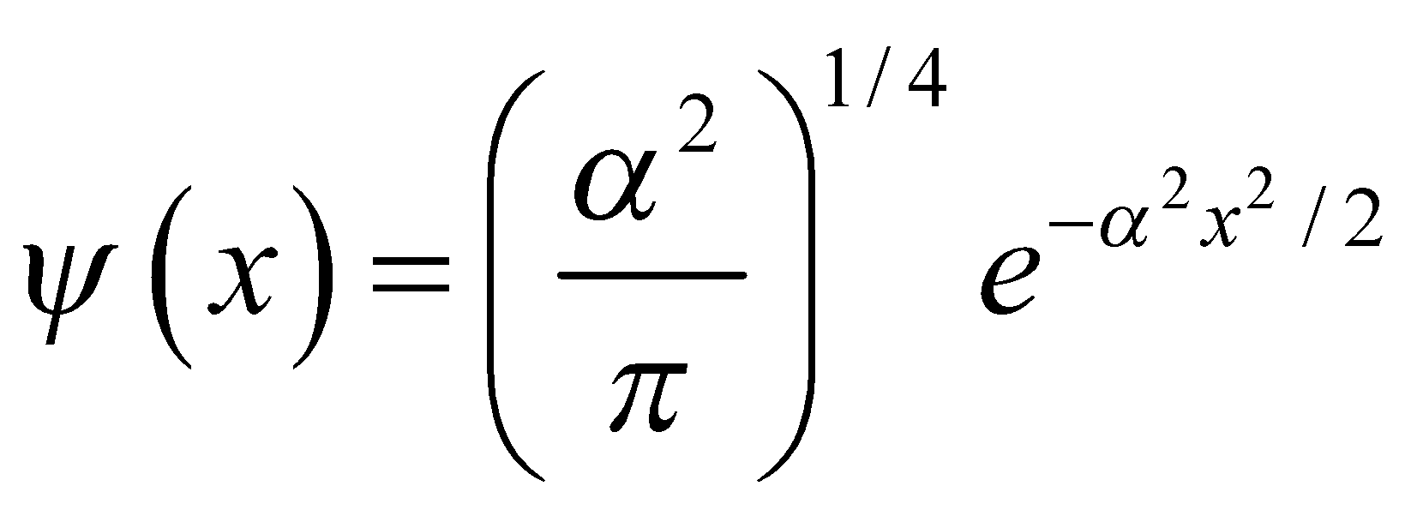

**Assess** The probability density for the ground state is a Gaussian, or "bell curve," as depicted in Figure 35.11a.

**54. Interpret** You want to show why fuel for a nuclear reactor is more concentrated in energy than traditional fuels that burn through chemical reactions.

**Develop** To make a rough comparison of the potential energy in nuclear and chemical or atomic physics, you model both the nucleus and the atom as square potentials, confining a proton and an electron in their respective cases. The ground state energy will be inversely proportional to the mass of the confined particle and the square of the potential's width: 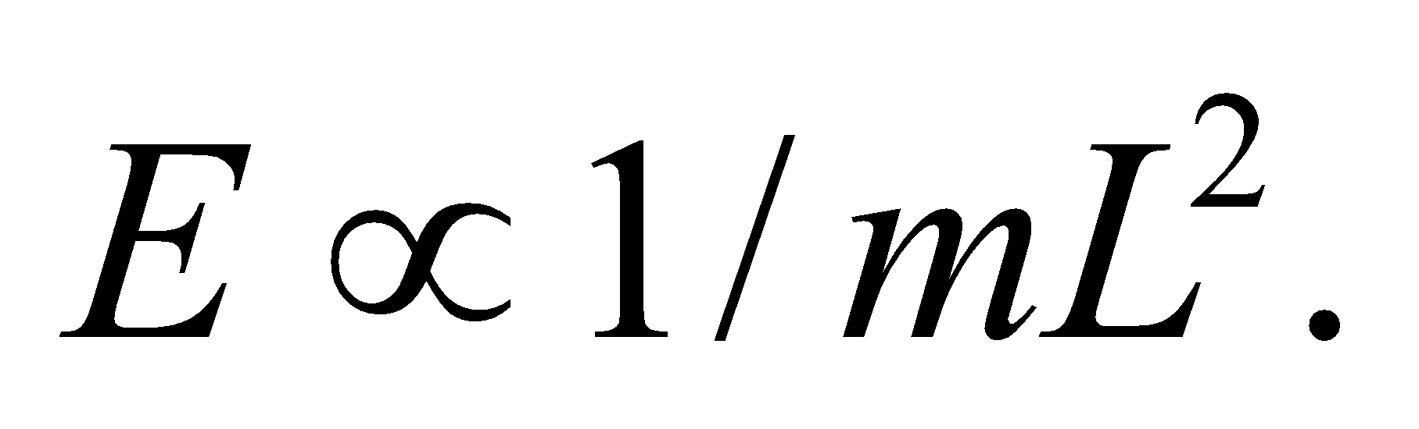

**Evaluate** Using the simplified model above, the ratio of nuclear energy to chemical energy is

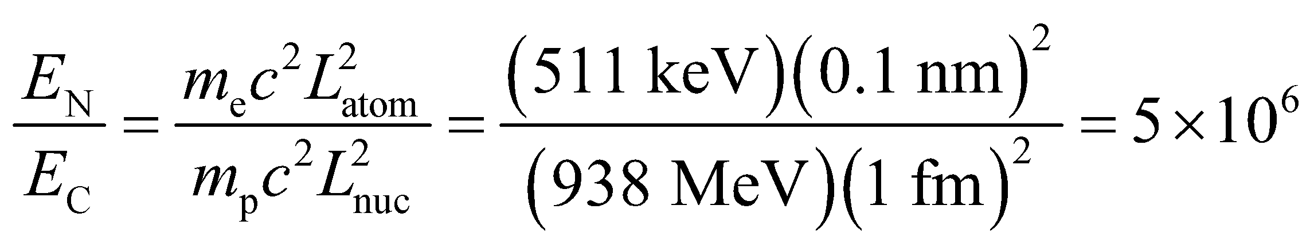

**Assess** This says that there is a million times more energy in the nucleus of an atom than in its electrons. This sounds about right, since a kilogram of pure uranium-235 contains 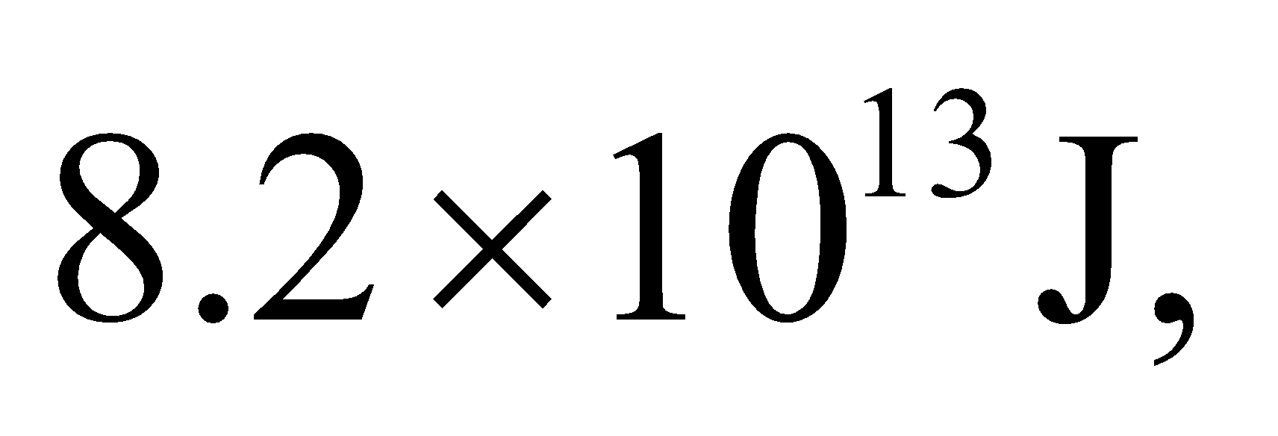 whereas a kilogram of gasoline has 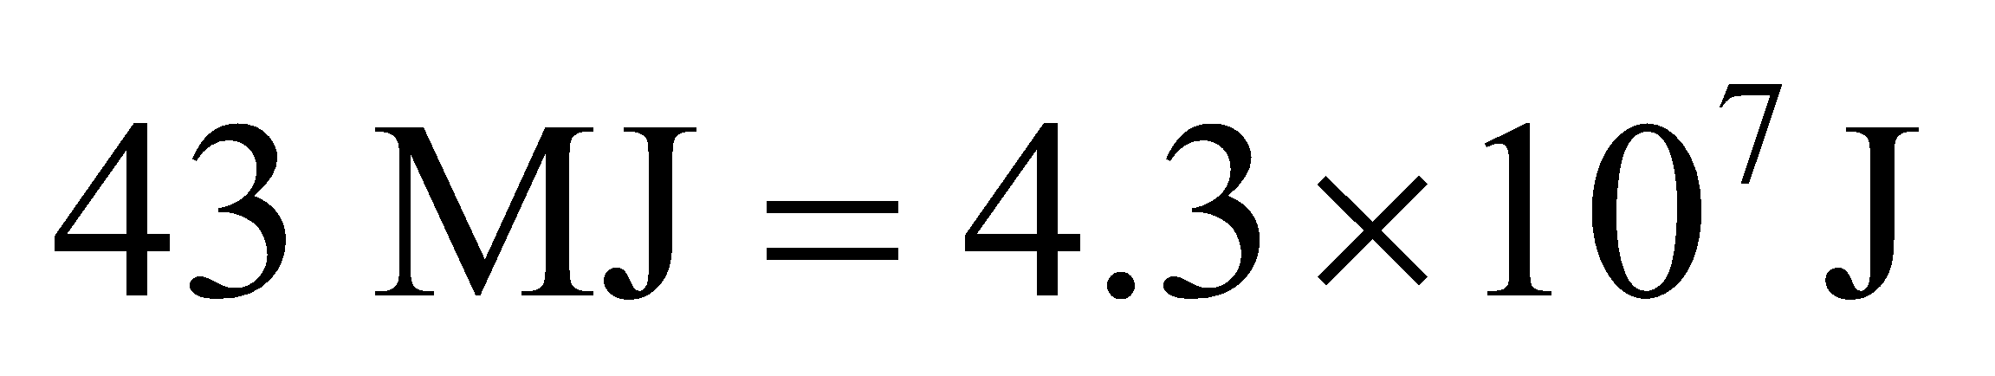 (see Appendix C).

**55. Interpret** We evaluate the energy levels of a quantum dot.

**Develop** A quantum dot is basically a three-dimensional square well. If we assume the qdot is a cube, the energy levels are given by Equation 35.8:



**Evaluate** The ground state has 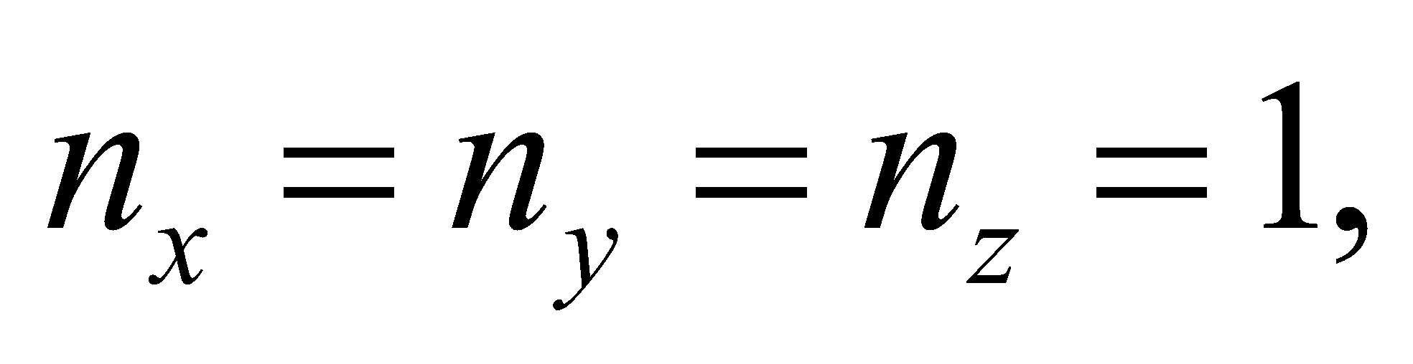whereas the first excited state has one of the *n*'s equal to 2. The energy difference between the two states is

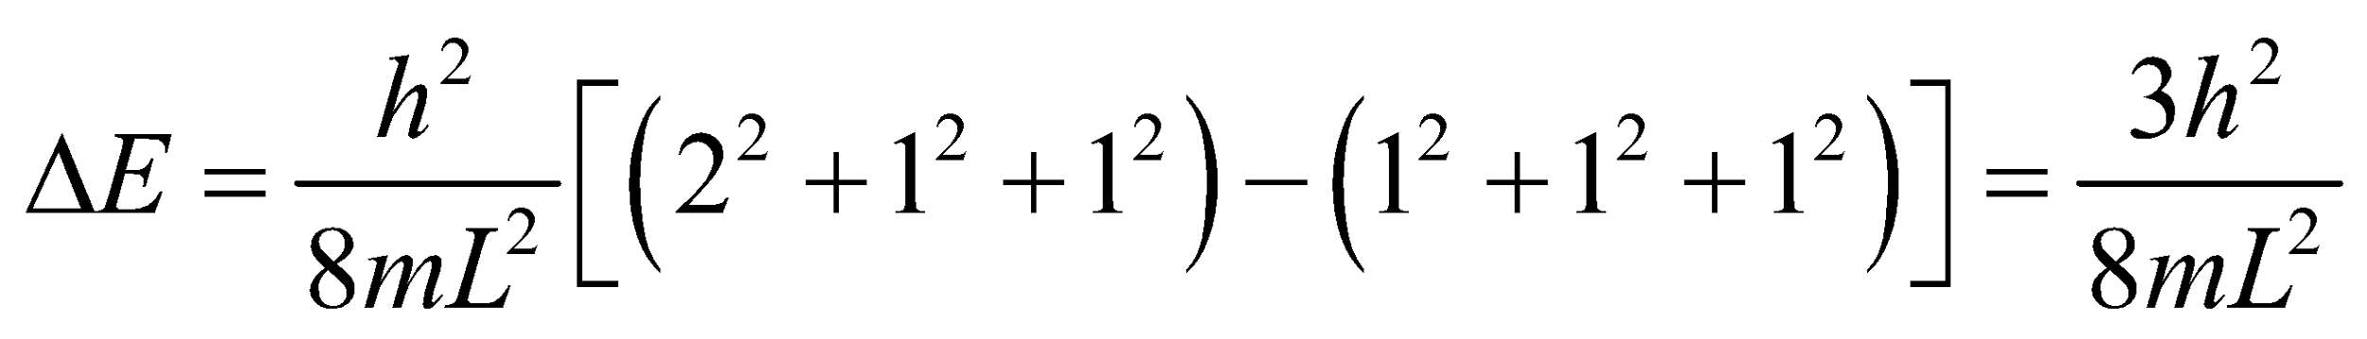

If the qdot decreases in size, the energy difference increases. The photon emitted when the qdot drops to its ground state will, therefore, have a smaller wavelength, since

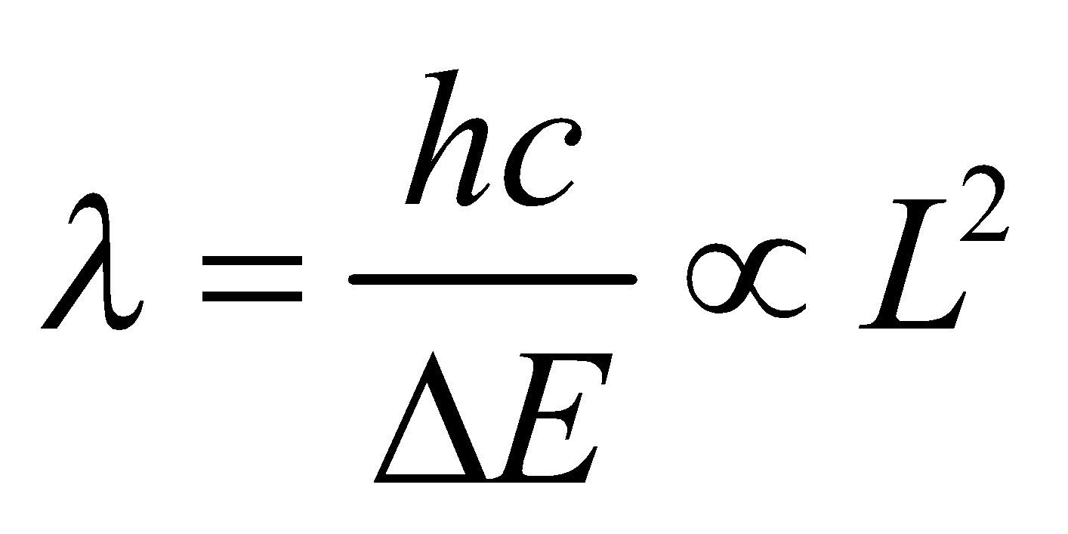

The answer is (b).

**Assess** The advantage of qdots is that they are like tunable atoms. You can essentially choose the wavelength at which it absorbs or emits by simply adjusting its size.

**56. Interpret** We evaluate the energy levels of a quantum dot.

**Develop** As was mentioned in the previous problem, a cubically symmetric qdot has a ground state given by 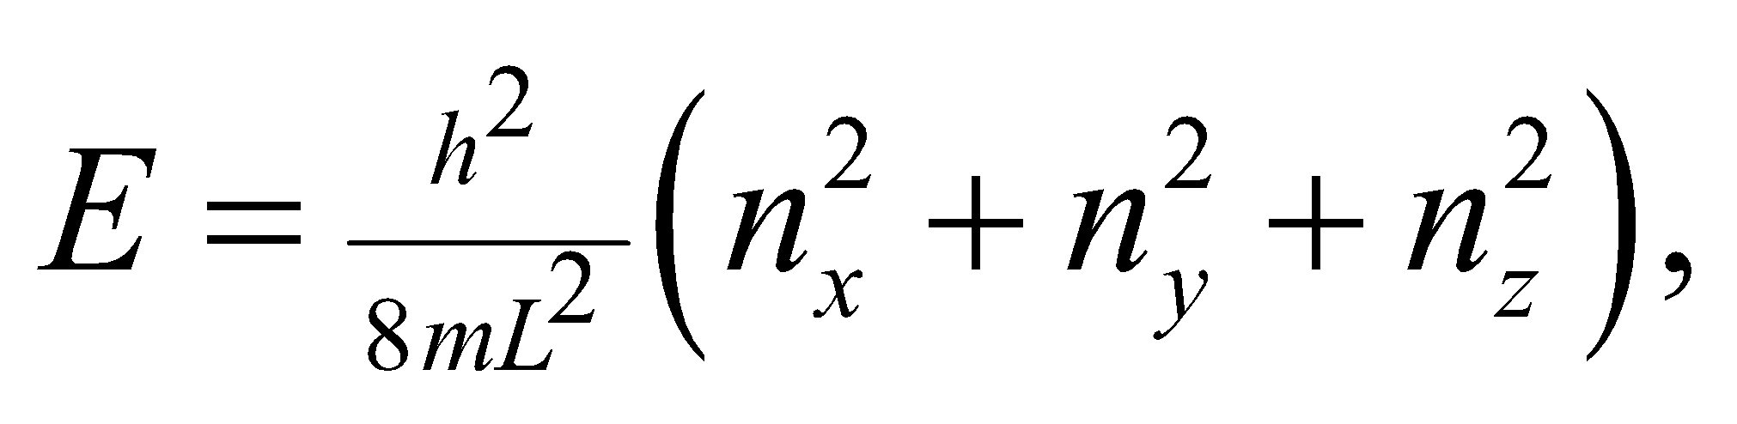where 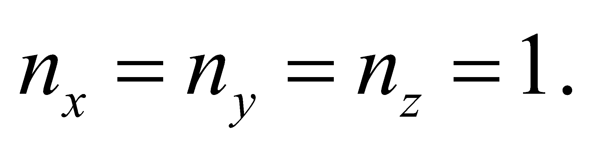 In other words, 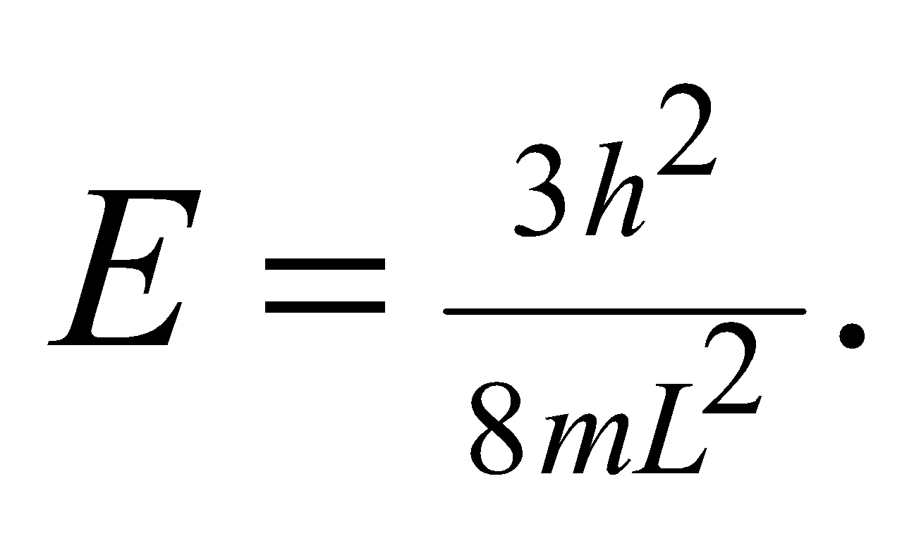

**Evaluate** There is only one ground state, since there are no ways to rearrange the *n*'s of the three dimensions. Another way to say this is that the state is nondegenerate.

The answer is (a).

**Assess** The ground state could be degenerate when other quantum numbers are considered. As we'll learn in Chapter 36, the spin of an electron is specified by a quantum number, 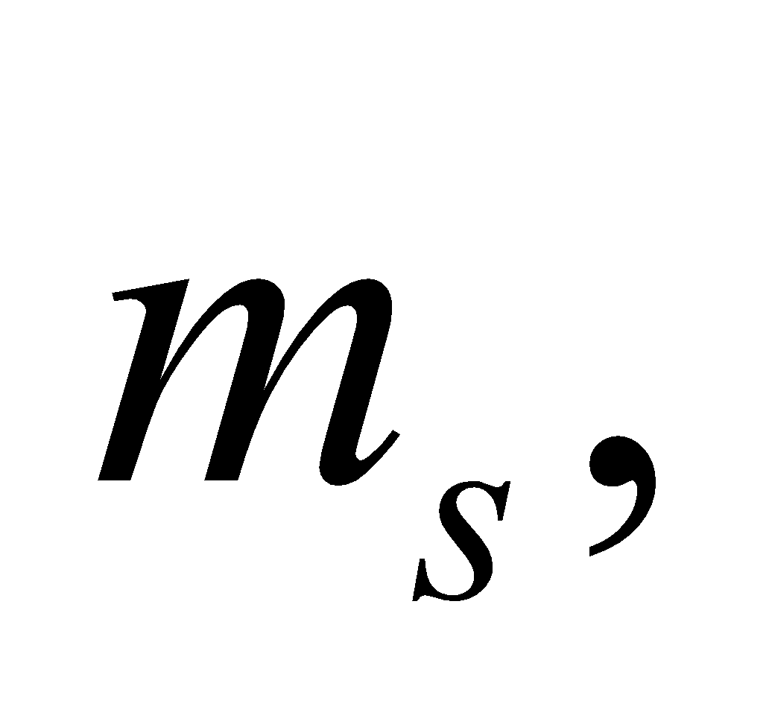which can be either +1/2 or –1/2. Assuming the spin doesn't affect the energy, the state with 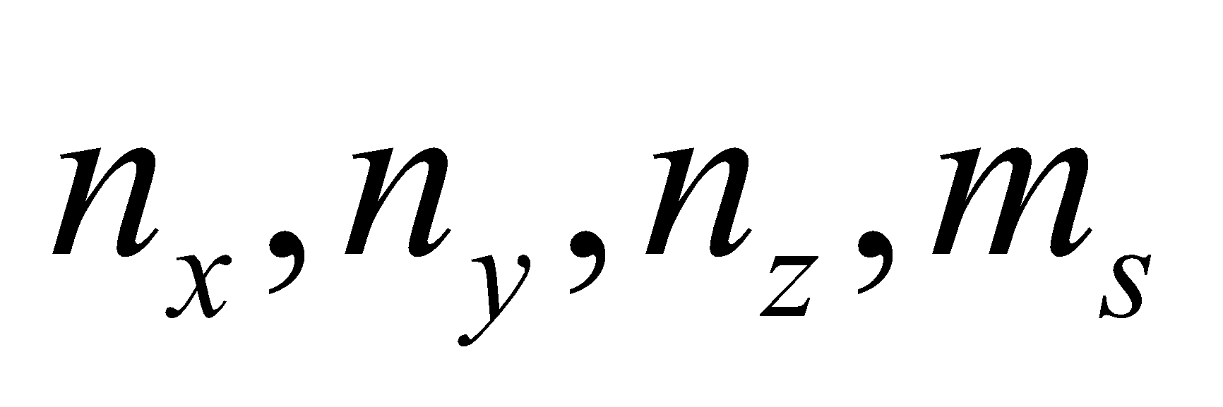 equal to 1,1,1,+1/2 is degenerate with the state with  equal to 1,1,1,–1/2.

**57. Interpret** We evaluate the energy levels of a quantum dot.

**Develop** The first excited state of a cubically symmetric qdot has energy of where one of the three quantum numbers equals 2, while the other two equal 1.

**Evaluate** There are three states that have the energy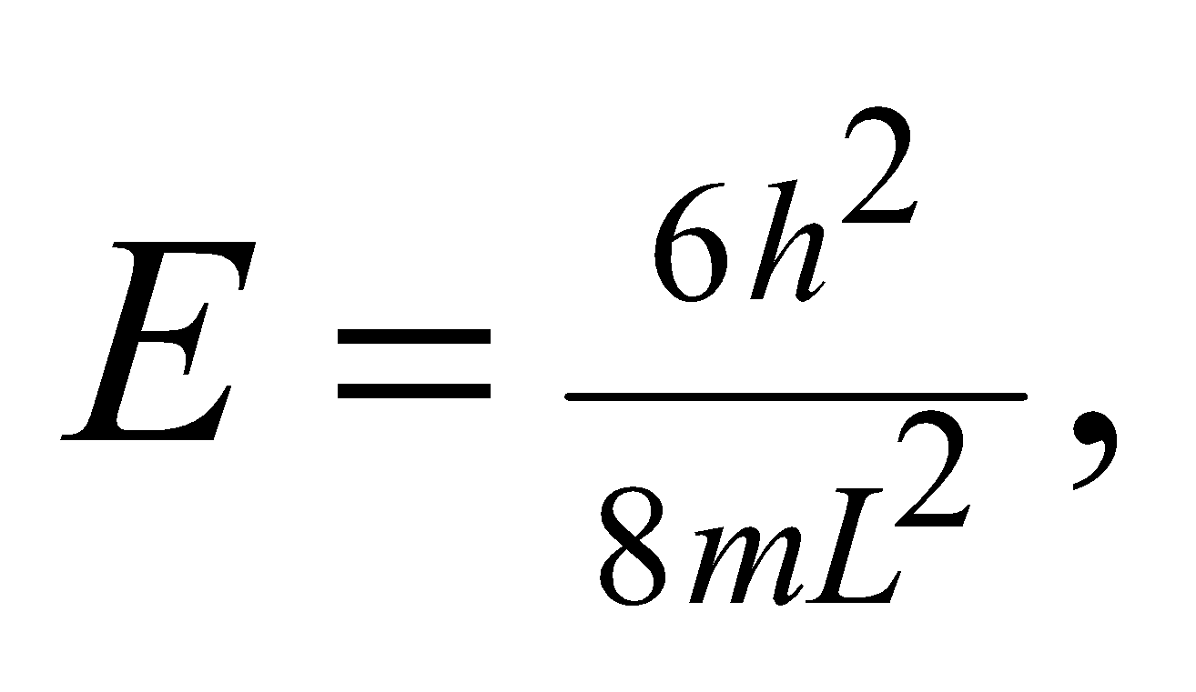 i.e., 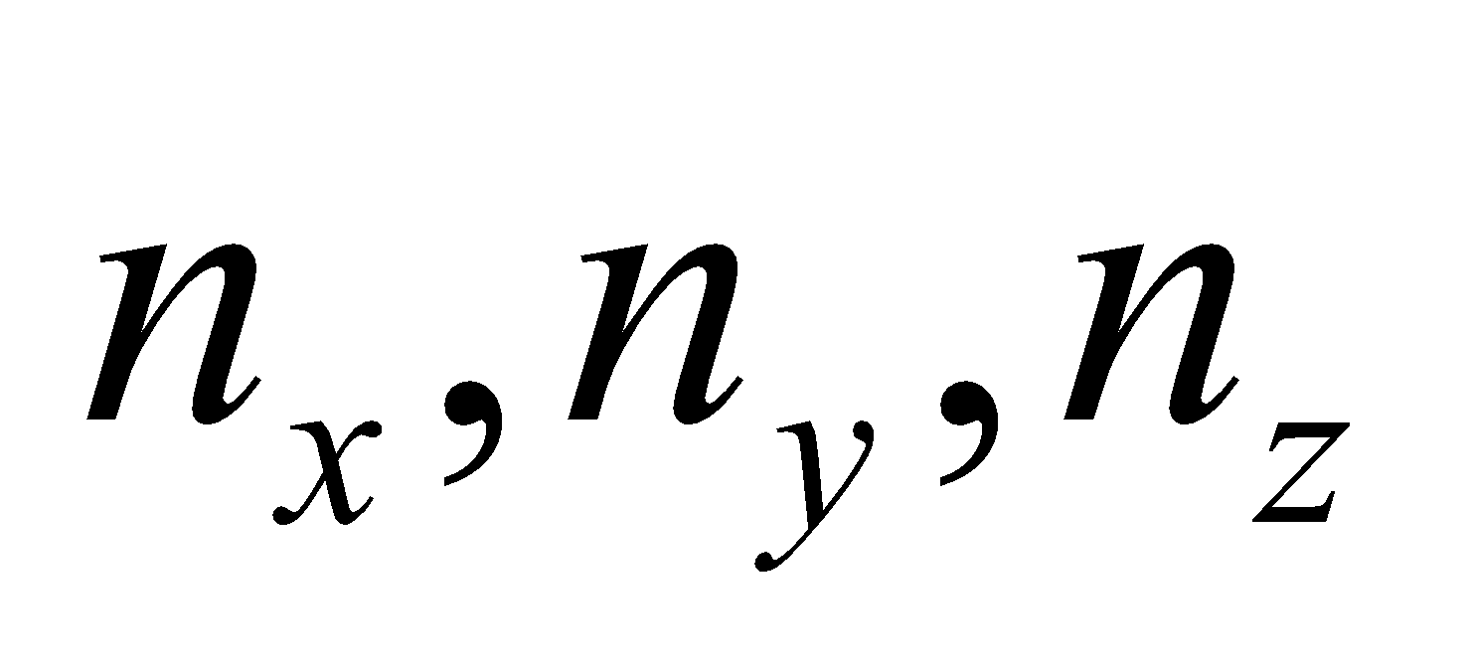 can equal 2,1,1 or 1,2,1 or 1,1,2. See Figure 35.17. We say this state is three-fold degenerate.

The answer is (c).

**Assess** Degeneracy often depends on there being some sort of symmetry. In this case, it is the symmetry of the cube. If the qdot's three sides were not equal, then the first excited state would nondegenerate.

**58. Interpret** We evaluate the energy levels of a quantum dot.

**Develop** For the general case of a quantum with sides of different length, the ground state energy is written as

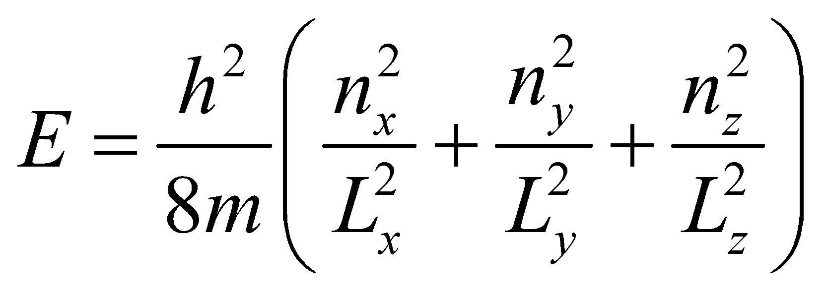

**Evaluate** If all three sides are reduced in length by half, then the ground state energy will increase by a factor of 4.

The answer is (d).

**Assess** The special case of a cubical qdot has 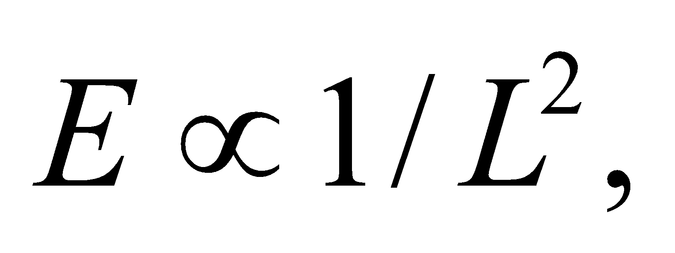 which clearly shows that the energy quadruples when the size of the cube shrinks by half.